Spelling test: Year 5
Given: 12.5.20
Test: 19.5.20
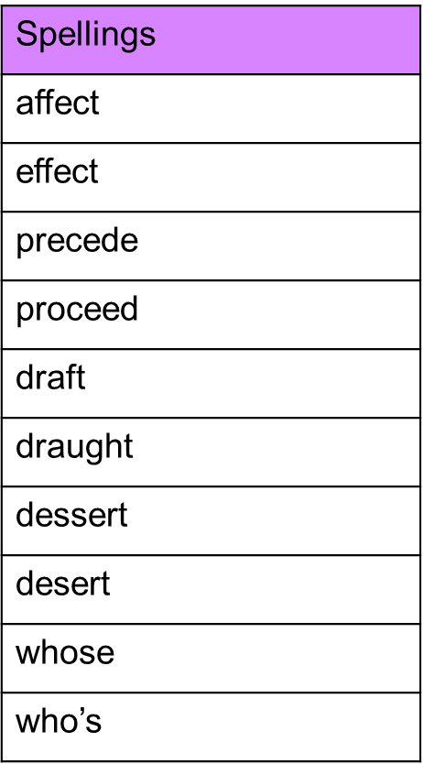

Spelling test: Year 6
Given: 12.5.20
Test: 19.5.20
