Spelling test: Year 5
Given: 29.9.20
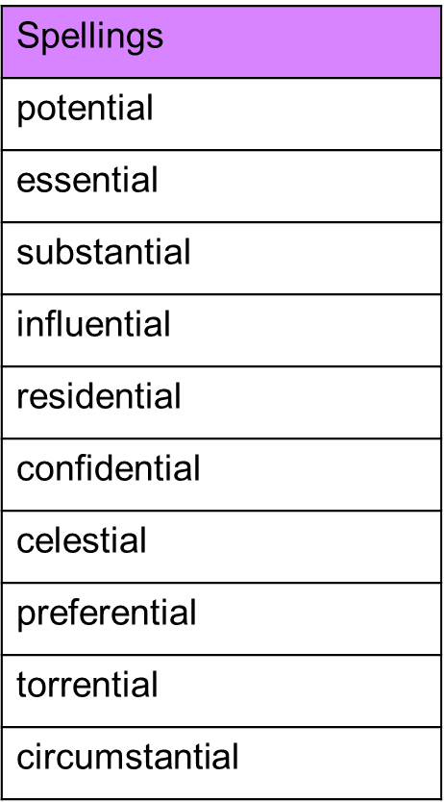
Test: 6.10.20

Spelling test: Year 6
Given: 29.9.20
Test: 6.10.20
