Spelling test: Year 5
Given: 24.11.20
Test: 1.12.20
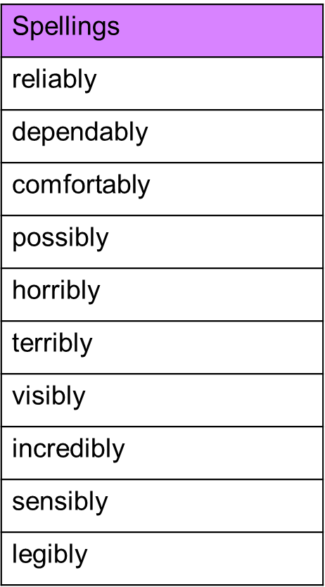

Spelling test: Year 6
Given: 24.11.20
Test: 1.12.20
