Spelling Test: Year 5
Given: 28.9.21
Test: 5.10.21
Rule: High Frequency Words
Spellings
out
tree
night
these
more
sister

Spelling test: Year 5
Given: 28.9.21
Test: 5.10.21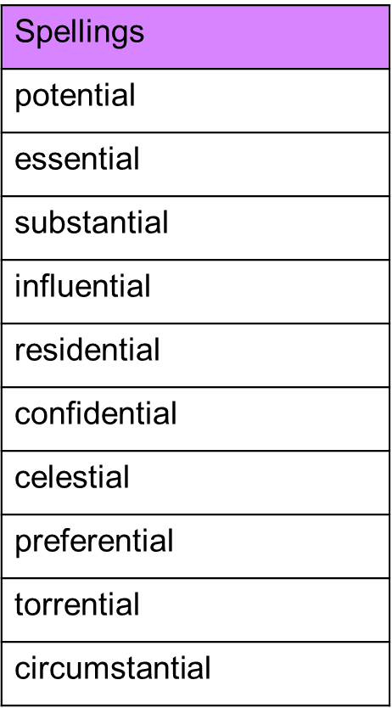

Spelling test: Year 6
Given: 28.9.21
Test: 5.10.21