Spelling test: Year 5
Given: 3.12.19
Test: 10.12.19
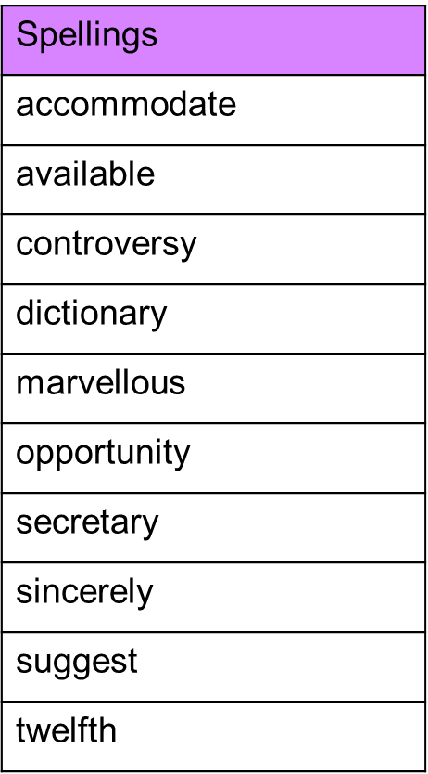

Spelling test: Year 6
Given: 3.12.19
Test: 10.12.19
