Spelling Test: Year 5
Given: 8.2.22
Test: 15.2.22
Rule: High Frequency Words
Spellings
another
half
back
house
brother
how

Spelling test: Year 5
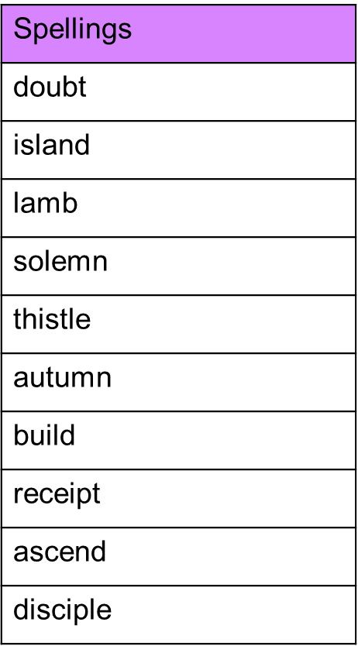
Given: 8.2.22
Test: 15.2.22

Spelling test: Year 6
Given: 8.2.22
Test: 15.2.22
