Spelling test: Year 5
Given: 19.5.20
Test: 26.5.20
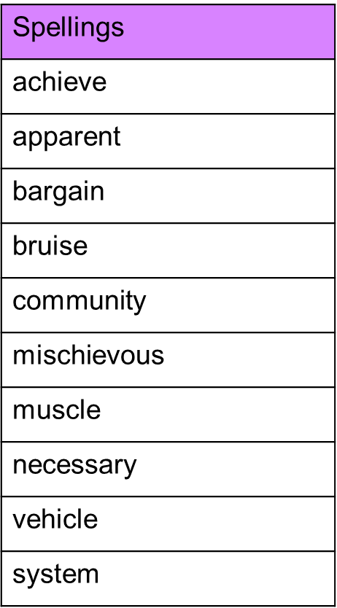

Spelling test: Year 6
Given: 19.5.20
Test: 26.5.20
