Spelling Test: Year 5
Given: 5.10.21
Test: 12.10.21
Rule: High Frequency Words
Spellings
where
Thursday
week
May
October
one

Spelling test: Year 5
Given: 5.10.21
Test: 12.10.21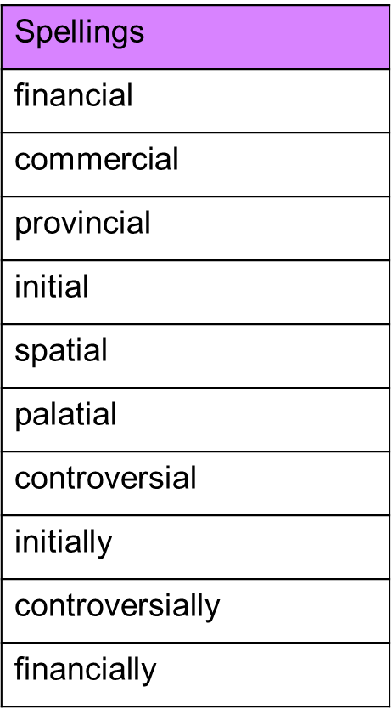

Spelling test: Year 6
Given: 5.10.21
Test: 12.10.21