Spelling test: Year 5
Given: 8.12.20
Test: 15.12.20
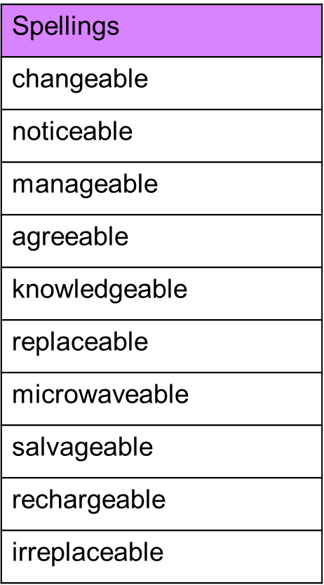

Spelling test: Year 6
Given: 8.12.20
Test: 15.12.20
