Spelling Test: Year 5
Given: 12.10.21
Test: 18.10.21
Rule: High Frequency Words
Spellings
six
eleven
sixteen
number
black
grey

Spelling test: Year 5
Given: 12.10.21
Test: 18.10.21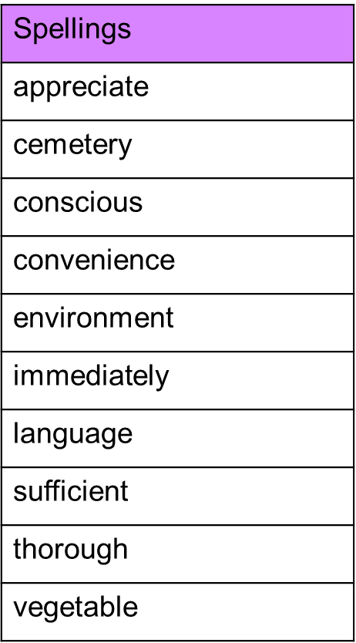

Spelling test: Year 6
Given: 12.10.21
Test: 18.10.21