Spelling Test: Year 5
Given: 19.10.21
Test: 2.11.21
Rule: High Frequency Words
Spellings
had
did
his
want
off
them

Spelling test: Year 5
Given: 1.11.21
Test: 9.11.21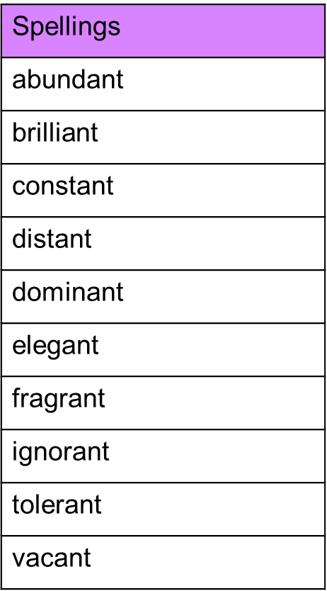

Spelling test: Year 6
Given: 1.11.21
Test: 9.11.21