
What’s coming up! Issue 13
7.7.25
Our Motto: Believe and Achieve
Our Christian Values: Love. Respect. Friendship.
Our Vision: Here at Anson we provide a stimulating environment of discovery and learning. Living our core Christian values of Love, Respect and Friendship. Developing helping hands and open hearts each and every day. Nurturing every young mind to achieve their very best.
Our Symbol: Helping Hands
Bible Verse: ‘Let all that you do be done in love’. 1 Corinthians 16:14

Dear Families,

We have enjoyed so many events during the past few weeks including Spelling Bee for KS1 and 2, PTFA fundraiser and the whole school transition day. If you would like to see these events and catch up with your child’s learning in class, then please remember to visit our website.
Class 1 | Anson CE Primary School
Class 2 | Anson CE Primary School
Class 3 | Anson CE Primary School
Class 4 | Anson CE Primary School
Staff Update
Miss Rackham will be leaving Anson at the end of this term and on behalf of the Local Governing Committee and staff at the school we would like to say thank you for your efforts this past year and we wish you all the best in your future career.
Although Mrs Cooper has worked within the Trust for the past year and been working in Class 1 this last half term, she will begin teaching Class 2 in September. We know that you will welcome her into our Anson family and we will allow some time at the beginning of the Autumn term to meet her face to face.
Class Teachers for September 2025
Class 1 Mrs Heath and Mrs Philp
Class 2 Mrs Cooper
Class 3 Mrs Walmsley and Mrs Hayward
Class 4 Mr Davies
Teaching Assistants will be supporting children with additional needs across the school but will also be assigned to the following classes:
Class 1 Mrs Bater and Mrs Elwell
Class 2 Mrs Grant
Class 3 Mrs Forrester
Class 4 Mrs Castell, Mrs Broome and Mrs Rock
Summer Club
We are really excited to offer a summer club again this year following last year’s success!
The dates offered for the Summer Club 2025 are 28th, 29th and 30th July and 4th, 5th and 6th of August. The club will run from 08:30 until 15:30 on each of these days.
There are still a few places left however we will not be able to admit more than 15 children on a particular day so to avoid any disappointment please complete the booking form should you need a place and/or places for your child/ren.
Discounts are available for siblings and children who will be attending Reception in September are also permitted to come along with their siblings. Year 6 children are also allowed to come along should they wish.
Summer Club Booking Form 2025
Trim Trail
We are thrilled that the Trim trail is now up and running; the children have been enjoying playing, offering greater opportunities to develop physical skills as well as improving children’s health, fitness and most of all levels of fun!
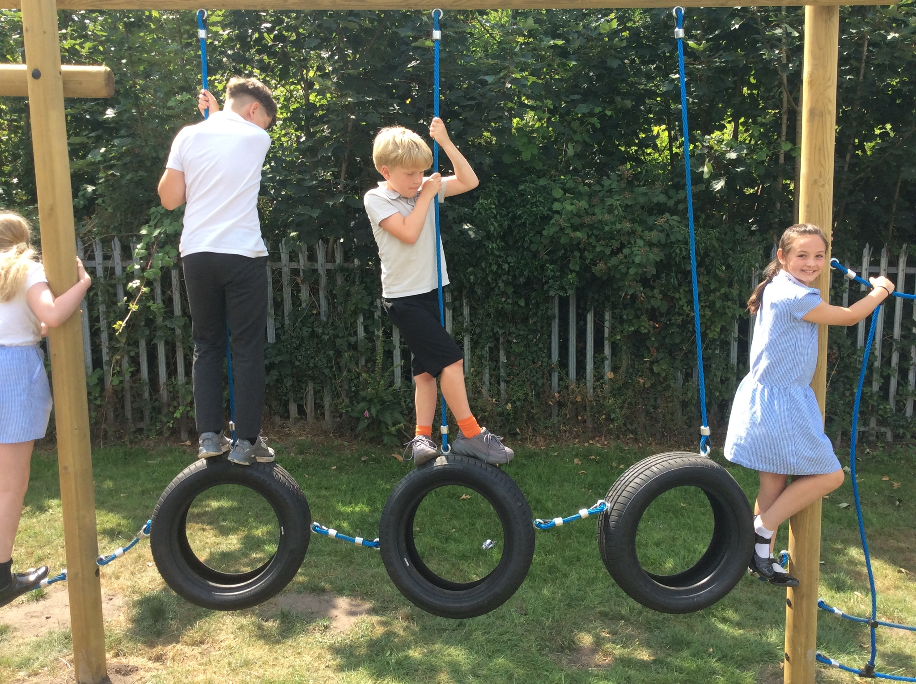
Colwich Parish Council kindly donated £1,000 towards the purchase of the TrimTrail -
THANK YOU!!!!
Canalside Farm, Shop and Cafe, a thriving local business, kindly nominated Anson as their fundraising charity for 2025-26. This opportunity and support has also helped our end goal of a Trim Trail for the whole school to enjoy! Already they have donated over £130 from their customers change - THANK YOU!!!

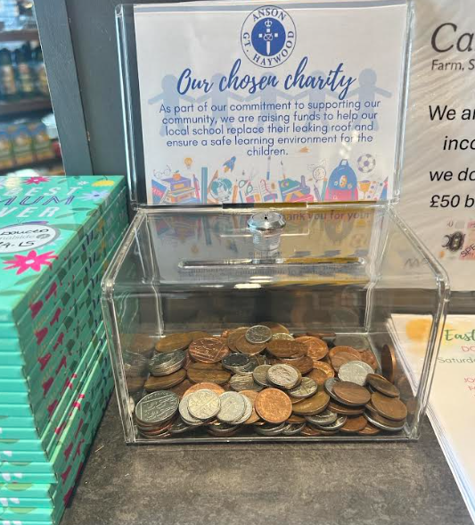

Thank you to you all for making this a reality! Christian Distinctiveness
If you would like to explore our Christian Distinctiveness then please click on the link:
Christian Foundation | Anson CE Primary School
If you would like to support Anson, then please click on the PTFA link:
PTFA | Anson CE Primary School
We appreciate your support and I will keep you updated with how we are doing. If you have any further ideas for fundraising then please contact the school office or the PTFA!
anson.office@tssmat.staffs.sch.uk
or
ansonptfa@tssmat.staffs.sch.uk


Other Services
We know that some children need a little more help at certain times and we would like to draw your attention to this newly formed offer to support children between the ages of 5-18.
Stay Well aims to offer support for emotional health and wellbeing.
Please click on the link to find out more:
Stay Well - Children and Young People Service | Anson CE Primary School
Thank you for all your continued support this half term!

Please remember that dates and times may have to change so continue to check your emails and the website
Key Dates:
https://www.anson.staffs.sch.uk/events
&
Anson Key Dates Spring and Summer 2024-25
7.7 | Year 6 Photographs | - Hall | - 8.45am - 9.30am
7.7 | Community Performance | - Hall | - 2pm - 3pm
8.7 | Class 4 Performance | - Hall | - 2pm - 3pm  - Google form sent out
8.7 | Class 4 Performance | - Hall | - 5pm -6pm  - Google form sent out
9.7 | New Reception Transition afternoon |  | - 12.30pm - 3pm  - Lunch included
11.7 | Diddi Dance | - Hall | - Class 1  - 10am -11am
11.7 | Emma Fry - PCSO |  | - 2.45pm  - Award Junior Cadets
11.7 | Swimming | Year 4 | - JD out pm
11.7 | SOW Assembly | Whole school | - 2.45pm - 3.10pm  - All are welcome!
16.7 | Year 4 SOW and Awards |  | - Year 4  - Hall  - All invited
17.7 | PTFA Summer Fayre | Whole School | - 2pm - 3.15pm  - Children picked up from the playground  - Children allowed to wear own clothes today  - Flyer sent out  - All children to be taken around the fayre by staff member  - Children allowed to leave after the fayre
18.7 | Swimming |  | - Mr Davies to drive the minibus  - 1.15pm leave  - 3.30pm return approx
18.7 | Celebration Assembly | - School Hall  - 2.45pm  - All are welcome! | - School Hall  - 2.45pm  - All are welcome!
21.7 | Y6 Leavers Service |  | - St Stephen’s Church  - 9.30am - 10.30am  - Families all invited  - Father Neale final blessing
22.7 | Anson’s Got Talent |  | - 9.30am -11.00am  - Only for staff and children in school sorry!
22.7 | Last Day of Term |  | - 3.15pm finish  - Final Goodbye to our Year 6!!!
Term Dates
https://www.anson.staffs.sch.uk/termdates
A prayer for our Year 6
"God our Father, we thank you for the time our pupils have spent with us at Anson CE Primary School. We ask you to bless them as they leave us and embark on new adventures. May they be guided by your wisdom and grace, and may they always remember the lessons they have learned here. We pray for their safety, health, and happiness in all their future endeavors. Amen."
Thank you for all that you do to support us at Anson, and ensuring our school remains a place of love and kindness so that we can all flourish. We are blessed to have such wonderful children, staff and families.
Best wishes
Nicola Jarrett
Headteacher

