
What’s coming up! Issue 9
14.3.25
Our Motto: Believe and Achieve
Our Christian Values: Love. Respect. Friendship.
Our Vision: Here at Anson we provide a stimulating environment of discovery and learning. Living our core Christian values of Love, Respect and Friendship. Developing helping hands and open hearts each and every day. Nurturing every young mind to achieve their very best.
Our Symbol: Helping Hands
Bible Verse: ‘Let all that you do be done in love’. 1 Corinthians 16:14

Dear Families,

Thank you for your continued support as we continue to thrive, here at Anson.
Christian Distinctiveness
As part of our journey exploring spirituality, we have introduced a new practice called - Noticing.
Why Noticing?
The Examen is a technical name for one of the Spiritual Exercises developed by St Ignatius of
Loyola. It is premised on noticing these apparently small and insignificant details of life but
realising that actually they are incredibly powerful signifiers of personal, spiritual and
community truth.
The Examen can take different forms, but generally speaking it invites us to notice times of
consolation, when we feel energised, alive, and full of life and possibility. It also invites us to
notice times of desolation when we feel empty, drained, hopeless, and lacking in energy and
vitality. If Jesus invites us to live life in all its fullness, then this would be consolation, and its
opposite would be desolation.
The Examen allows us to attend quietly, reflectively, and prayerfully on noticing these dynamics
of consolation and desolation in our lives. This practice is a central tenet of Ignatian spirituality
(on which much of the Contemplative Toolkit is built). Ignatius, when asked which of the many
spiritual exercises he thought was of greatest value, answered without hesitation “the
Examen!”
We would welcome your feedback regarding this practice and any aspect of Worship and RE.
Outdoor Thursdays | Anson CE Primary School
The Muddy Jar
Stilling
Courageous Advocacy


Isobella has shown true kindness by making lemonade and selling it to raise funds for the school. She proudly donated £6. Thank you for being a courageous advocate Izzy.
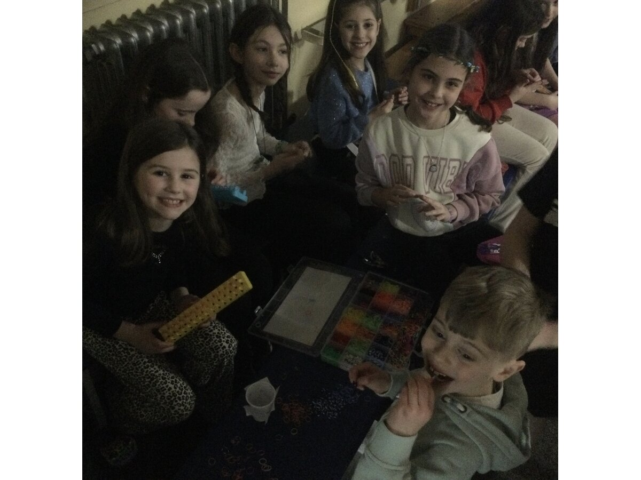
Erin, Amelia, Freya, Annie and Amelie and Annabelle also used the school disco to make loom bands in the shape of bracelets to raise money for the Trim Trail inspired by Isala and Erin’s work for the fayre. Thank you girls for raising £26!
Worship
Our value for the next half term is Forgiveness. We will be looking at what Forgiveness means and how we can share this value both in school and within the school community.

During our whole school worship, we will be thinking about the importance of forgiveness and if you would like to continue this discussion at home then here is a link to the website to support this.
HomeSchoolValues-FORGIVENESS.pdf
Anson's Christian Foundation
Class Blogs
If you would like to find out what your child/ren have been up to at school, then simply click on the links below:
Class 1 | Anson CE Primary School
Class 2 | Anson CE Primary School
Class 3 | Anson CE Primary School
Class 4 | Anson CE Primary School
Reminders:
School Library
- Class 1 are invited to change or select a library book - Mondays
- Class 2 are invited to change or select a library book - Mondays
- Class 3 are invited to change or select a library book – Tuesdays
- Class 4 are invited to change or select a library book – Wednesdays
- Year 5/6 librarians support the changing of books during their break times
Dinners
- Lunch menu is now available on the school website
- Remember Class 1 and Class 2 do not pay for their lunch
- Remember to pay for all your lunch via ParentPay
- Remember your child can only have a lunch if they are paid for
- Remember to contact the office if you think you may be entitled to free school meals
Thank you for all your continued support this half term!


Reminders:
- Remember to complete Care Club forms to reserve a place
- Contact the office you need an appointment to see your child’s class teacher
- Remember to check expiry dates for inhalers or medication held in school
- Remember to contact the office if you need a meeting with the class teacher, Deputy Headteacher or Headteacher to discuss any concerns so that they can be addressed as soon as possible.
Please remember that dates and times may have to change so continue to check your emails and the website
Key Dates: https://www.anson.staffs.sch.uk/events
Monday 17th March | Class 3 Community Performance | - Community Members  - 1.45pm arrival  - 2pm start  - 2.40pm finish
Tuesday 18th March | Class 3 Performance | - School Hall  - 1.45pm arrival  - 2pm start  - 2.40pm finish  - Additional request for tickets confirmed  - Children/siblings allowed to go home after the performance
Tuesday 18th March | Class 3 Performance | - School Hall  - 4.40pm arrival  - 5pm start  - 5.40pm finish  - Additional request for tickets confirmed
Friday 21st March | Red Nose Day | - Where something funny for money  - £1 donation  - Non uniform
Friday 21st March | Celebration Assembly | - 2.45pm -3.10pm  - School Hall  - All welcome
Monday 24th March | Dr Allen - Greenpower | - 8.45am - 12pm  - School Hall  - Class 4
Tuesday 25th March | Young Leaders Programme | - Worship leaders  - 1pm - 2pm  - Virtual National Meeting  - Miss Jarrett to lead
Friday 28th March | Mothering Sunday Afternoon Cream Tea | - School Hall  - 1.30pm -2.30pm  - Invitations sent  - RSVP to reserve a place  - PTFA Mothering Sunday Cream Tea | Anson CE Primary School
Friday 28th March | Mothering Sunday Service in School Hall | - School Hall  - 2.45pm  - All are welcome!
Sunday 30th March | Mothering Sunday Service in St Stephen’s Church | - St Stephen’s Church  - 10am  - All Welcome
Friday 4th April | Animal Roadshow | - Class 1  - Details to follow  - Playground  - 10am
Friday 4th April | Celebration Assembly | - School Hall  - 2.45pm  - All are welcome!
Term Dates
https://www.anson.staffs.sch.uk/termdates

We pray our school would be a place of great discovery, adventure and creativity. May it be a place where we love to learn and where we learn to love, A place where everyone is respected and all are deeply valued. We ask all this through Jesus Christ our Lord.

Thank you for all that you do to support us at Anson, and ensuring our school remains a place of love and kindness so that we can all flourish. We are blessed to have such wonderful children, staff and families and we wish you all a relaxing weekend.
Best wishes
Nicola Jarrett
Headteacher

