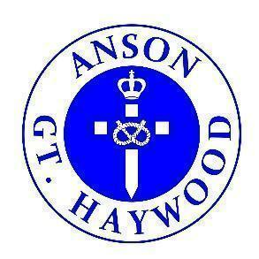
What’s coming up! Issue 2
18.9.2023
Our Motto: Believe and Achieve
Our Christian Values: Love. Respect. Friendship.
Our Vision: Here at Anson we provide a stimulating environment of discovery and learning. Living our core Christian values of Love, Respect and Friendship. Developing helping hands and open hearts each and every day. Nurturing every young mind to achieve their very best.
Our Symbol: Helping Hands
Bible Verse: ‘Let all that you do be done in love’. 1 Corinthians 16:14

Dear Families,

What a busy few weeks we have had in school and here is a list of key dates that are to follow.
Reminders:
School Library
- Class 1 are invited to change or select a library book - Mondays
- Class 2 are invited to change or select a library book - Mondays
- Class 3 are invited to change or select a library book – Tuesdays
- Class 4 are invited to change or select a library book – Wednesdays
- Year 5/6 librarians support the changing of books during their break times
Extra-Curricular Clubs
- Extra-Curricular clubs will begin next week – Monday 11th September – 3.25/3.30pm – 4.20pm
- Please check your emails for a google form to complete.
- Monday – Class 2 Construction Club
- Monday – Class 3 and Class 4 Football Club
- Monday – Whole School Choir Club (LUNCHTIMES) - No charge
- Wednesday – Class 3 and Class 4 Netball Club
- Thursday – Class 2 Book Club
- Thursday – Class 3 and Class 4 Yoga and Mindfulness
Dinners
- Lunch menu is now available on the school website
- Remember Class 1 and Class 2 do not pay for their lunch
- Remember to pay for all your lunch via ParentPay
- Remember your child can only have a lunch if they are paid for
- Remember to contact the office if you think you may be entitled to free school meals
Key Dates: https://www.anson.staffs.sch.uk/events
Wednesday 20th September | Class Photographs | 8.45am - 10.00am  - Richard Greenwood  - Class Photos  - Dress Smartly Please
Tuesday 26th September | Pupil Flu Immunisation | Check emails for further details from the Immunisation Team
Thursday 28th September | Macmillan Coffee Morning | 8.45am - 9.45am  - All welcome to share tea or coffee  - Cakes and biscuits available  - School Hall  - All money going to charity  - Children are allowed to bring 50p to buy a biscuit or cake that maybe left over
Friday 6th October | Harvest Festival in School | 2.55pm  - School hall  - All Welcome
Sunday 8th October | Harvest Festival in Church | 10am - 11am  - All welcome  - Worship council to support service

Term Dates
https://www.anson.staffs.sch.uk/termdates
Best wishes
Nicola Jarrett
Headteacher

