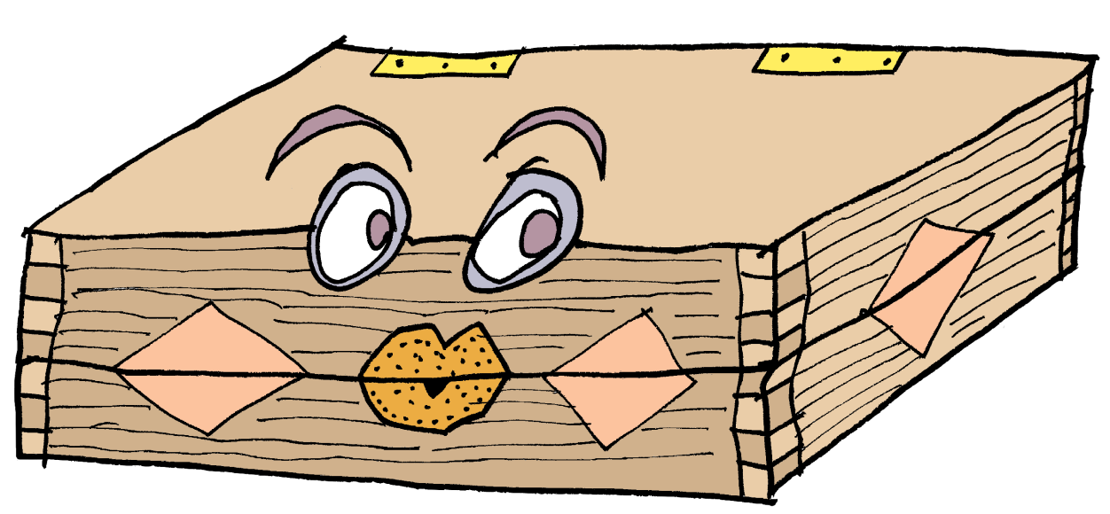
The

Magical

Box

By

Emma

Caulfield

Hello!

I
’
m

a

magical

teaching

box

and

I’m

going

to

tell

you

a

story
.

The Myth of Pandora’s Box

Are you nosy? Do you like secrets? Have you ever done something that you’ve been warned not to, just to find out a secret? All through time there have been stories about people being told not to open doors, cupboards, gates and all sorts of other things, and in many of the stories the people just didn’t listen. One person who did not listen is Pandora. Her story is from Ancient Greece, where her nosiness changed the world forever!

Hello!

Let’s

start

by

reading

a

story

together

Not hundreds but thousands of years ago, in ancient Greece, there lived two brothers called Epimetheus and Prometheus. Although they lived in a world where the gods were in charge, they liked nothing more than to annoy the gods. One day, Zeus, a particularly powerful god, decided to teach them a lesson.

Zeus ordered the gods to create a beautiful woman. Her name was
Pandora and she was to marry Epimetheus. As a wedding present, Zeus gave Pandora a beautiful box but there was one special condition, she was never to open it!

All day Pandora’s husband Epimetheus was out working. All day all she could think about was what was in the box. Pandora could not understand why Zeus would give her a box that she could not open. It made no sense to her. Pandora was bored and lonely and her curiosity became unbearable.

★
Let’s

stop

here

and

do

an

activity

…

★
What

do

you

think

the

box

looked

like?

Draw

it

here:

- Continue reading the story here

One day, when she was sure that Epimetheus was out annoying the gods, Pandora searched for the key to open the box. “I know it’s here somewhere,” she muttered to herself as she opened cupboards and drawers. There it was, high on a shelf in their bedroom! With shaking hands, Pandora slid the key into the lock and turned it.
Let’s stop reading for a moment and think about what

could be in the box. Draw or write your ideas below.

- The story continues here …
She took a deep breath, closed her eyes and slowly, with trembling hands, opened the lid of the box, imagining what could be inside: rubies as red as the blazing sunset, jewel encrusted gowns, piles of gold coins. But there were no coins or jewellery, no gowns or gems, for all at once every evil and spite, every sadness and misery flew out. Like a swarm of insects, they fled the house and infested the earth with heartache and sorrow.

Pandora slammed the lid shut and turned the key. “What have I done?” she sobbed, holding her head in her hands. Sometime later,
Pandora noticed a fluttering sound coming from the box, as if
something was trapped inside. Terrified, she pressed her ear to the box. “Let me out,” a small voice pleaded gently, “I mean you no harm.”

Once again, with shaking hands, Pandora unlocked the box and opened the lid. A beautiful butterfly of hope fluttered out of the box, for although Pandora had released pain and suffering into the world, she had also allowed hope to follow them.
- Now draw the evil that came out of the box. Your magical teaching box has already drawn one idea for you:

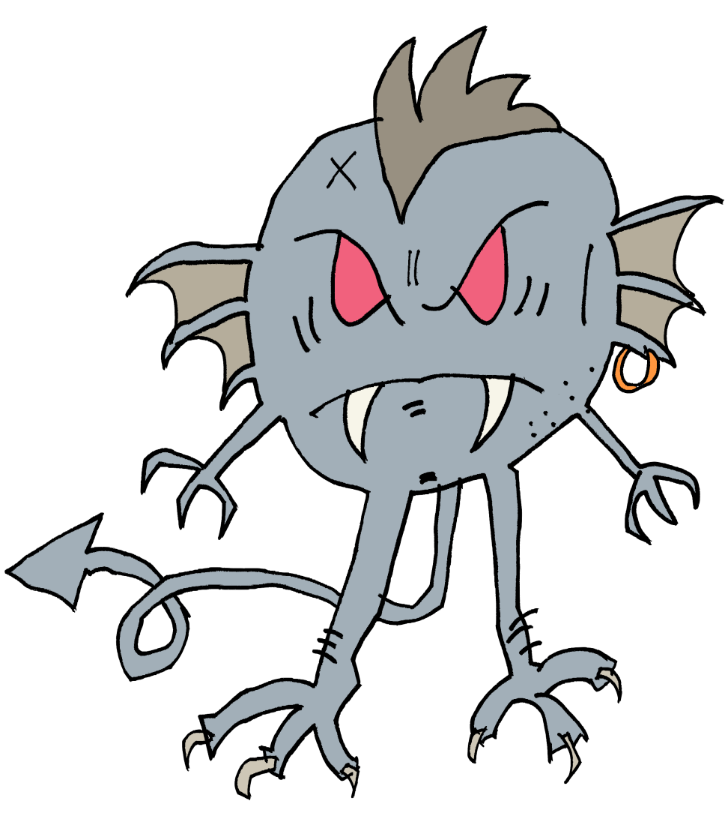
★
Finally,

share

the

story

with

someone

at

home.

Talk

and

then

write:

Did you like this story? Why?

- Read this first, then sketch Zeus and label the features listed – a stick drawing will be fine!

Zeus was a sky god who controlled thunder and lightning. He was a strong, striking man with a muscular body and long, curly hair. He had a short beard and carried his trusty thunderbolt at all times.

He was also king of the gods and would sit on his golden throne at the top of Mount Olympus.

- Can you answer these questions about the story in complete sentences? (Don’t forget to read the story again to help you.)

▪ How did Pandora change the world forever?
▪ When is the story set?
▪ Who was in charge of the Ancient Greeks?
▪ What kind of character was Pandora?
▪ Who was Prometheus?
▪ What is the evil that comes out of the box compared to?
▪ Why do you think hope is a butterfly in the story?
▪ Do you like the ending of the story? Explain your answer.

