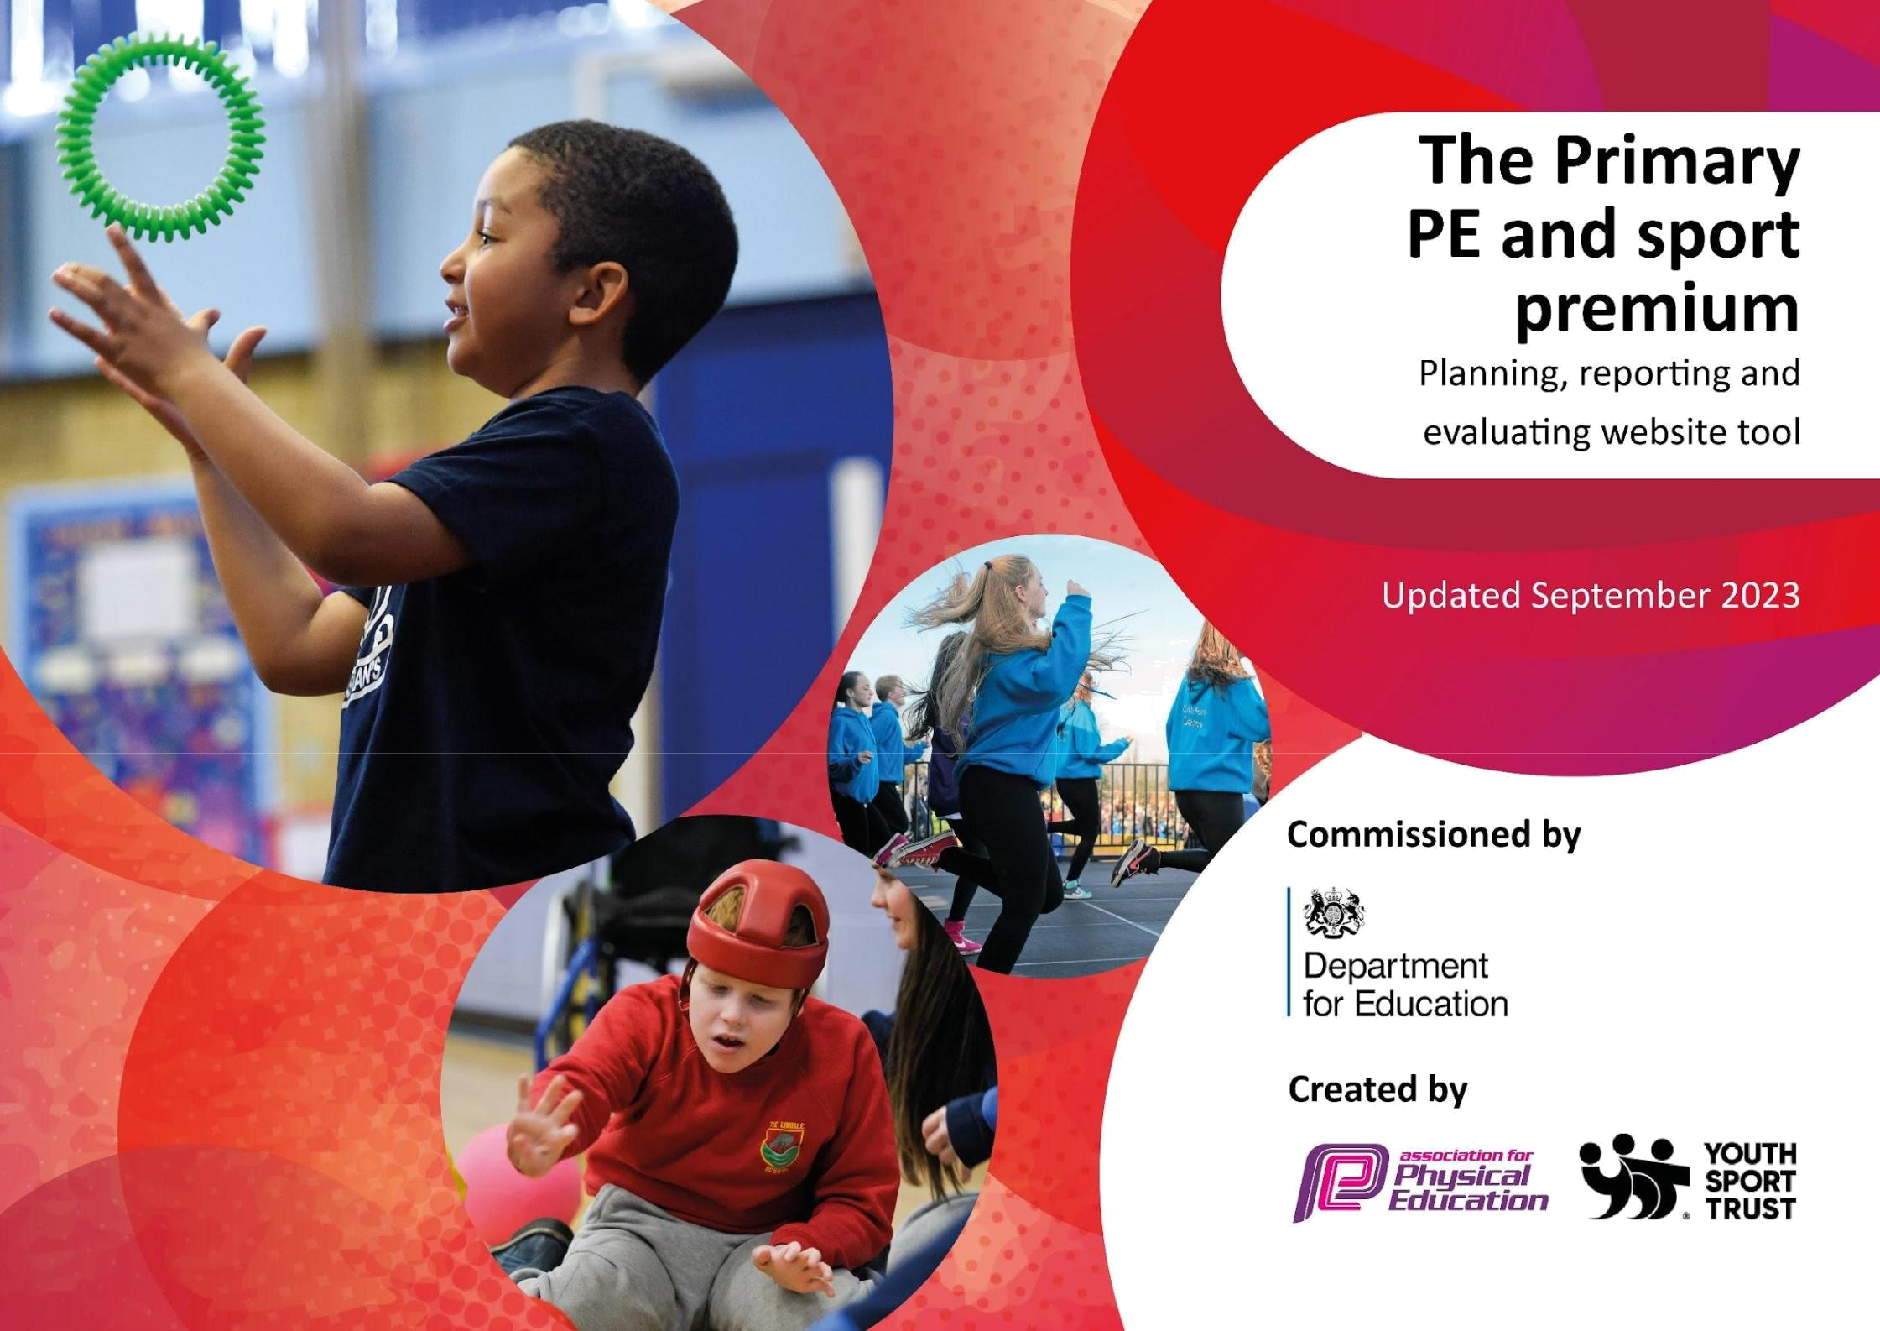
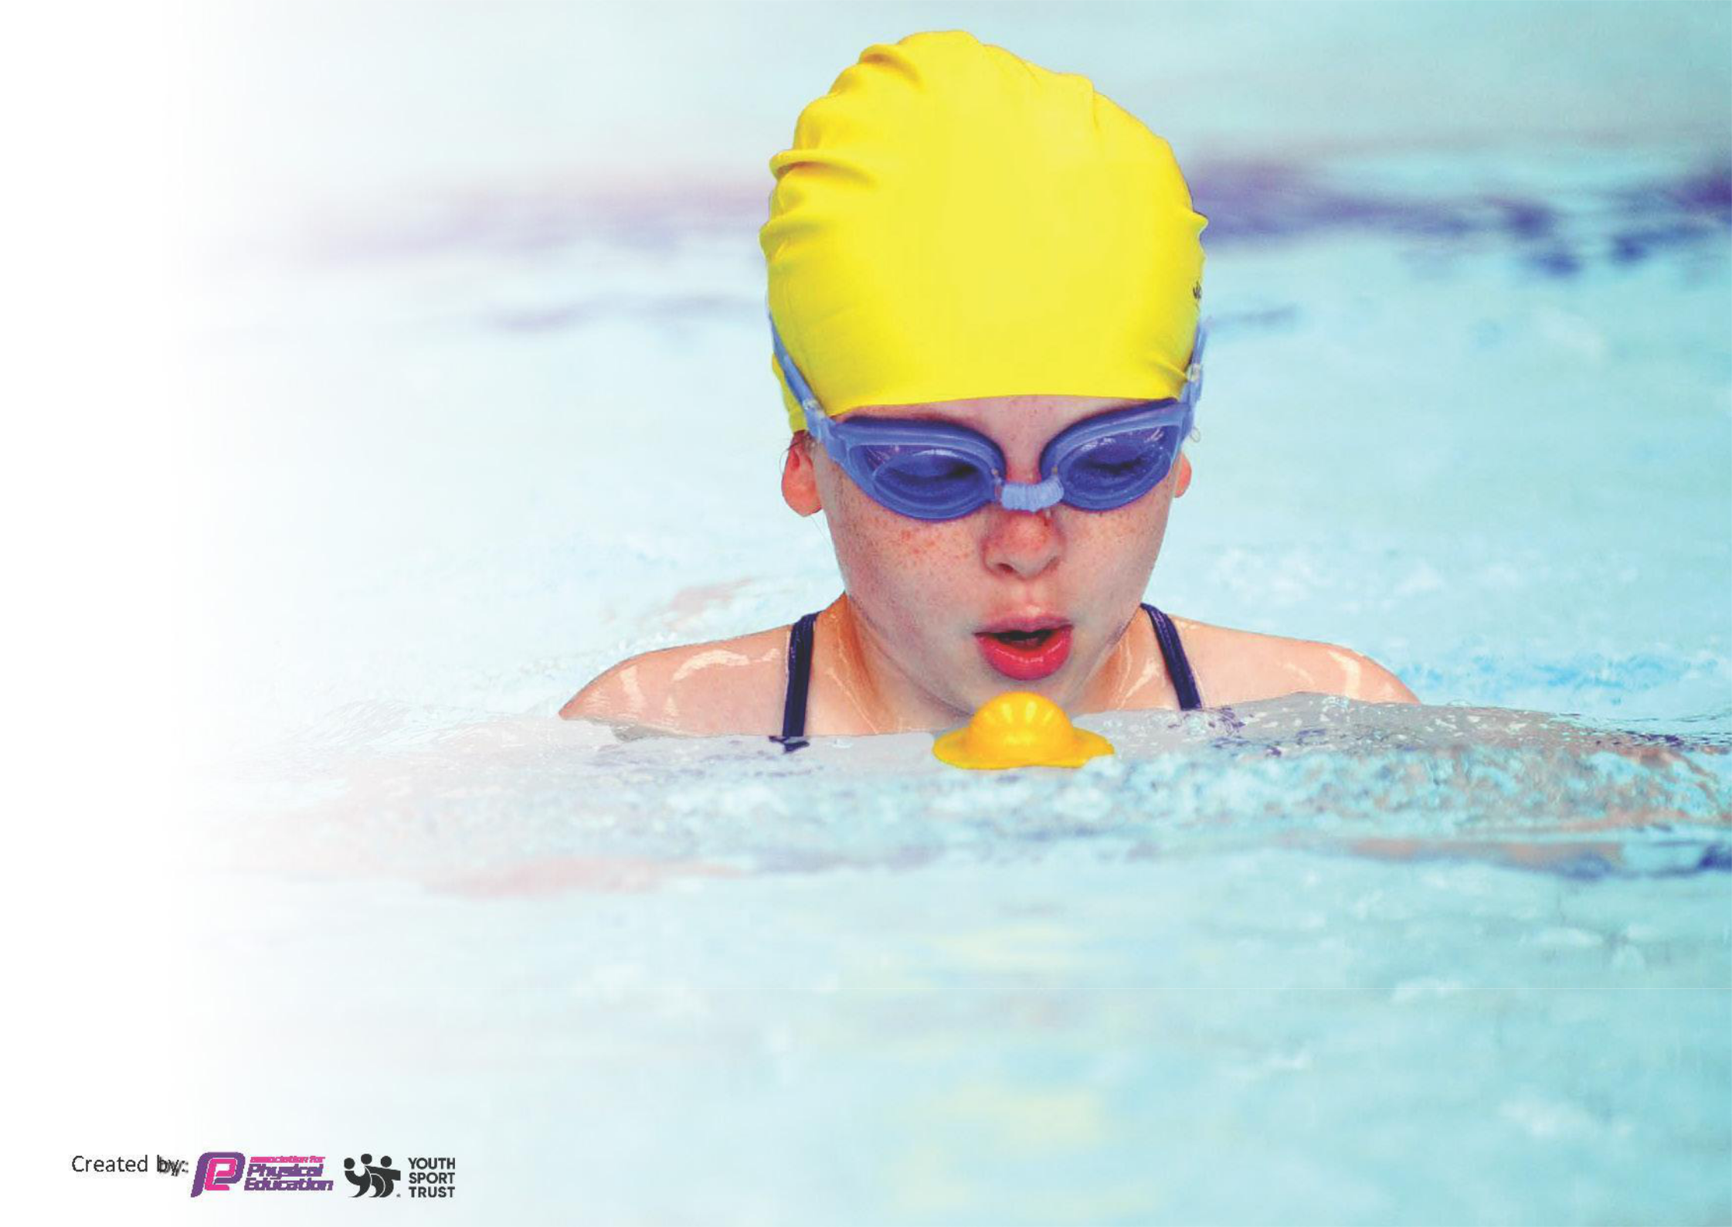
This template can be used for multiple purposes:

- It enables schools to effectively plan their use of the Primary PE and sport premium

- It helps schools to meet the requirements (as set out in guidance) to publish information on their Primary PE and sport premium

- It will be an effective document to support Ofsted inspections enabling schools to evidence progress in Physical Education (PE) and evidence swimming attainment, which forms part of the PE National Curriculum. We would recommend schools consider the Intent, Implementation and Impact of any spend, as examined within the Education Inspection Framework.

It is important that your grant is used effectively and based on
school need.

Schools must use the funding to
make additional and sustainable
improvements to the quality of the PE,
School Sport and Physical Activity (PESSPA)
they offer. This means that you should use the Primary PE and sport premium to:

- Build capacity and capability within the school to ensure that improvements made now will benefit pupils joining the school in future years

- Develop or add to the PESSPA activities that your school already offers.

The Primary PE and sport premium should not be used to fund capital spend projects; the school’s core budget should fund these. Further detail on capital expenditure can be found in the updated Primary PE and sport premium guidance.
The Primary PE and sport premium guidance, outlines 5 key priorities that funding should be used towards. It is not
necessary that spending has to meet all the key priorities, you should select the priorities that you aim to use any funding towards.

Although completing this template is not a requirement for schools, schools are required to publish details of how they spend this funding. Schools must also outline what the impact this funding has had on pupils’ PE and sport participation and attainment and how any spending will be sustainable in the future. All funding must be spent by 31st July 2024.

The Department for Education has worked closely with the Association for Physical Education (afPE) and the Youth Sport Trust (YST) to develop this template and encourages schools to use it. This template is an effective way of meeting the reporting requirements of the Primary PE and sport premium.

We recommend you start by reflecting on the impact of current provision and reviewing your previous spend.

Review of 2023-24

Review of Expenditure 2023/2024

The provision for PE and school sport has continued to go from strength to strength during this academic year. We are proud to have achieved the School Games Silver Award for our commitment and involvement to school PE and Sport. Our continued involvement in the ‘School Games and Stoke City’’ programme has enabled us to achieve many of the planned targets for our Sports Premium expenditure. Our link with Stoke City Football Club has continued to have a positive effect on our children. A number of projects have been delivered in order to achieve many of the key indicators for expenditure. These include:

Playground Leaders - Key Indicator 2

Leadership has been a key focus this year. All children in years 5 and 6 have completed the ‘Playground Leaders Award’. This was an intensive 6 week course delivered in PE lessons. This involved children learning how to be a confident leader in terms of planning and delivering small PE based games to KS1 children. The children now use these skills on a rota basis during lunchtimes. They set up small games (parachute, cricket, football, dodgeball etc) while the younger children have lunch. They then deliver 30 minute ‘active sessions’ under the supervision of a trained TA. The main success has been the involvement of those children who may previously been classed as ‘non sporty’. Evidence of this includes improvements with self esteem and social interaction.




Premier League Reading Stars - Key Indicator 3
This targeted a number of reluctant readers - generally the lowest 10% in terms of age related expectations. Weekly sessions have enthused the children by giving them access to a wide range of texts. The use of sport as a theme has ensured that children have been enthused by the content and parents have stated that they have gone home and shown a willingness to ‘carry on reading for pleasure’.

Extra Curricular Activities - Key Indicator 2 and 4

Active lunchtimes have been a focus for our commitment of achieving the Government's aspirational target of all children achieving 1 hour of physical activity per day. We have also taken into consideration what the surrounding area has to offer and we have tried to broaden the opportunities available to our children. These have included:

- Girls’ football
- Netball
- Boys Football
- Gymnastics
- Tag-Rugby

Healthy Potters - Key Indicator 2
The project targeted our KS1 children and was a mix of active and classroom based lessons and taught the children the importance of healthy eating and exercise. Children learned about the importance of looking after their heart and also the eatwell plate.

Educational Visit - Key Indicator 3
All children went on a visit to The Britannia Stadium to experience how a professional football club is run. The ’behind the scenes’ experience looked at all the different kinds of jobs people have other than being the elite sportsperson. All children also took part in a morning of events in the training dome led by the Stoke City coaches.

Mental Well Being - Key Indicator
Our year 3/4 children were involved with a mental well being project. It focused on being positive and how PE and Sport can contribute to this. Practical and theory lessons gave children the opportunity to look at how a positive mindset can impact results, both inside and outside the classroom.

Staff CPD - Key Indicator 1
In addition to initiatives led by Stoke City, we have continued to maintain our broad and balanced curriculum. Our HLTAs have received training and support in delivery of PE Outside coaches have also worked alongside school staff.



Competitive Sport - Key Indicator 2, 4 and 5
Giving our children experience of competitive sport has been a key priority. Sports Premium has allowed us to provide transport and release staff to ensure our children have taken part in the following events during the academic year:

- Athletics
- Mixed Cricket
- Cross Country
- Tennis
- Swimming
- Dodgeball
- Cricket
- Football
- Orienteering
- Tag-Rugby
- Netball

Bikeability- Key Indicator 2,4
We continued our commitment to road safety and all children in Year 5 completed the Bikeability award. We do this every year and children are taught how to stay safe while on the road.

Swimming - Key Indicator 2
All children in Year 4 took part in a term of swimming lessons. These 45 minute sessions were targeted at the end of key stage requirements and gives us an early indication of those who may need extra support if they are to meet the expectations.

This planning template will allow schools to accurately plan their spending.

Action – what are | Who does this action | KI | Impacts and how sustainability will | Cost linked to the action
you planning to do | impact? |  | be achieved?
2024-25
A number of staff members | All those who are involved | 1 | Children will be able to work in a | £500 for external trainer to
to take part in PE delivery sessions | with the teaching of |  | safe and developmental | carryout twilight sessions at hub
 | gymnastics on the floor and |  | environment and develop a love of | school
 | apparatus understand what |  | gymnastics. Local gymnastics clubs
 | constitutes a safe and |  | will be promoted as an exit route for
 | ‘outstanding’ gymnastics |  | those wishing to continue out of
 | lesson where children make |  | school.
 | good progress.
Take the children on | Year 5 and 6 will visit Stoke | 3 | Children will be inspired by visiting a | £250 for transport costs (Trip
an aspirational visit | City Football Club for a ground | 3 | professional club. The writing | included as part of the Bronze
to a professional | tour and sports activities in |  | opportunities will prove invaluable | Primary Stars project)
football | the training dome. (Tuesday |  | as a tool for progress. All children
environment. | 5th December) |  | will receive 2 hours of physical
 |  |  | activity.
Employ coaches to | All children will receive a | 1,2,4 | TAs to be upskilled in teaching PE | £2415
teach 1 PE lesson | lesson taught by a PE | 1,2,4 | and children to be taught high
per week plus 1 | specialist. More children will |  | quality PE and physical activity.
lesson of dance and | meet the national
drama to each class | expectations for specific year
– working alongside | groups and teaching staff will
a TA to provide CPD | develop more mastery of the
£1000 to resource break and

Every member of staff to attend two subject specific CPD courses to improve confidence levels and knowledge of the PE curriculum

Stoke City to deliver a Bronze Package of the Primary Stars programme

Deliver a structured Inter MAT festival calendar.

Ensure each child is receiving at least 2 hours of curriculum PE with a further 3

curriculum.

All children

Health Potters (KS1) Playground Leaders (Year 5) Minority Sports Curriculum Day (Whole School) Reading Stars (reluctant readers)

English Programme (Year 5 and 6 Writing and SCFC media centre visit)

All children across the 5 schools in the Trust

Whole School


1

2,3,4

5

2

All staff will have increased | £1500 for 3 staff to attend 2
confidence when teaching the PE | courses each
curriculum. Delivery of lessons will
be rated good or above during
observations.

Our links with SCFC have been in | £1500 to buy in the services of
place for several years. The coaches
are outstanding practitioners and
our less confident staff have
benefited tremendously from being
involved with each unit of learning
(both practical and classroom
based)
More children will have the | £1500 for medals, equipment,
experience of representing the | transport, supply cover and
school and taking part in competitive certificates.
sport. Calendar to include football,
tag rugby, netball, cross country,
boccia and athletics

Children will become fitter. Teaching £500 for subscription to Teach will cater for all learning styles and Active
will move us towards our target of
1-hour physical activity per day.

hours physical activity.

To include:

- Daily Mile

- Active Math’s

- Active Literacy

- Weekly Forest School

- Structured Breaktime/Lu nchtime led by Playground Leaders

Specialist PE teacher employed to coordinate PE across the MAT. To include 1 day per term in each school to support planning, lesson observations, assessment etc.

After school provision for physical activity will be sustained

An active PSHE

All staff

All Children (particular focus on girls and pupils who do not take part in sport outside of school.
To embed a PSHE scheme that incorporates the health and

1

2

2

All staff will be observed and be set developmental targets to ensure we are moving towards all lessons being outstanding. Outside coaches will be moderated and quality assured. The coordination of PE will include both curricular and extra-curricular responsibility.

Children will be targeted through pupil voice.

Children take part in ‘active’ PSHE lessons rather than the traditional

lunchtimes

£1000 for equipment for active lunch time and breaktimes.

£3000 to cover supply costs.

£1000 for coaches to deliver high quality after school provision.

£405

scheme to be used across the key stages.

Opportunities for physical activities are increased with the use of the outdoor area

well-being of children while contributing to our 30 minute daily physical activity target. A focus to be on the physical warm up activities.

A common and progressive scheme of work is implemented for PSHE. Curriculum aims are being met and staff to receive training to ensure confidence in delivery.

Time in the outdoor classroom is provided for all children on a rota basis. Range of OAA requirements are met. Families are invited to share in the experiences (termly). Each year group to continue to access the outdoor classroom

1
passive approach. Children taught

importance of healthy lifestyles and
the links to health and well–being.
Class 1 are inspired by involvement
of professional football club.

Multi-sensory opportunities help | £2000 for resources and
improve concentration and the | developmental training and release
motivation to learn. Self-confidence, _{time}
independence, reduced anxiety,
improve resilience and
concentration.

This template will be completed at the end of the academic year and will showcase the key achievements schools have made with their Primary PE and sport premium spending.


Activity/Action | Impact | Comments

See 2023-24 review above
Meeting National Curriculum requirements for swimming and water safety.

Priority should always be given to ensuring that pupils can perform safe self-rescue even if they do not fully meet the first two requirements of the National Curriculum programme of study

 | Question |  | Stats: |  |  |  | Further context
 |  |  |  |  |  |  | Relative to local challenges
 | What percentage of your current Year 6 cohort can swim |  | 100% |  |  |  | Use this text box to give further context behind
 | competently, confidently and proficiently over a distance |  |  |  |  |  | the percentage.
 | of at least 25 metres? |  |  |  |  |  | e.g., 30% - we are struggling to get pool space
 |  |  |  |  |  |  | due to our local pool closing so we have had to
 |  |  |  |  |  |  | use a much smaller local school pool. We have
 |  |  |  |  |  |  | had to limit the number of pupils attending
 |  |  |  |  |  |  | swimming lessons during one term which means
 |  |  |  |  |  |  | some pupils have attended fewer swimming
 |  |  |  |  |  |  | lessons than others.
 | What percentage of your current Year 6 cohort can use |  | 100% |  |  |  | Use this text box to give further context behind
 | a range of strokes effectively [for example, front crawl, |  |  |  |  |  | the percentage.
 | backstroke, and breaststroke]? |  |  |  |  |  | e.g., Even though your pupils may swim in
 |  |  |  |  |  |  | another year please report on their attainment
 |  |  |  |  |  |  | on leaving primary school at the end of the
 |  |  |  |  |  |  | summer term 2024
What percentage of your current Year 6 cohort are able | 94% | Use this text box to give further context behind
to perform safe self-rescue in different water-based |  | the percentage.
situations?
If your schools swimming data is below national | No | 45 minute lessons each week instead of the traditional
expectation, you can choose to use the Primary PE and |  | 30 minutes.
sport premium to provide additional top-up sessions
for those pupils that did not meet National Curriculum
requirements after the completion of core lessons. Have
you done this?
Have you provided CPD to improve the knowledge and | No | We employ trained swimming instructors.
confidence of staff to be able to teach swimming and
water safety?
Signed off by:

Head Teacher: | Nicola Jarrett
 | 0
Subject Leader or the individual responsible | Nicola Jarrett
for the Primary PE and sport premium:
Governor: | Anna Freeman
Date: | July 2024

