
What’s coming up! Issue 5
2.12.2024
Our Motto: Believe and Achieve
Our Christian Values: Love. Respect. Friendship.
Our Vision: Here at Anson we provide a stimulating environment of discovery and learning. Living our core Christian values of Love, Respect and Friendship. Developing helping hands and open hearts each and every day. Nurturing every young mind to achieve their very best.
Our Symbol: Helping Hands
Bible Verse: ‘Let all that you do be done in love’. 1 Corinthians 16:14

Dear Families,

We have been blessed to have experienced so many wonderful times at Anson.
Thank you to those who donated a gift for 'Silver Santa'. Jane and Claire have collected all of the presents to take to the Manor House Care Home in Stafford, all of these gifts will bring so much joy to someone on Christmas Day.

Also we completed our very first Sponsored Sign. The children, as well as the staff, have been learning British Sign Language for the past month with the help of Tina - Chair of Staffordshire Deaf Children’s Society - and our very own Mrs Rock and Mrs Forrester. Friday afternoon showcased songs, hymns, blessings and even a Christmas Carol! We know that raising money for the school and the charity is extremely important, however seeing our whole school develop a very important skill has proved even more special. This is just the beginning of our journey learning sign language and who knows how many words our children will be able to sign by the end of the year!

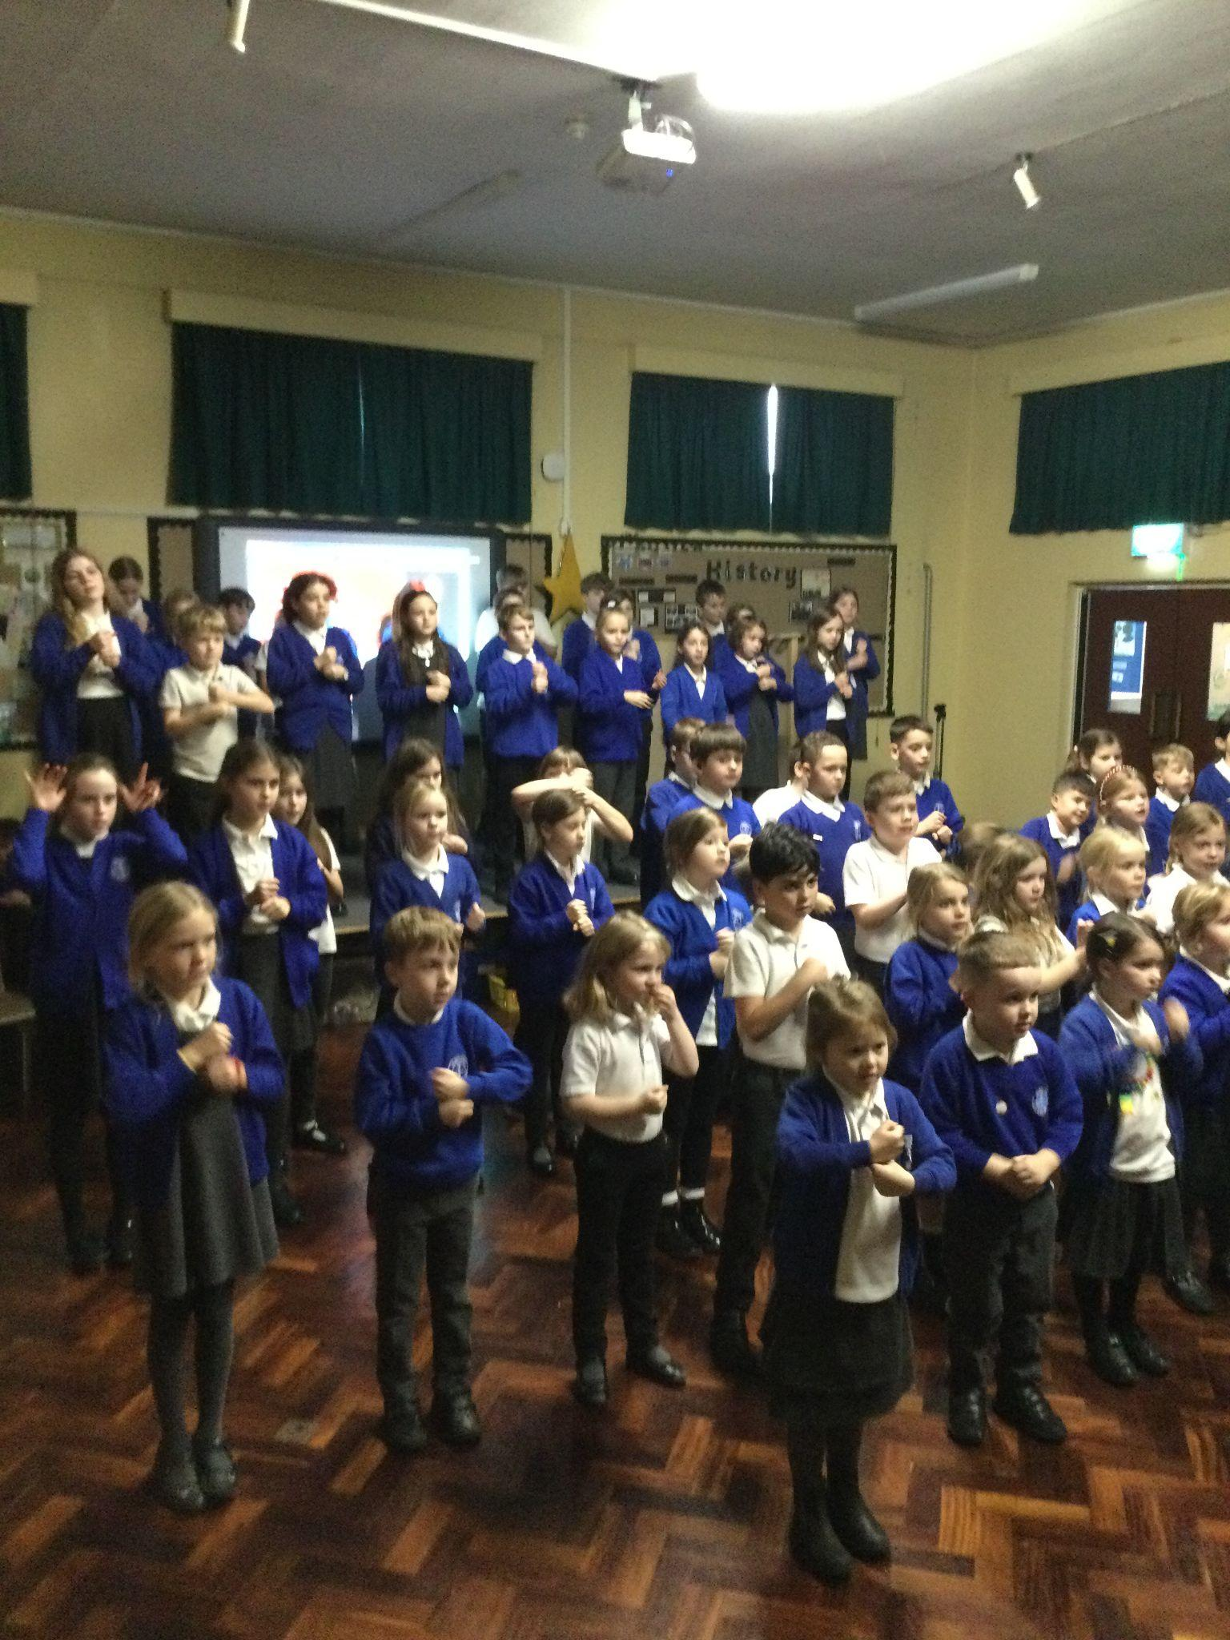
Thank you so much for all your support and we will keep you posted with the total raised in the coming weeks!

Worship and Christian Distinctiveness


Our value, generosity, has been the focus of our worship this half term. We have been looking at what generosity means and how we can share this value both in school and within the school community. We have shared bible stories including The Widow’s Mite.
Think Together
Words of Wisdom
“God loves a cheerful giver”
2 Corinthians 9.7
New King James Version
®
of the Bibl

Jacob and Theo have demonstrated this value as well as being courageous advocates. Both children took it upon themselves to raise money for the school’s sponsored sign, selling their own belongings and home made cards, raising a magnificent £150 - we are so proud of you both.
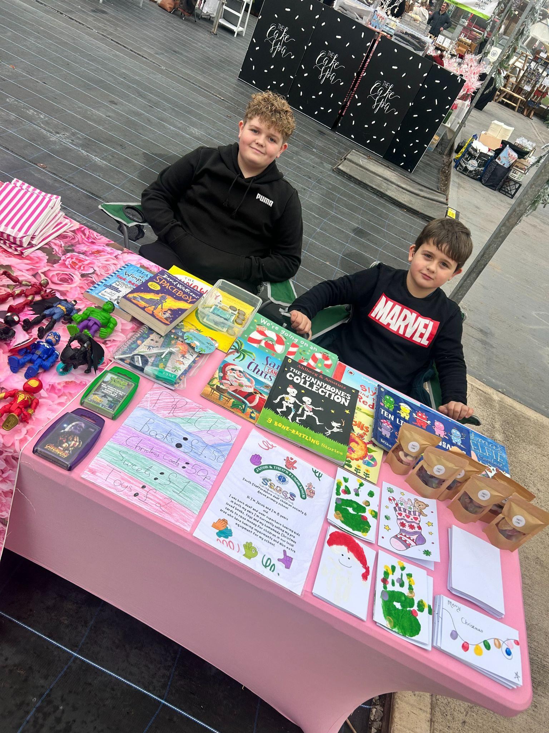

Christian Foundation - Generosity
Courageous Advocacy
What a busy few weeks we have had in school and here is a list of key dates that are to follow.
Reminders:
School Library
- Class 1 are invited to change or select a library book - Mondays
- Class 2 are invited to change or select a library book - Mondays
- Class 3 are invited to change or select a library book – Tuesdays
- Class 4 are invited to change or select a library book – Wednesdays
- Year 5/6 librarians support the changing of books during their break times
Extra-Curricular Clubs
- Extra-Curricular clubs - the last one will Thursday 12th December 2024
- Please check your emails for Parentpay details.
- Monday – Class 2 Construction Club 3.15pm - 4.00pm
- Monday - Art Club 3.15pm - 4.00pm
- Monday – Class 3 and Class 4 Football Club 3.15pm - 4.00pm
- Tuesday – Whole School Choir Club (LUNCHTIMES) - No charge
- Thursday – Class 2 Book Club 3.15pm - 4.00pm

Dinners
- Lunch menu is now available on the school website
- Remember Class 1 and Class 2 do not pay for their lunch
- Remember to pay for all your lunch via ParentPay
- Remember your child can only have a lunch if they are paid for
- Remember to contact the office if you think you may be entitled to free school meals
Thank you for all your continued support this half term!


Reminders:
- Remember to return Bikeability Permission forms
- Remember to complete Care Club forms to reserve a place
- Remember to have paid for clubs via parentpay
- Remember to complete permission forms for trips and residentials
- Remember to contact the office to view the school for new Reception Class 2025 by the end term.
- Remember to check expiry dates for inhalers or medication held in school
- Remember to contact the office if you need a meeting with the class teacher, Deputy Headteacher or Headteacher to discuss any concerns so that they can be addressed as soon as possible.
Please remember that dates and times may have to change so continue to check your emails and the website
Key Dates: https://www.anson.staffs.sch.uk/events
Friday 6th December | Farm on Wheels | - Class 1  - Details sent home  - PTFA supported event  - Thank you!
Friday 6th December | Non Uniform Day | - Children to wear own clothes  - Class1 & 2 donations of chocolates  - Class 3 & 4 donations of a bottle  - Thank you!
Friday 6th December | Celebration Assembly | - School Hall  - 2.45pm  - All welcome
Monday 9th December | Community Performance | - Arrival time 1.30pm -onwards  - Start time 1.45pm Class 1  - Start Time 2.30pm Class 2  - Times may vary  - Normal finish times 3.15pm
Monday 9th December | Christmas Filming | - PLEASE COMPLETE GOOGLE FORM  - Filming of Class 1 and 2  - Google form sent out for permission  - Download will be available for sale before Christmas
Tuesday 10th December | Nativity and Class 2 Christmas Performance | - Class 1 at 9.30am  - Class 2 at 10.30am  - Class 1 at 4pm  - Class 2 at 5pm  - Children in Class 1 & 2(plus siblings) will be allowed to leave school at 3pm if desired.  - Please return to school 15 minutes before the start time for the evening performance
Tuesday 10th December | Choir Singing at Memorial Hall | - 11.00am – 11.30am  - Memorial Hall  - School uniform  - Christmas accessories allowed
Wednesday 11th December | Class 1 Trip | - Wednesday 11th December  - Time 9.30am leaving Anson  - Time 2.30pm leave farm  - Time 3.20pm ETA at Anson  - Lower Drayton Farm  - Mr Davies driving the minibus  - Wear own clothes for soft play  - Warm coats, gloves and hats needed  - Packed lunch and drinks bottle  - Christmas theme accessories allowed
Thursday 12th December | Christmas Jumper Day | - Non Uniform Day  - Christmas Jumper  - Donation of £1 for Save the Children UK
Thursday 12th December | PTFA Christmas Fayre | - Thursday 12th December  - 1.15pm – 3.15pm  - School Hall, library, Class 3 and 4  - Children can be collected at 1.15pm to visit the fayre  - Children are free to leave after visiting the fayre  - Children will be supervised around the fayre at 1.45pm with staff so no one misses this occasion!  - See flyer for details of stalls
Friday 13th December | Christingle Service in St Stephen’s Church | - Friday 35th December  - Time 2.45pm  - Worship Council to lead  - All welcome
Wednesday 18th December | Christmas Lunch and Party Day! | - Whole School  - 12.00pm - 1.30pm  - In school hall  - School leaders invited  - Complete google form to order lunch  - Children are allowed to come to school in party clothes  - OR children are allowed to bring clothes in a labelled bag - it’s up to you!!!
Friday 20th December | Last Day of Term | - Pyjama Day!  - Children are allowed to come to school in lounge/pyjamas etc  - Children can bring in a toy to play with  - Toys cannot be electronic toys or expensive so to avoid damage or loss
Monday 6th January | School open to children | - First day back at school  - 8.45am gates open  - Welcome back!
Term Dates
https://www.anson.staffs.sch.uk/termdates
Above all else, guard your heart,
for everything you do flows from it.
Proverbs 4:23

We wish you and your family the most wonderful Christmas and we thank you for continuing to support our very precious school.
Season’s Blessings
Nicola Jarrett
Headteacher

