ANSON CE PRIMARY SCHOOL

Main Road
Great Haywood
Stafford
ST18 0SU Tel no: 01889 881200
email office@anson.staffs.sch.uk

Headteacher: Mr Edward Howard BSc (Hons)

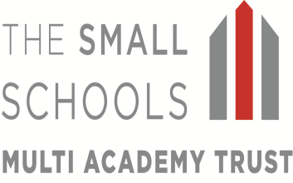
Dear Parents

Welcome back to a new school year, I hope you have had a lovely summer. The loss of Mrs Allen is felt by everyone across the school and I hope that, with your support, I will settle quickly into the role of class 2 teacher and get to know you and your children well. If there is anything you would like to ask then please don’t hesitate to approach me. Our topic for this term is all about The Great Fire of London. You can find details of our intended learning on the topic web over the page. The children will be working towards the targets detailed in their reports at the end of last term. These can also been found in the back of their homework diaries.

Class Information:

Spellings: These are weekly in Class 2 and will be tested on a Monday. Pupils will then be given new spellings on Monday of each week, giving them plenty of time over the week to practice. Spellings will be based on different sounds each week and time will be spent in class building these words into sentences. The availability of an app that you can download and use at home to learn the set spellings through puzzles and games. The app is called ‘Spelling Shed’ and has a bee on the picture. Your child’s log in for this and other digital learning opportunities available can be found inside the front cover of their diary.

Homework: Is set weekly in Class 2. Homework will be sent out on Friday and must be returned the following Friday. Homework is intended to be a consolidation of what has been learnt in class and should therefore not be too difficult for your child to complete. It is designed to give you the opportunity to spend time with your child, encouraging them in their efforts. Each week your child will receive one piece of literacy related homework and one piece of maths related homework. This will be placed in a named poly pocket and should be returned in the same to avoid homework being damaged in transition from home to school.

Reading: Reading is the key to all good learning and should be actively encouraged. Children’s books should be read each night for a minimum of 10 minutes, preferably out loud to an adult. School Reading books will be changed on a Monday, Wednesday and Friday if they are placed in the basket with the diary signed. Lots of children also enjoy reading through ‘Bug club’ and this could be used if your child has completed their book on a Tuesday or Thursday. Home-school diaries will be checked each day for messages. In school, the children are also listened to at least once a week, in guided reading or individually to an adult when possible.

Water bottles: Each child should have a water bottle in school that is clearly named, the children can have a drink from these at any time throughout the school day and they are sent outside at breaks and lunches. Bottles will be returned home and the end of each day for washing and refilling.

Before school routines At 8.55 the bell is rung on the playground and Class 2 children should circle up on the hopscotch area in the playground.

Uniform Please ensure that all uniform including PE kits are clearly labelled with your child’s name. This year, PE will be on Tuesdays and Fridays. Class 2 will be gardening on Thursday afternoons this year and will need suitable footwear on this day.

Snacks All children in class 2 are provided with a piece of fruit each day free of charge.

Milk A form will be sent home separately for parents who wish their child to also receive milk each day. Payment for this will be through ParentPay.

Open Door Policy: Please do not hesitate to contact us at school if you have any concerns, the open door policy at Anson means we are available for 15 minutes before or after school to talk through any problems. (If you need longer, we can arrange a mutually agreeable time.)

We look forward to an exciting and challenging term.

Miss Upton

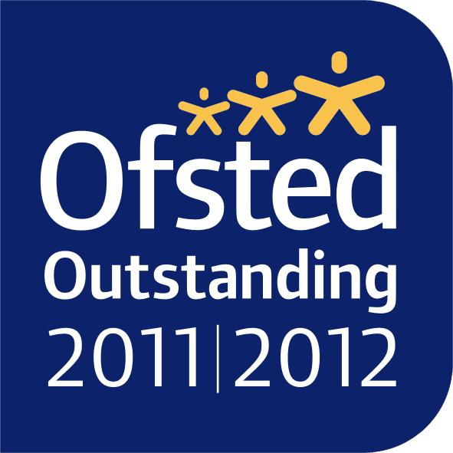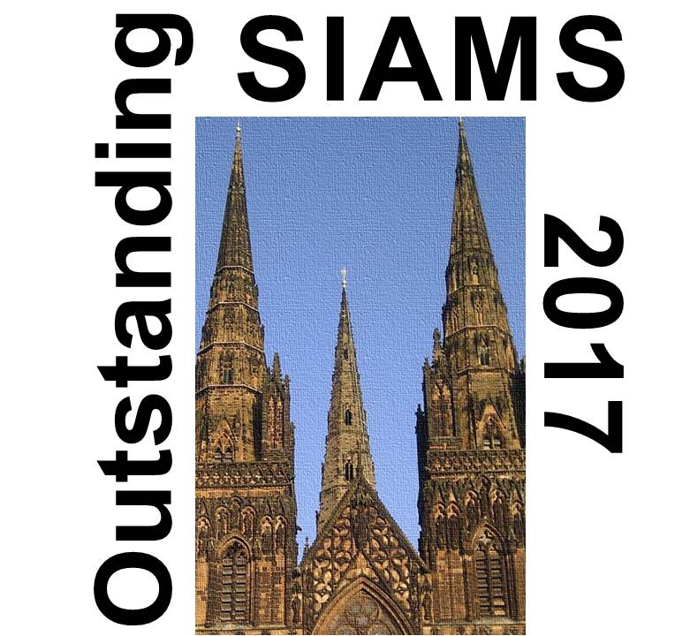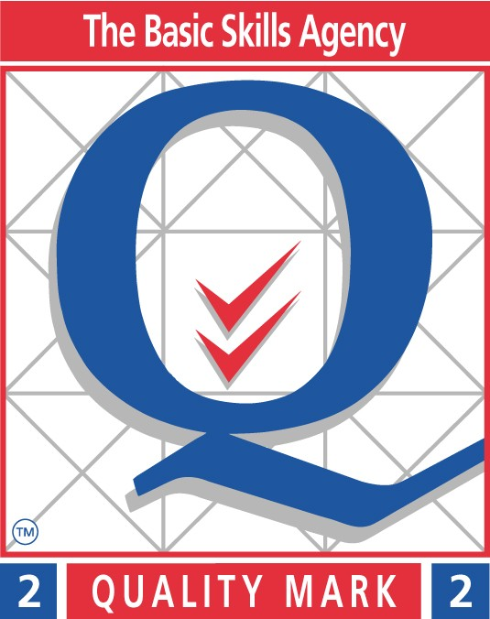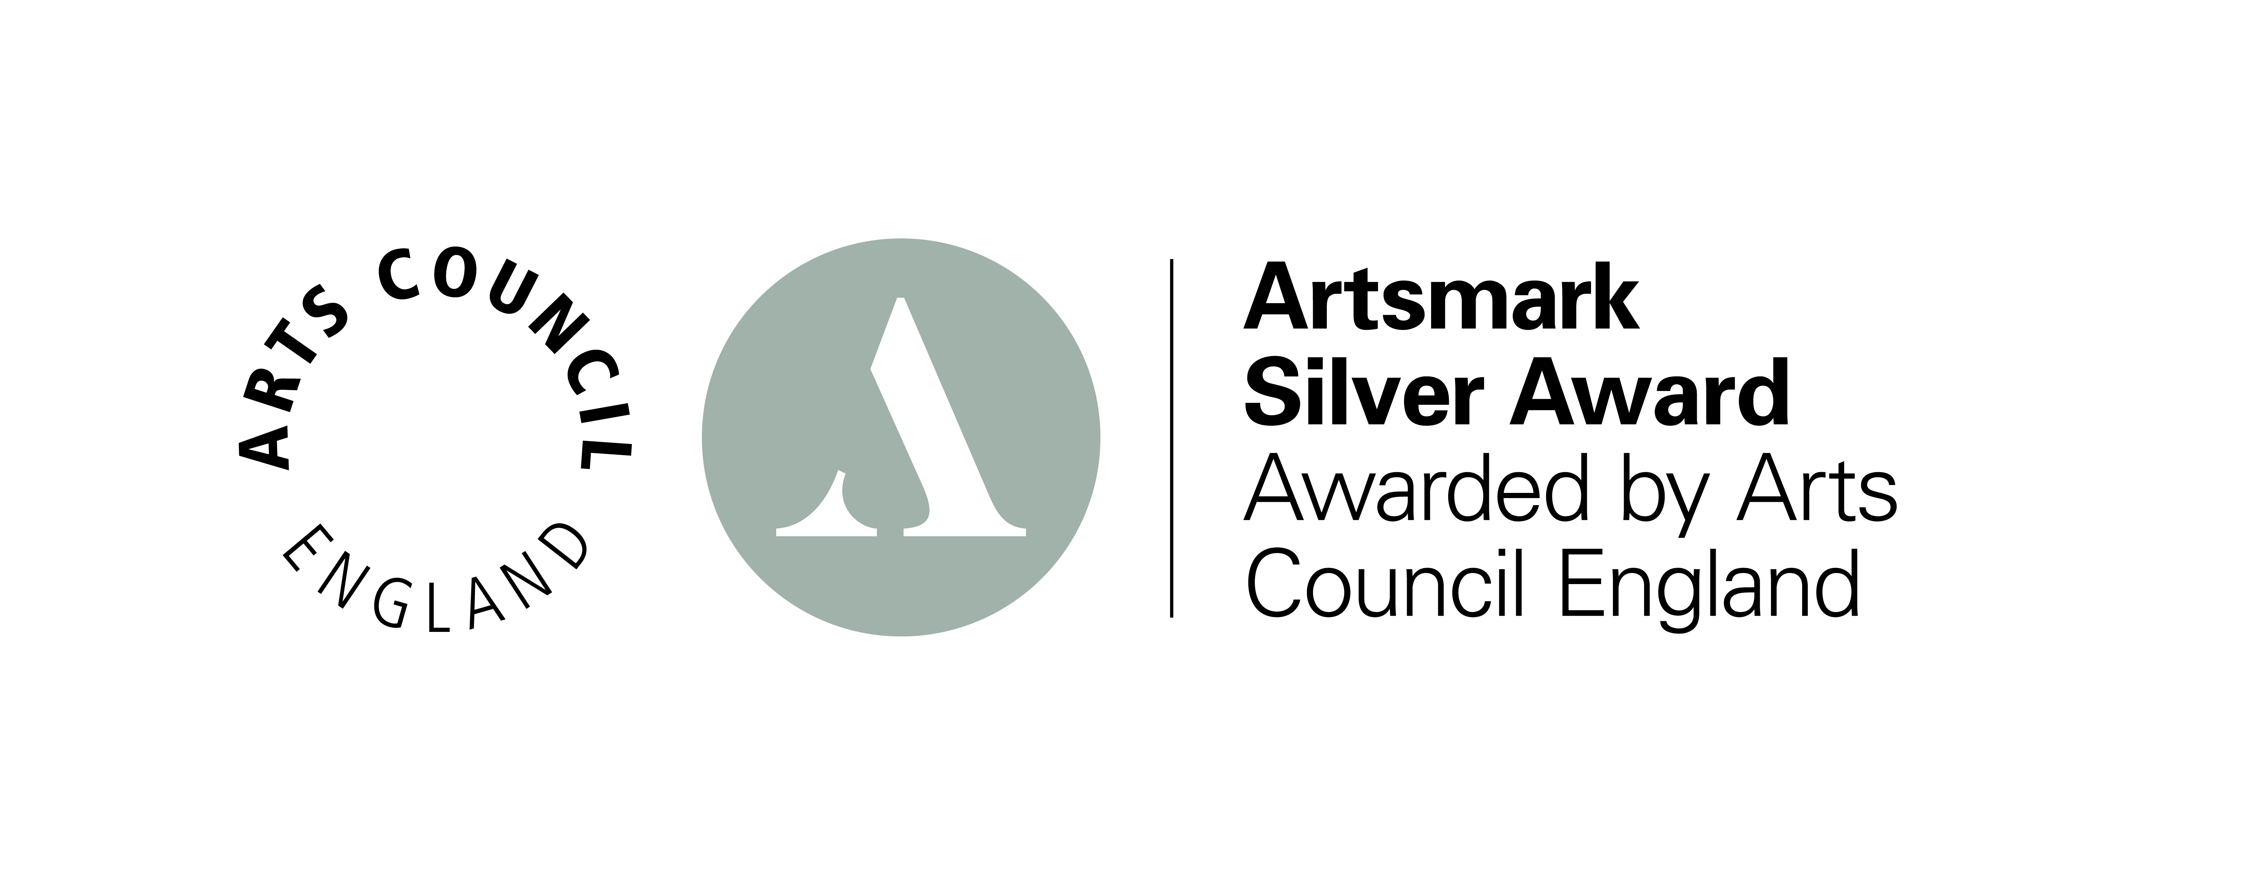

Topic Web Autumn 2019
The Great Fire of London
Reading

Building fluency.
Reading fiction, non-fiction and poetry.
Exploring traditional tales.
Art & Design

Explore ideas and collect visual information.
Explore different methods and materials as ideas develop

DT

Explore objects and designs to identify likes and dislikes of the designs.
Suggest improvements to existing designs.
Explore how products have been created.
History

Observe evidence to ask questions and find answers to questions about the past.
Use artefacts, pictures, stories, online sources and databases to find out about the past.

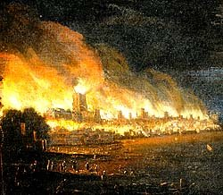
Science

Animals including humans

Designing and carrying out simple experiments.
Geography

Use aerial images and plan perspectives to recognise landmarks and basic physical features.

Writing

Exploring the vocabulary of
traditional tales.
Story and report writing.
Describing characters and settings.
Poetry.

Maths

Place value
Number bonds
Addition and subtraction.

RE

Creation – Who made the world?
Computing

Online safety.
Effective searching online.

French

Bonjour
Ca va?

Music

In the groove

PE

Multiskills
Gymnastics

