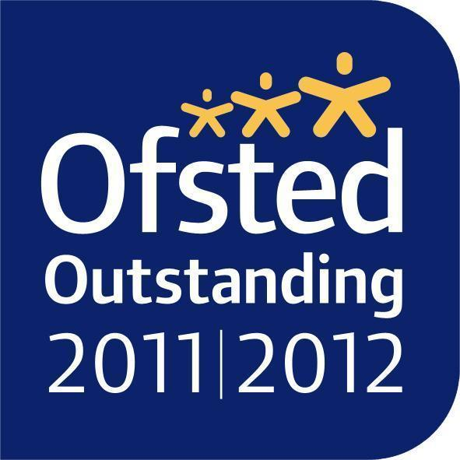
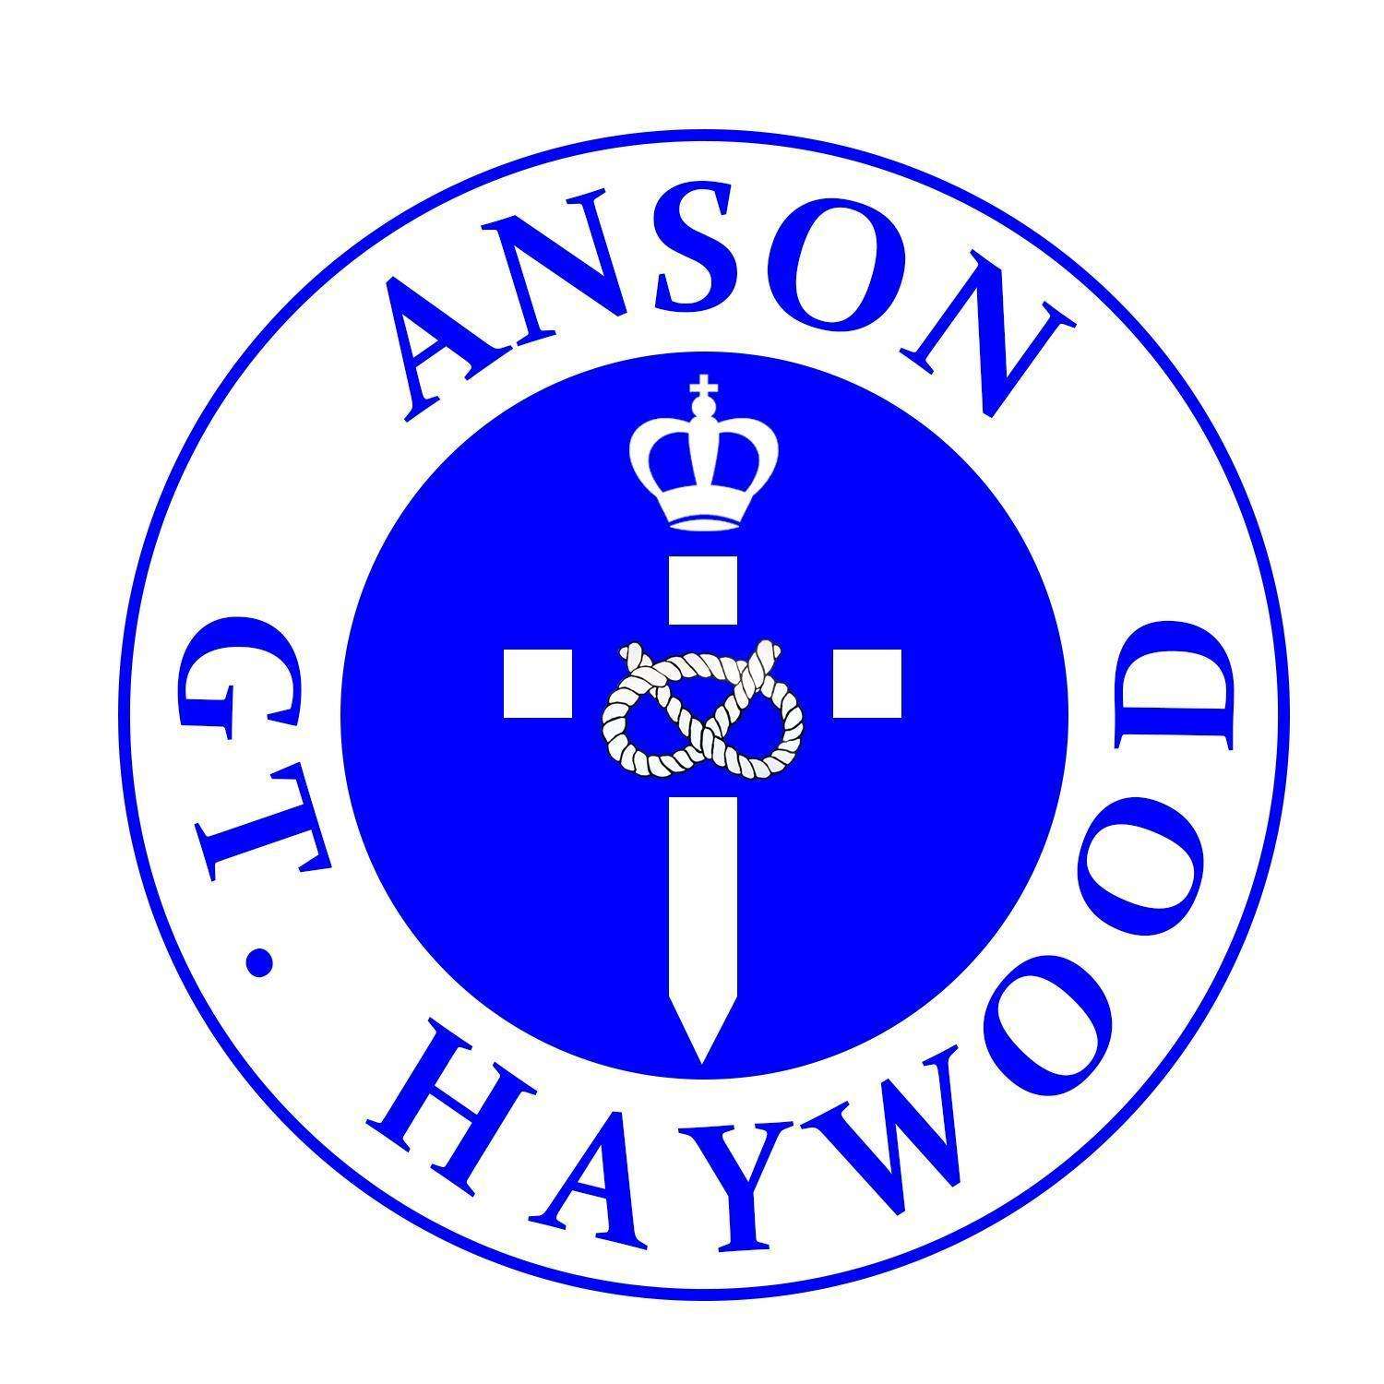
ANSON CE (A) PRIMARY SCHOOL

Main Road
Great Haywood
Stafford
ST18 0SU
Tel no: 01889 881200
Email office@anson.staffs.sch.uk

Headteacher: Miss N Jarrett

Dear Parents/Carers,

Welcome to a brand new school year! We hope you all had a fantastic summer. Class Two will begin the year with a new topic ‘My World and me.’ More information about our areas of learning can be found below.

Reminders

Spellings: These will be linked to our Monster Phonics programme, which we teach every day. Spellings will be set on a Friday and tested the following Friday.

Homework: This will be set at the end of each half term. The children will be given different projects to choose from and their work can be returned and displayed when they return to school.

Reading: Reading books should be read each night for a minimum of 10 minutes, with an adult. All reading at home should be recorded in the children’s diaries and signed by a parent/carer. Diaries are checked every Friday and any child who has read 5 times that week will receive a raffle ticket, which will go into a class draw each week for the chance to win a new book, to keep! The children will also regularly choose a book to share at home from our ‘Recommended Reads’ box.

Water bottles: Each child should have a water bottle in school that is clearly named. The children can have a drink from these at any time throughout the school day and they are sent outside at breaks and lunches.

Uniform: Please ensure that all uniform, especially jumpers, cardigans and PE kits are clearly labelled with your child’s name inside. Where possible, please ensure clothing has the Anson logo.

PE: Please ensure that your child has an Anson PE top in their house colour and PE shorts. PE will take place on a Wednesday .and a Friday so please make sure that your child brings in their kit at the beginning of the week - we are hoping most children will bring their kit at the start of term and leave it in their locker until the end of each half term, when it can be sent home to be washed.

Open Door Policy: Please do not hesitate to contact us if you have any concerns, a member of staff will be on the playground to greet your children every morning and dismiss them at the end of the school day. If you need longer, we can arrange a mutually agreeable time.

Kind Regards
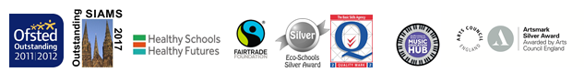
Ms Sumner and Mrs Hayward
Class 2 Teachers
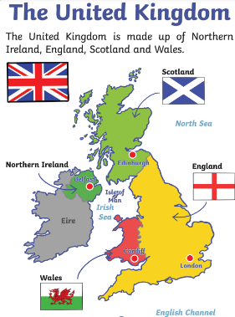

My World and Me
Music:
Class 2 will be using their voices to sing songs, speak chants and rhymes. Music will be taught by our specialist Music Teacher.

Music:
Mama Mia! Unit

P.E:
Swimming, Rugby & Hockey.

Religious Education:
We will be learning all about the Creation Story. After the children will explore what Christians learn from this story.

Literacy:
Children will be working on a range of fiction and non-fiction texts. Our first unit of work will be based around Traditional tales such as Little Red Riding Hood and the children will be learning more about structuring a story then writing their own version of a traditional tale. We will then be writing a non-chronological report and moving onto performing poetry. Finally, we will finish the term looking at lists (and writing our own to Santa!).

PE:
Some of our PE lessons will be taught by our specialist PE teacher – Mr James. Our focus this term will be Gymnastics and then Multi skills.

Religious Education:
Christianity is the Religion we will be focusing on during the Autumn term– looking at what Christians think God is like. Much later in the term we will also be learning about the Christmas story.
Numeracy:
The children will start their Maths learning this term with Place Value. Once we have a secure knowledge of this we will move on to Addition & Subtraction followed by shape. Yr 2 children will also be using arrays to start to divide and multiply!

French:
French will be taught by Madame Elliot this term. Class 2’s units will be ‘Je m’appelle’ and ‘Jai ans’.

Science:
This term we will be learning about different materials. We will be completing some experiments to test the properties of materials (such as whether they are waterproof) and use the results to decide on which materials are the most suitable for different uses.

Art:
We will study the artist Andy Goldsworthy and linking to our ‘World’ topic, looking at how he uses natural materials to create beautiful pieces of art using natural, raw materials found in his surroundings.

Computing:
We will start off learning how to stay safe on the internet and search for information. We will then be exploring the ‘Purple Mash’ programme – which supports all areas of the curriculum can also be used with our log-ins at home!
Geography:
We will be identifying where we live on a globe. We will study both our local area as well as a more detailed look at the UK, using maps, atlases and aerial images. We will name the capital cities of and the seas around the UK. We will also be looking at human and physical features around us.

Religious Education:
Creation Story

P.E:
Swimming, Rugby and Hockey.

Music:
We will be learning how to appraise different types of music

