
ATTENDANCE POLICY

Policy approved & adopted by
Date | Sept 2026
Review cycle | Annual
Next Review | September 2027

Contents
Introduction 2
School Targets and Initiatives 2
Why Regular Attendance Matters 2
Roles and Responsibilities 2
Local Governing Body 3
Senior Leadership/Management Team (SLT/SMT) 3
Pastoral Team 3
Teachers 3
Teaching Assistants 3
Administrators 4
Pupils 4
Parents & Carers 4
Absence Procedures 4
First Day of absence procedure if we do not hear from the Parent/Carer 4
Working together to improve attendance 5
Strategies to Improve Attendance and Punctuality – a tiered approach 5
Understanding Types of Absence 6
Supporting Pupils Too Ill to Attend School 6
Holidays in Term Time 6
Lateness 7
Religious Absence 7
Children Missing in Education 7
Summary 7

Introduction
Applebee Wood School is a thriving community, and every child plays an important role in its success. To ensure pupils gain the maximum benefit from their education, regular and punctual attendance is essential. Children should attend school every day it is open, unless absence is unavoidable.
Applebee Wood’s attendance vision is that all children will attend school well to access the curriculum so that they can make progress and be prepared for adulthood.
Our school community includes pupils who may not be able to attend full-time or who experience prolonged absences due to medical conditions. This policy reflects our responsibility to support these pupils and provide flexible learning opportunities in alternative settings such as hospices, hospitals, or at home.
Our identified Senior person for attendance is Eddie Blundell, Assistant Headteacher, who works collaboratively with the school Pastoral Manager, Julie Beaghan.
School Targets and Initiatives
Our target is 93% attendance. For pupils with complex medical needs, 90% may be an aspiration.
Why Regular Attendance Matters
Any absence affects the pattern of a child’s schooling and regular absence will seriously affect their learning. Any pupil’s absence disrupts teaching routines so may also affect the learning of others in the same class.
Ensuring your child’s regular attendance at school is your legal responsibility and permitting absence from school without a good reason creates an offence in law and may result in a prosecution.

Roles and Responsibilities
Trust including Trustees
- Set the strategic vision for attendance across the Trust.
- Hold leaders accountable for the effective implementation of the attendance policy.
- Ensure statutory duties are met, including safeguarding and inclusion.

Local Governing Body
- Monitor the effectiveness of the attendance policy at school level.
- Support school leaders in creating a safe, respectful and inclusive environment.
- Ensure decisions are informed by local context and community needs.

Senior Leadership/Management Team (SLT/SMT)
- Promote high expectations by setting an annual whole school attendance target.
- Lead a consistent whole-school approach to attendance.
- Induct and train staff to empower them to be leaders of attendance in line with their role.
- Model high expectations and ensure policies are embedded and understood.
- Analyse attendance data to inform decisions and improvements.
- Intervene to focus and improve the attendance of learners requiring specific support.

Pastoral Team
- Provide early help and targeted support for learners and their families struggling with attendance.
- Build strong relationships with families and external agencies.
- Support an inclusive culture.
- Conduct absence monitoring procedures in line with statutory and local needs e.g. first day absence procedures.

Teachers
- Accurately complete registers in a timely fashion as this is a safeguarding duty.
- Set and maintain high expectations for attendance throughout school.
- Fulfill wider professional responsibilities (Teaching Standard 8) by contributing to positive school and classroom climates regarding attendance.
- Provide encouragement and intervention where necessary to encourage regular attendance.
- Initiate, implement and review Attendance Intervention Plans (AIPs) for learners within the targeted and specialist tiers of attendance intervention.
- Liaise with Parents and Carers to support home-school links.
- Record and communicate concerns appropriately in line with school policies and procedures, including those related to safeguarding and the graduated approach.

Teaching Assistants
- Reinforce expectations consistently and positively in line with school policies and practices.
- Promote regular attendance to contribute to positive classroom climates through consistent application of relational practice and policy.
- Support learners’ emotional regulation and access to learning.
- Contribute to the initiation, implementation and review of Attendance Intervention Plans (AIPs) for learners within the targeted and specialist tiers of attendance intervention.
- In the absence of teachers, complete accurate attendance records to fulfil safeguarding duties (TA3 and HLTA).
- Provide encouragement and intervention where necessary to encourage regular attendance.
- Record and communicate concerns appropriately in line with school policies and procedures, including those related to safeguarding and the graduated approach.
- Work collaboratively with teachers and pastoral staff.

Administrators
- Follow up with staff to ensure the school maintains accurate attendance records.
- Under the direction of the Assistant Headteacher (Pastoral), fulfil the duties outlined in the attendance communication strategy.

Pupils
- Attend regularly.
- Demonstrate resilience regarding attendance.
- Work with Teachers and Teaching Assistants to work towards the goals and support in Attendance Intervention Plans (AIPs).

Parents & Carers
- Support the school’s attendance vision and expectations.
- Work in partnership to encourage regular attendance and resolve concerns.
- Ensure we have up-to-date contact details. We require three emergency contacts for safeguarding purposes.

Absence Procedures
If your child is absent, parents/carers must:
- Contact us as soon as possible on the first day of absence (and on each day of absence), via Studybugs via the app or link on the school website.

First Day of absence procedure if we do not hear from the Parent/Carer
If your child is absent, we will:
- Telephone the parents/carer to follow up.
- Contact emergency contacts.
- If we do not have a reason as to why a pupil is absent and all contacts, including emergency contacts have been telephoned, we will pass this information on to the Police Community Support Officer or contact 101 by 1pm. This is following our First Day Response Pathway. (See Appendix 1)

Working together to improve attendance
We will work in partnership with Parents/Carers and other agencies, including health care professionals, charities and children’s social care professionals to encourage and improve pupil attendance where necessary. We have developed a communication strategy to support Parents and Carers to encourage and improve their child’s school attendance (Appendix 2).
If school-based strategies fail, cases may be referred to the Local Authority Attendance Consultant, who can issue Penalty Notices or initiate legal proceedings.

Strategies to Improve Attendance and Punctuality – a tiered approach
We adopt a tiered approach to intervening with pupil attendance. This is determined by clear attendance boundaries set out below:

The Senior Leadership/Management Team can use their discretion to apply this approach to learners where necessary.

Understanding Types of Absence
- Authorised Absence: Illness, unavoidable medical appointments, emergencies.
- Unauthorised Absence: Absences without valid reason or permission, including truancy, unexplained absences, lateness beyond registration, shopping, birthdays, day trips, and holidays without approval.
Supporting Pupils Too Ill to Attend School
While a child may not be well enough to attend school in person, they may still be able to engage in educational activities at home, in a hospice, or in hospital. In such cases, we will follow the procedures outlined in the document “Children Who Are Too Poorly to Attend School.” These activities are important because they:
- maintain the link between home and school which in turn will aid the child’s return to school.
- provide normality for the child and their family.
- provide educational stimulation for the child at home/hospice/hospital.
- enable the child to maintain their level of attainment and continue to make progress even though they cannot attend school.
- enable the family/carers to be involved in their child’s education and to deliver activities when the child is well enough.
- enable us to review the child’s educational provision regularly and respond to any changes in their learning need.
Holidays in Term Time
Taking holidays during term time impacts your child’s education. We ask parents to support us by avoiding taking children out of school during term time.
Any perceived financial savings from booking holidays in term time are outweighed by the cost to your child’s learning. Please note that there is no legal entitlement to time off during school term for holidays.
All requests for leave must be submitted in writing in advance. Leave will only be authorised at the school’s discretion and in ‘exceptional circumstances.’
Each application will be considered individually, considering previous patterns of term-time leave.
Only in exceptional cases, as determined by the Headteacher, will leave of more than four days be authorised.
Exceptional means rare and unusual, not typical.
Any leave taken without the school’s agreement, or beyond what has been authorised, will be recorded as unauthorised and may result in sanctions, including a Penalty Notice.
Lateness
Arriving late means lost learning and disruption. Being 10 minutes late daily equals two weeks of missed school annually.
- School starts: 8:40am
- Registers close: 9:30am
Persistent lateness will lead to a meeting with senior staff.
Religious Absence
One day per religious festival (up to three days per year) may be authorised. Requests must be made in advance.

Children Missing in Education
If we have not had any confirmation with a reason for pupil absence, from any of the emergency contacts listed on the school’s system which has been provided by the parents, the Senior Leadership Team will take the decision and refer pupils to the Children Missing in Education Team.
A child missing in education is defined as a child of compulsory school age who is not on a school roll and not receiving an education via other means, for example, via Elective Home Education or an alternative provider such as a college.
This includes but is not limited to situations where:
- A child / young person has been removed from roll after being permanently excluded and no alternative provision is in place.
- A child / young person has not been attending school, and a home visit reveals that the family may have moved away.
- A child / young person has moved to the area, but no arrangements have been made to access a new school.
- A child / young person has moved out of the area (this includes moving outside of the UK) or is about to move out of the area, but no arrangements have been made to access a new school.
- A child / young person who has been offered a school place, but parents have refused the place offered by the authority is not aware of alternative arrangements for the child / young person’s education.
- A child may still be at risk of missing education or missing out on education even if they are on a school roll and such cases should be reported to the Local Authority via cme@lancashire.gov.uk for advice.

Summary
We have a legal duty to promote attendance and publish absence figures. Parents share responsibility for ensuring children attend school. Together, we can achieve high attendance and support every child’s education.

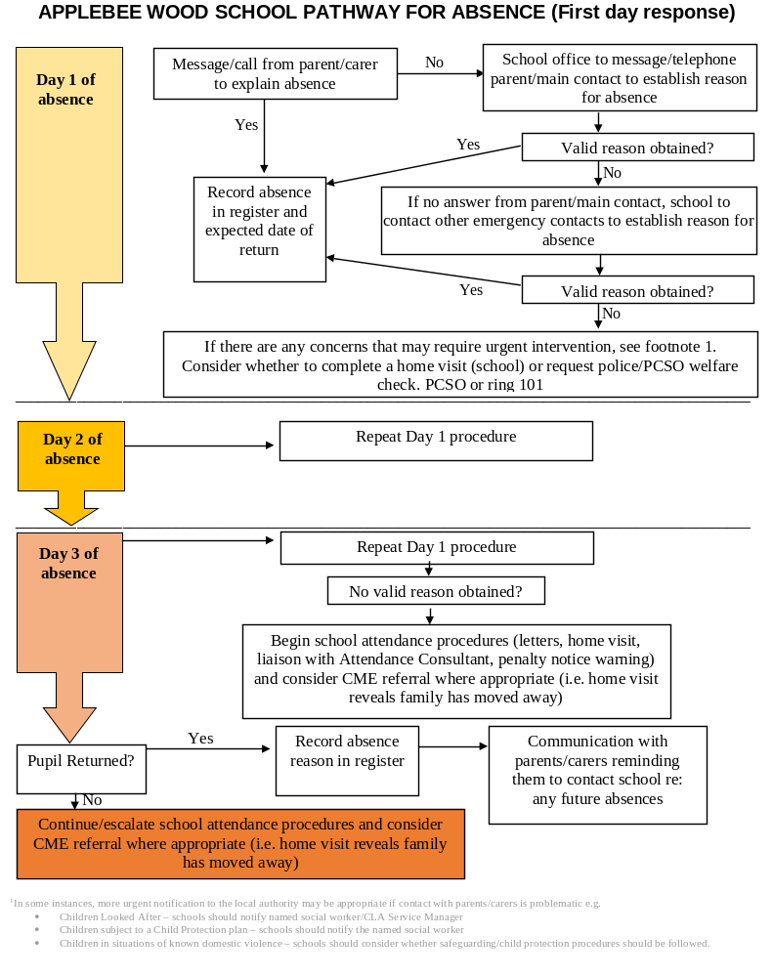
Appendix 1 – First Day Absence Procedure

