Applebee Wood Community Specialsist School
Semi-Formal curriculum

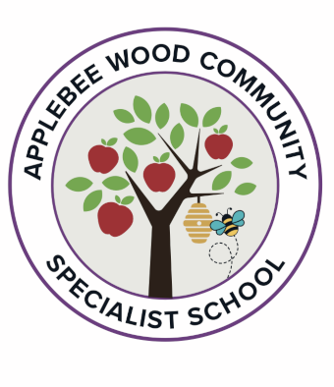

 | Autumn: |  |  | Spring: |  |  | Summer:
 | Self-Awareness  (Me, who I am, my likes, dislikes, strengths and interests) | Self-Care, Support and Safety  (Looking after myself and keeping safe; aspects of Relationships and Sex Education.) |  | Managing Feelings (Understanding feelings, and that how I feel and how others feel affects choices and behaviour; aspects of Relationships and Sex Education) | Changing and Growing (How I and others are changing; new opportunities and responsibilities; aspects of Relationships and Sex Education) |  | Healthy Lifestyles (Being and keeping healthy, physically and mentally) | The World I Live In (Living confidently in the wider world)
 | 1. Things we are good at  2. Kind and unkind behaviours  3. Playing and working together  4. People who are special to us  5. Getting on with others | 1. Taking care of ourselves  2. Keeping safe  3. Trust  4. Keeping safe online  5. Public and Private |  | 1. Identifying and expressing feelings 2. Managing strong feelings | 1. Baby to adult  2. Changes at puberty  3. Dealing with touch  4. Different types of relationships |  | 1. Healthy Eating 2. Taking care of physical health 3. Keeping well | 1. Respecting differences between people  2. Jobs people do  3. Rules and laws  4. Taking care of the environment  5. Belonging to a community
Donaldson and Rosen on different planning- topic based.
Park- Encountering
Ion – Foundation
Dahl- Core

