Applebee Wood Community Specialsist School
Formal curriculum

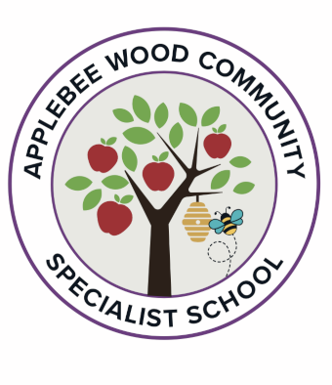

Our Programme Builders (.pdf version) include links to the quality assured resources for each area of PSHE education and advice on using the tools effectively. These Programme Builders are updated as soon as new resources are available, so we would encourage you to check in regularly to see the latest recommended resources.

We have also published one of these fully-editable MS Word templates for each Programme Builder to allow you to easily customise and tailor your long-term overview and term-by-term plans to meet the needs of your pupils.



Terms of use:

The PSHE Association reserves the right to request the removal of any content which infringes on its terms of use policy as outlined in the terms and conditions of membership. Commercial use or publication of this material (including reproduction, storage, modification and distribution) without the prior written consent of PSHE Association is prohibited. You are free to use and share this material non-commercially within your school only. Please note that publication of the one-page long-term overview (or your adapted version of it) on your school website is permitted. However, publication of the medium term grids, or adapted versions of them, is not permitted.

PRIMARY PSHE EDUCATION: LONG-TERM OVERVIEW — THEMATIC MODEl
 | Autumn: Relationships |  |  | Spring: Living in the wider world |  |  | Summer: Health and Wellbeing
 | Families and  friendships | Safe relationships | Respecting ourselves and others | Belonging to a  community | Media literacy and  digital resilience | Money and work | Physical health and Mental wellbeing | Growing and  changing | Keeping safe
 | Donaldson and Rosen on different planning- Semi formal.
Year 2  Cycle 2  Park | Making friends;  feeling lonely and  getting help | Managing secrets;  resisting pressure  and getting help;  recognising hurtful  behaviour | Recognising things  in common and  differences; playing  and working coop-  eratively; sharing  opinions | Belonging to a  group; roles and  responsibilities;  being the same  and different in the  community | The internet in  everyday life; online  content and infor-  mation | What money is;  needs and wants;  looking after money | Why sleep is im-  portant; medicines  and keeping healthy;  keeping teeth  healthy; managing  feelings and asking  for help | Growing older;  naming body parts;  moving class or year | Safety in different  environments; risk  and safety at home;  emergencies
Year 4  Cycle 2  Iom | Positive friendships,  including online | Responding to  hurtful behaviour;  managing confiden-  tiality; recognising  risks online | Respecting differ-  ences and similari-  ties; discussing dif-  ference sensitively | What makes a  community; shared  responsibilities | How data is shared  and used | Making decisions  about money; using  and keeping money  safe | Maintaining a bal-  anced lifestyle; oral  hygiene and dental  care | Physical and emo-  tional changes in  puberty; external  genitalia; personal  hygiene routines;  support with pu-  berty | Medicines and  household products;  drugs common to  everyday life
Year 6  Cycle 2  Dahl | Attraction to others;  romantic relation-  ships; civil partner-  ship and marriage | Recognising and  managing pressure;  consent in different  situations | Expressing opin-  ions and respecting  other points of view,  including discussing  topical issues | Valuing diversity;  challenging discrim-  ination and stereo-  types | Evaluating media  sources; sharing  things online | Influences and  attitudes to money;  money and financial  risks | What affects mental  health and ways  to take care of it;  managing change,  loss and bereave-  ment; managing  time online | Human reproduc-  tion and birth;  increasing indepen-  dence; managing  transition | Keeping personal  information safe;  regulations and  choices; drug use  and the law; drug  use and the media

