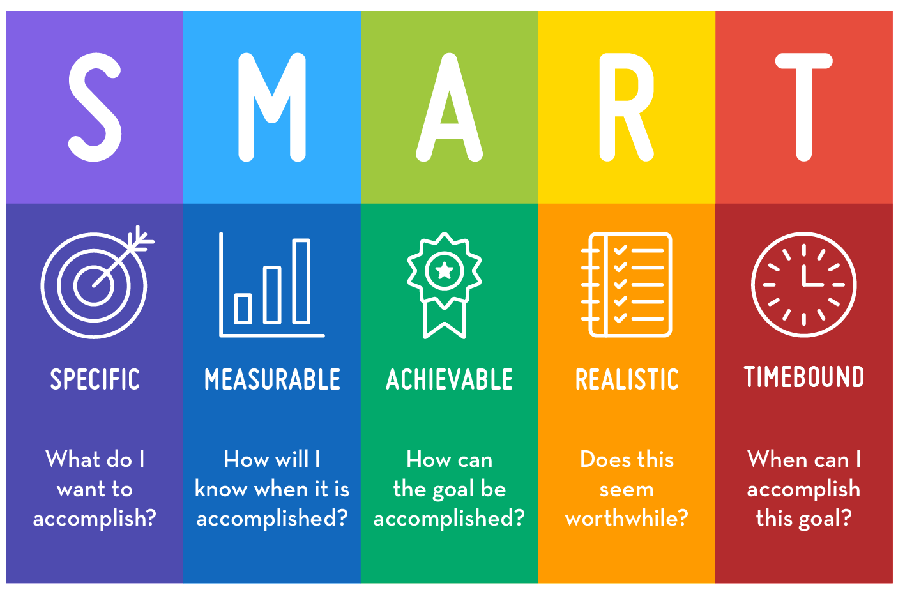
Smart targets…what are they?
All send support plans need targets, but these must be smart:
X will achieve Y by Z as measured by W.

X=student, Y=specific, Z=time, W=measurable

Examples:
- Jayden (X) will know 36 of the 44 phonics sounds (Y) by the end of the Spring term (Z) as measured using a branded phonics assessment (W).
- Grace (X) will be able to multiply single digit numbers by 5 without counting (rote recall) (Y) by Easter (Z) as measured using a simple oral assessment (W).
- Daniel (X) will point to his preferred choice of snack when given a choice of two (Y) 3/5 times (W) over the course of a week (Z).
What is the graduated approach?
Students who continue to face challenges in their learning, despite receiving Quality First Teaching, are likely to need additional strategies, or different provision, in order to meet their needs.
The SEND Code of Practice states that, for these learners, teachers are required to remove barriers to learning and put effective special educational provision in place through SEND support. This SEND support takes the form of a four-part cycle (assess, plan, do, review).
Through this cycle, actions are reviewed and refined as understanding of a student’s needs and the support required to help them secure good outcomes increases.
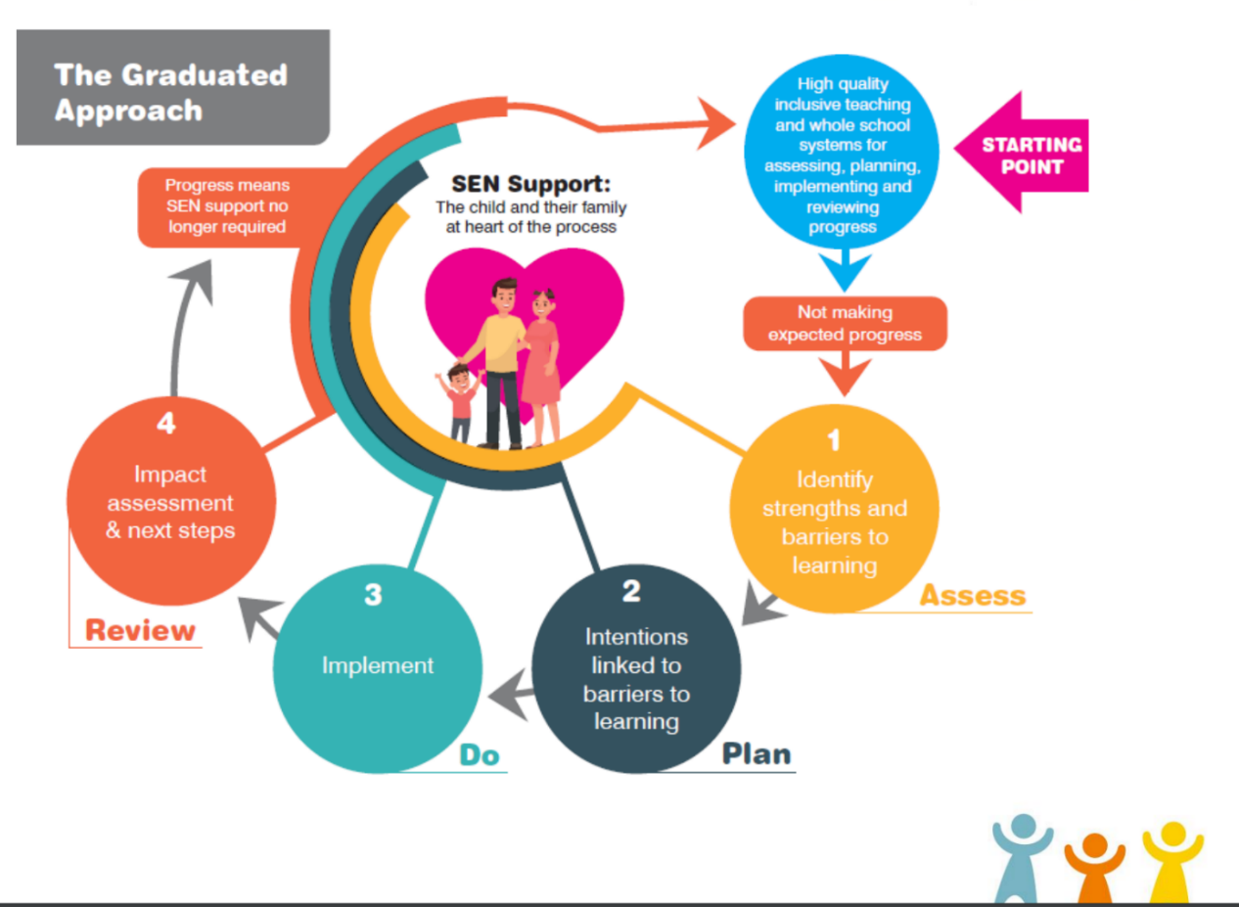
This is known as the graduated approach.

What are the four broad areas of need?
A CYP will always be categorised by these areas of need on their support plan. The CYP may be included into more than one area, but their ‘priority 1’ will always show on Bromcom.
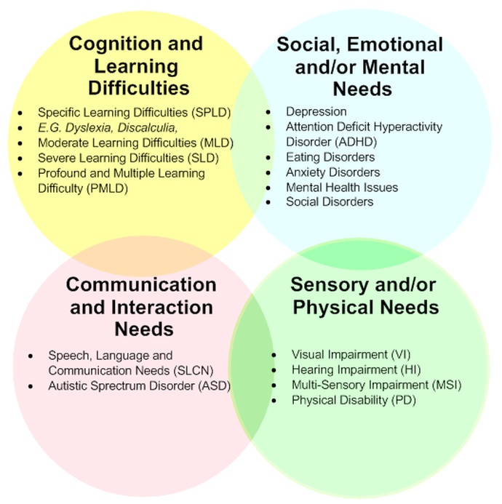

What are the Sunderland ranges?
The SEND range descriptors are based on national best practice in determining and describing the needs of CYP with SEND. They are based on the four areas of the SEND Code of Practice (2014/15) and on the ‘golden thread’ of the graduated approach – of assess, plan, do and review that pervades all best practice.
The SEND range descriptors provide a core framework for all professionals working with the CYP and will give greater clarity for parents, families, and carers in terms of what their child’s needs are, and what each child is receiving. They provide a helpful reference point in relation to identifying the level of need and will support children and young people with additional needs with consistency across schools/colleges and other settings.
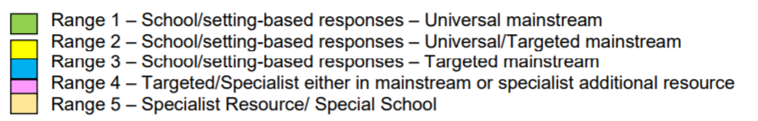
Identifying the Range
This will be done by SENDCo and added to the CYPs support plan.
- Read the descriptors in each document and identify those that best describe your pupil. You may find it useful to print off a copy of these and highlight ones that apply.
- Use the SEND guidance descriptor information (Presenting Behaviours) in the first column of each range to think about how the pupil’s individual profile affects their access to the curriculum and school/setting life. These statements support a decision about whether the pupil is mildly, moderately, severely, or profoundly affected and give guidance about how contexts and support needed affect placement at a range.
- Steps 1 and 2 above should enable professionals to make a judgement about which range the pupil is at currently. It is important to recognise that these ranges can alter either because the pupil’s profile changes or because of context changes such as times of transition/ school/setting placement.
What is a pupil passport?
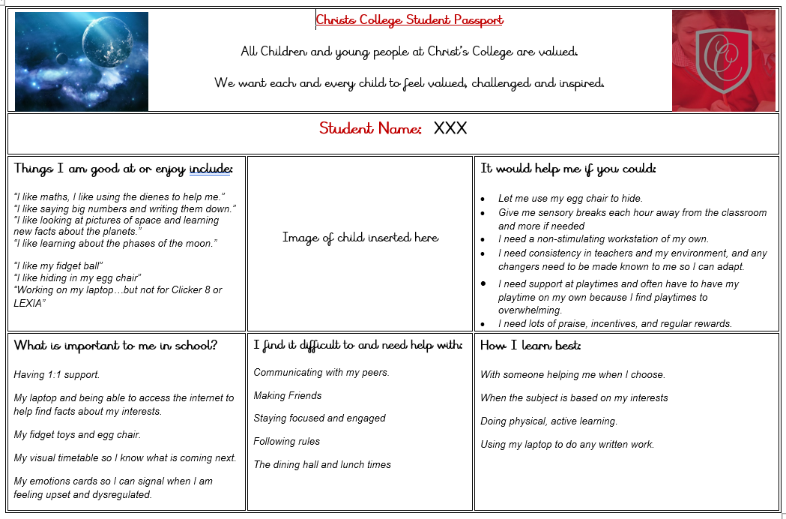
Also known as a one-page-profile, this document captures all the important information about a person on a single sheet of paper under simple headings. Here is the example we use at Christ’s College:
Why scaffold?
Similar to the scaffolding used in construction to support workers as they work on a specific task, instructional scaffolds are temporary support structures faculty put in place to assist students in accomplishing new tasks and concepts they could not typically achieve on their own. Once students are able to complete or master the task, the scaffolding is gradually removed or fades away—the responsibility of learning shifts from the instructor to the student.
One of the main benefits of scaffolded instruction is that it provides for a supportive learning environment. In a scaffolded learning environment, students are free to ask questions, provide feedback and support their peers in learning new material. When you incorporate scaffolding in the classroom, you become more of a mentor and facilitator of knowledge rather than the dominant content expert. This teaching style provides the incentive for students to take a more active role in their own learning. Students share the responsibility of teaching and learning through scaffolds that require them to move beyond their current skill and knowledge levels. Through this interaction, students are able to take ownership of the learning event.
When you incorporate scaffolding in the classroom, you become more of a mentor and facilitator of knowledge rather than the dominant content expert.
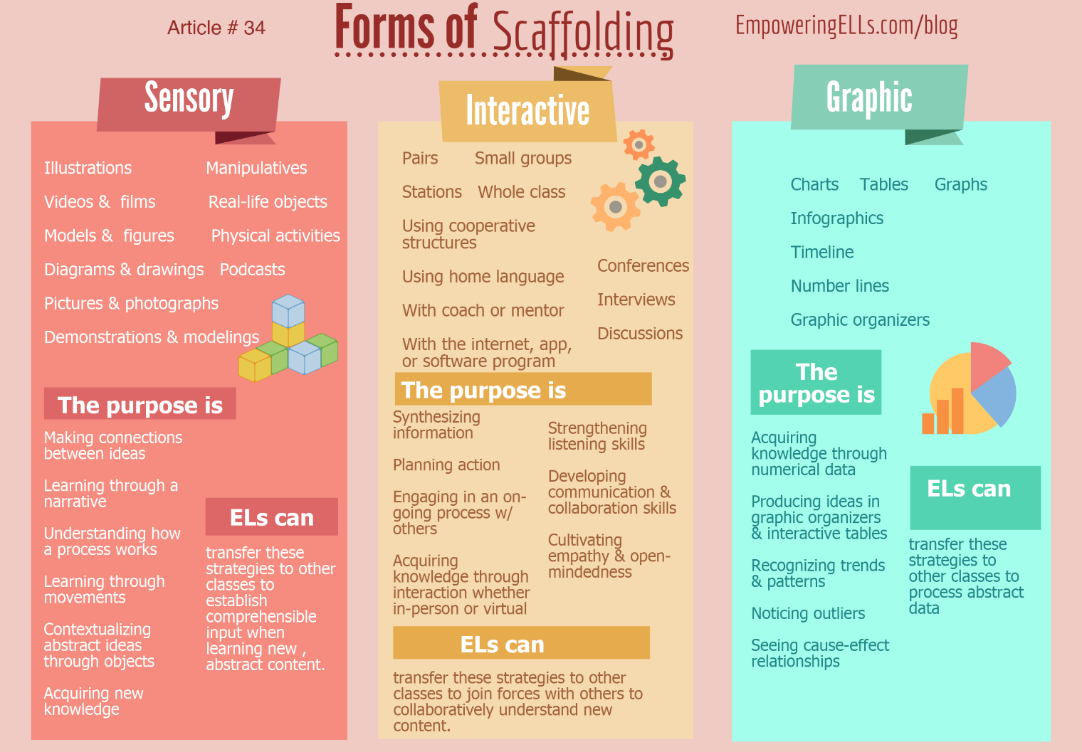
The need to implement a scaffold will occur when you realize a student is not progressing on some aspect of a task or unable to understand a particular concept. Although scaffolding is often carried out between the instructor and one student, scaffolds can successfully be used for an entire class. The points below are excerpted from Ellis and Larkin (1998), as cited in Larkin (2005), and provide a simple structure of scaffolded instruction.

https://www.sec-ed.co.uk/best-practice/assess-plan-do-review-the-graduated-approach-to-sen/
https://sunderlandpcf.co.uk/wp-content/uploads/2019/11/Ranges-Final-Consultation-Sept-2019pdf.pdf

