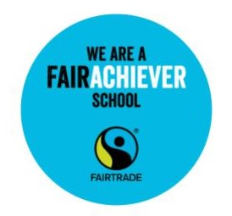All Saints Primary School

Fairtrade Policy

All Saints’ School is committed to supporting Fairtrade wherever possible.

Fairtrade is about guaranteeing a better deal for producers in developing countries.

In particular the school will:

• Support the Fairtrade Steering Group, the World Heroes.

• Ensure Fairtrade is part of the School Development Plan.

• Use Fairtrade products wherever possible:

* tea, coffee, sugar and biscuits in the staffroom and at meetings
* in food technology activities
* Traidcraft Christmas cards for governors and prospective pupils

• Consider the purchase of Fairtrade sports balls when buying new ones.

• Ensure Fairtrade products are available wherever possible. For example, at events in the school including those for the community

• Ensure learning about Fairtrade happens in a range of lessons and in

whole school activities, especially in Y3 and Y5.

• Promote Fairtrade within the school and wider community, particularly during Fairtrade Fortnight.

• Do something extra each year to promote Fairtrade.

|  |  |  |
| --- | --- | --- |
| **This Policy is supported by:** | **Name:** | **Date:** |
| **The Governors** |  | **22/11/24** |
| **The Staff** |  | **22/11/24** |
| **The Headteacher** |  | **22/11/24** |

Revised by the World Heroes (formerly the Fairdos) on 22nd November 2024.