**Wonderlab+**

Are you looking for something fun to do online with your child? The Science Museum group have a wide array of activities, games and quizzes on their website:

<https://wonderlabplus.sciencemuseumgroup.org.uk/home>

**Cyberbullying**

**What is cyberbullying?**

Cyberbullying is a form of bullying that takes place online and can take many forms, such as sending malicious messages. Cyberbullying can happen at any time of the day, so often feels unrelenting. It can take place across many different platforms, such as on messaging apps like WhatsApp and Snapchat, on social media platforms such as Instagram and TikTok and via online games. Here are some examples of what cyberbullying can look like online:

**Minecraft**

Minecraft is rated as PEGI 7, meaning it is suitable for those over 7 years of age.

Minecraft is a game where players can create worlds using blocks. There are two different modes – creative and survival. In creative mode, users can build what they wish and have unlimited resources whereas in survival mode, players must gather resources, find food and defend themselves against mobs. Survival mode may include mild violence and scary characters.

You should be aware that there is a multiplayer option available where players can chat to each other. In-app purchases are also available to buy items such as skins, so ensure purchases are disabled or that a password or PIN is required to make them. Ensure appropriate parental controls are applied, on both Minecraft and the console itself. Find out more here:

<https://www.minecraft.net/en-us/article/parental-controls>

**Further information**

<https://parentzone.org.uk/article/minecraft>

* Sending nasty or hurtful messages
* Leaving unkind comments
* Sharing photographs of somebody else without their permission
* Excluding somebody on purpose
* Impersonating somebody with a fake account
* Telling/sharing lies
* Blackmailing

**What should I do if my child is being bullied online?**

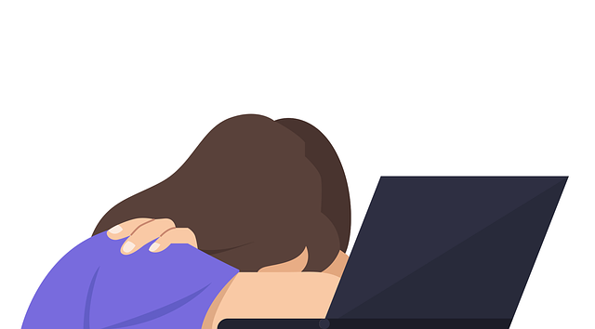If your child is being bullied, then try to stay calm and let them know that it is not their fault. It is always useful to keep evidence of any online bullying and inform their school so that they are aware. Show your child how to block and/or report any users/content and review their privacy settings to limit what others can see. You may also wish to review/set up any available parental controls.

**Further information**

There is a vast amount of information available online about cyberbullying. The following links provide further information on types of online bullying, and who you can contact if you need any further advice or support.

* <https://www.childnet.com/help-and-advice/online-bullying/>
* <https://anti-bullyingalliance.org.uk/tools-information/advice-and-support/advice-parents-and-carers/sources-information-advice-and>

*Users of this guide do so at their own discretion. No liability is entered into. Current as of the date released 01.05.25. The inclusion of any links does not imply any affiliation with or endorsement of the linked websites, documents, or videos, nor are we claiming any ownership or copyright in the content of the linked materials.*

**How to best use location tracking apps within your family**

Location tracking gives us the ability to see where somebody is via their smart device and is often one of the reasons children receive their first device. Internet Matters have published an article discussing location tracking, including the benefits and risks and provide links to other supporting resources. You can read the article here:

<https://www.internetmatters.org/hub/expert-opinion/how-to-use-location-tracking-apps-in-your-family/>

**What is Roblox?**

Roblox is a platform consisting of a collection of games. Players can either create games or play games that other users have created. It is free to download (however subscription options and in game/app purchases are available) and can be played across numerous devices.

**A lot of the content is user generated, which may mean not all games will be suitable for your child to view/play.** If your child is playing Roblox, it is important to monitor what your child is accessing and set up appropriate parental controls.

**PEGI rate Roblox with a Parental Guidance label, this is because it is difficult to rate due to the huge level of user generated content.**

**New Parental Features**

Roblox have released three new parental controls for your child’s Roblox account. These are:

**JusTalk**

Users can use this app to video chat, call, and text. There are two versions – JusTalk and JusTalk Kids with both versions having the option to unlock further functions via a premium subscription. **JusTalk is rated as 12+ and JusTalk Kids is rated as 4+ on the App store.**

**Even though the apps may be rated as age appropriate for your child, there are still risks in using either version.**

The Ineqe Safeguarding Group provide an overview of JusTalk, including the risks you need to be aware of:

<https://ineqe.com/2023/02/08/what-is-the-justalk-app/>

1. **Friend blocking** - you can now block anyone on your child’s friends list that you do not want them direct messaging.
2. **Experience blocking** – you can now block any specific experiences (games) that you do not want your child to access.
3. **Top game insights** - you can now see the 20 experiences (games) your child has spent the most time on in the last week.

You can find out more here: <https://corp.roblox.com/newsroom/2025/04/new-parental-controls-on-roblox>

**Further information**

You can find out more about Roblox here: <https://en.help.roblox.com/hc/en-us/articles/30428248050068-Parental-Controls-FAQ>

**Keeping up with technology**

It can be difficult to keep up with what our children are doing online as it can change so quickly. UK Safer Internet Centre have published an article with suggestions on what we can do: <https://saferinternet.org.uk/safer-internet-day/safer-internet-day-2024/parents-and-carers/things-change-so-fast-online-its-hard-to-keep-up-with-what-my-child-is-doing>

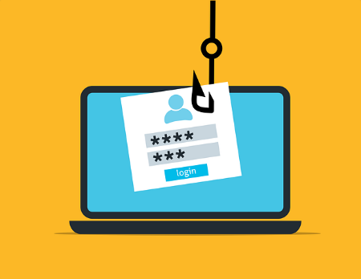Ask Silver is a tool that anyone with a smartphone can use to protect themselves from scams. To use the service, you will first need to sign up and then you can simply upload a screenshot of anything that you are unsure of, and think could be a scam. Ask Silver will let you know whether they think it is safe or not. Find out more here:

<https://www.getsafeonline.org/asksilver/>