Church of England and Methodist Schools
Diocese of Blackburn and Lancashire Methodist District



Appley Bridge All Saints’ Church of England Primary Academy

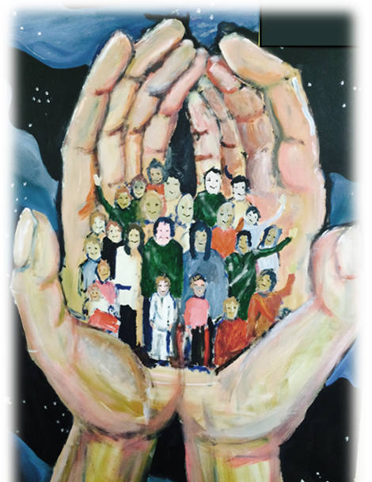
Religious Education Policy

Religious Education in our Church School is of the highest standard,
always striving for excellence
and reflecting our school’s distinctive Christian character.

In this Voluntary Aided Academy, the management of Religious Education is a distinctive role of the governors and headteacher. RE has to be in accordance with the Trust Deed and in accordance with the rites, practices and doctrines of the Church of England. The Governing Body as a whole is responsible for determining the nature of Religious Education provided in its school.
Although Religious Education and Collective Worship naturally compliment and enrich one another, they are managed separately.

Religious Education in our Church School lies at the very heart of the curriculum
- Governors have adopted the Blackburn Diocesan Board of Education Syllabus for RE, ‘Questful R.E.’, which reflects the National Framework for RE, the National Society Statement of Entitlement and the requirements of SIAMS;
- 5% of curriculum time is devoted to RE;
- Christianity plays a central role in RE, taking up between two thirds and three quarters of the time available;
- Appropriate teaching about other faiths and world views is included.

The Religious Education curriculum maintains a balanced approach of learning about religion and learning from religion.

Learning about Religion
We learn about
- God who reveals the truth about himself and humanity through creation, the giving of the law, his action in history and through the prophets;
- God who reveals himself ultimately in Jesus his Son, living among us and dying and rising for us;
- God who reveals himself in his Spirit working in the living faith of the Church experienced through scripture, tradition and reason.

Learning from Religion
We learn from
- an empathetic response to the Christian faith and a critical engagement with it;
- responding personally to the stories and teachings of Jesus Christ;
- examples of Christian living which give priority to the values of unconditional love, forgiveness, reconciliation, justice, compassion and faith.

Religious Education helps pupils to:

- reflect theologically and explore the ultimate questions and challenges of life in today’s society;
- reflect critically on the truth claims of Christian belief;
- see how the truth of Christianity is relevant today;
- understand the challenge faced by Christians in today’s pluralist and post-modern society;
- develop the skills to handle the Bible text;
- recognise that faith is based on commitment to a particular way of understanding God and the world;
- begin to develop their own commitments, beliefs and values;
- develop a sense of themselves as significant, unique and precious;
- experience the breadth and variety of the Christian community;
- engage in thoughtful dialogue with other faiths and traditions;
- become active citizens, serving their neighbour;
- find a reason for hope in a troubled world;
- understand how religious faith can sustain believers in difficult circumstances and in the face of opposition.;

It is entirely appropriate and necessary in today’s world that children should be encouraged to foster a respect for the followers of the other world faiths. It is essential that this respect is based on an accurate and sympathetic understanding of those faiths.

Therefore RE also helps pupils to:
- learn about other faiths, their beliefs, traditions and practices and from them through encounter and dialogue;
- recognise and respect those of all faiths in their search for God;
- recognise areas of common belief and practice between different faiths;
- enrich and expand their understanding of truth while remaining faithful to their own tradition;
- enrich their own faith through examples of holy living in other traditions.
The Religious Education Curriculum in school includes:
- opportunities to explore the experience of the Church’s year;
- study of the story of the local Christian community with its saints and martyrs;
- visits to places of worship, especially the local parish Church and a Cathedral, to develop the understanding of the Church as a living community; during school residential holidays we usually incorporate a visit to a place of worship e.g. Edinburgh’s St Giles Cathedral, York Minster and London’s St Paul’s Cathedral.
- welcoming visitors from the local parish to share their experience of Christian belief and life;
- liaison with the local parish to enable these visits and links to occur;
- skills to confidently use religious language to express knowledge and opinions;
- a well-used set of Bibles in language that can be understood by the learners and examples of Bibles and prayer books from a variety of contexts;
- the facility to listen to Christian ‘psalms, hymns and spiritual songs’ from a wide variety of traditions;
- access to Christian artefacts that are used with care, respect and confidence;
- a sacred space that can be used as a focus for prayer and silent reflection in each classroom and also the Garden area;

Religious Education in our Church School enables:
- pupils and teachers to talk openly and freely about their own personal beliefs and practice without fear of ridicule;
- pupils to make excellent and appropriate progress in their knowledge and understanding of Christianity;
- pupils from Christian families to talk openly about their beliefs and values in lessons and to grow in their faith;
- pupils from other faith backgrounds to understand and be encouraged in their faith;
- pupils with no religious background to be given an insight into what it means to be a person of faith;
- pupils of all backgrounds to have a safe place to explore the ultimate questions and challenges of life in today’s society.

RE makes a significant contribution to pupils’ Spiritual, Moral Social and Cultural development.
Spiritual development within RE in a Church School enriches and encourages the pupils’ discovery of God the creator, of their ‘inmost being’ and of the wonder of the environment.
Moral development is based on the teachings of Jesus Christ, which offer pupils a secure foundation stone on which to make decisions and build their lives.
Social development enriches pupils’ understanding of what it means to live in a Christian community where Jesus’ command to love one another is put into practice.
Cultural development provides opportunities to develop an understanding of Christianity as a worldwide, multi-cultural faith that has an impact on the lives of millions of people.

British Values
Adults in school actively promote British Values and RE provides excellent opportunities for pupils to learn about the British Values of mutual tolerance and respect, democracy, the rule of law and individual liberty. Through our teaching and learning about major world faiths, pupils develop skills including being reflective, respecting others, appreciating others’ points of view, listening to others and understanding.

Equal Opportunities
All children irrespective of race, creed, colour, gender or need will be given the same Religious Education experiences and opportunities to make the greatest possible progress.
Children with SEN are taught within the lesson, where the class teacher may differentiate the work to meet their needs.

Resources
Resources are stored in labelled boxes in the storeroom near the staff room. Resources specific to the major world religions are stored in labelled boxes by Y4/Y5 cloakroom. All staff are responsible for returning resources promptly after use. Resources are updated and added to on an annual basis in line with the SDP and the units being taught the following year.
In addition the clergy and advisers from the diocese provide valuable advice and support.

Assessment and Record Keeping
Each unit includes some assessment activities and how they should be recorded. Children will record some learning in their own books but a large class book is also added to throughout the year to capture any evidence which would otherwise be lost, eg photographs from visits, post it notes from discussions. These assessments together with pupils’ work provide information for class teachers, subject leader, Church School governor and SLT.
The outcomes from these tasks will contribute to the teacher’s overall judgements about each child’s progress. The annual report to parents includes a section devoted to progress in RE.

A parent may request the governing body to provide Religious Education for their child according to the Agreed Syllabus. This can only be requested when parents cannot, with reasonable convenience, arrange for their child to attend another school where Religious Education is provided according to the Agreed Syllabus. The governing body should make provision unless the circumstances make it unreasonable to do so.
Should the governing body be unable to make such arrangements for Religious Education to be delivered according to the Agreed Syllabus, the responsibility then falls on the Local Authority. The Local Authority may decide that such a request for separate Religious Education is unreasonable and the parental request then fails.
Parents may withdraw their children from Religious Education as they may in any school and this is explained in the school prospectus.

‘The Worship and Religious Education provided by the school is in accordance with the Church of England Foundation. This foundation is also reflected in the curriculum and the whole life of the school community. Since the conduct of the school as a whole reflects the Church of England ethos, removal of pupils from Worship and/or Religious Education (as parents are legally entitled to do) cannot insulate them from the religious life of the school.’

If such a request is made, the Headteacher should explore the reasons for the request and seek to arrive at an accommodation. It may be that only some elements of Religious Education or Worship are objected to.

Policy revised: January 2025
Next Review: September 2027
R.E. Subject Leader: Mrs Janet Dunn

