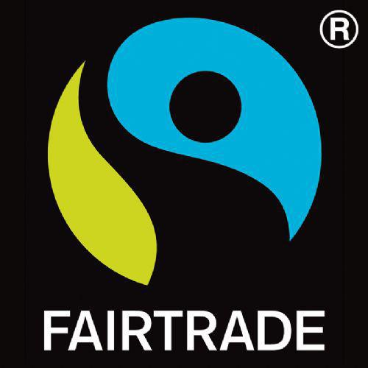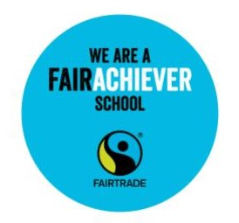We are really proud

to have been a

Fairtrade school since 2012.

The earth is the Lord ’s, and everything in it. The world and all its people belong to him. (Psalm 24:1)  
   
This reminds us why choosing Fairtrade is important.  
   
Everything in the world belongs to God, but sadly not everyone remembers this.  
   
Sometimes people who run businesses forget that they have to care for God’s world and God’s people. Sometimes the desire to make money makes people forget that they should still be fair.  
   
That’s why CAFOD and many other charities helped to form the Fairtrade Foundation back in 1992.  
   
By paying a fair price to those who make and produce food, cotton and other products, the Fairtrade Foundation helps to protect people’s lives and gives them a better future.  
   
So choosing a fairly traded banana or bar of chocolate might not seem to make much of a difference.  
   
But it’s actually a really good way of helping others.  
   
Swapping to Fairtrade is a good choice – but also a really easy one!  
   
And if we all do it, then we can be God’s hands on earth.  
   
A Prayer for Fairtrade   
   
Dear God  
   
We pray for those people around the world who grow and produce the things we eat and buy.  
   
We pray that they get a fair price for the things we buy from them.  
   
We pray that we can help support these people by buying Fairtrade goods so that we can help create a better and more just world.  
   
Amen