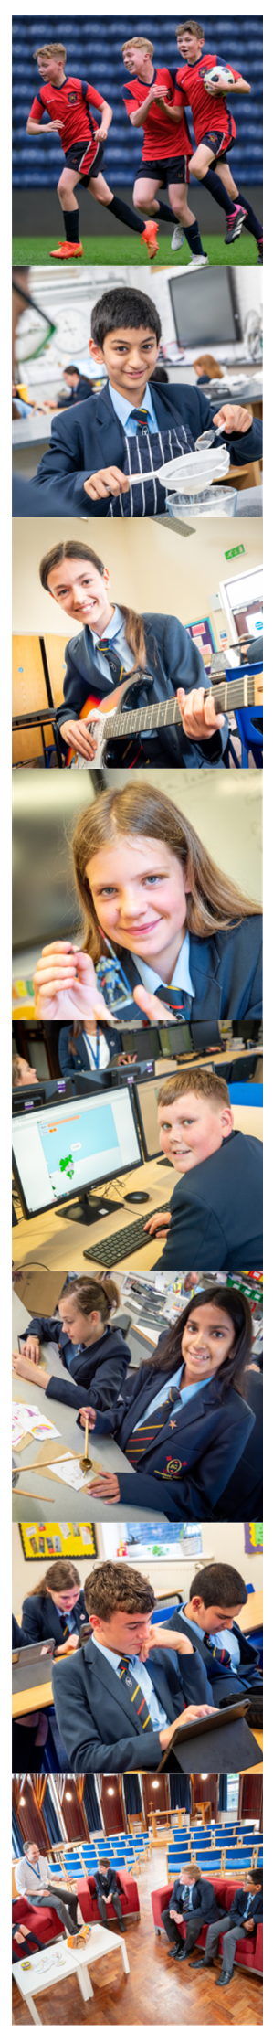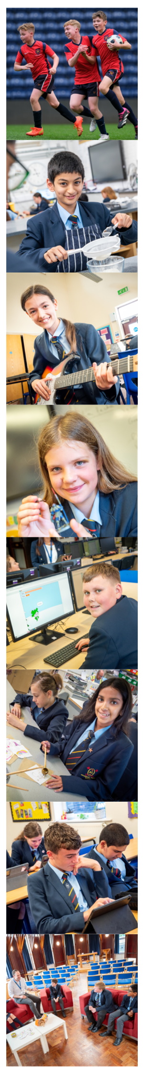**Welcome to Archbishop Temple**



Application Pack for

Teacher of Music with Drama (permanent, full-time)

MPS/UPS

Required from

September 2025

**May we shine God’s light through**

**Faith ✝ Nurture ✝ Service**

**Church of England High School**

Dear Applicant

Thank you for showing an interest in the position of Teacher of Music with Drama at Archbishop Temple Church of England High School.

Due to our school expansion, we are seeking to appoint an inspirational teacher who shares our commitment to educational excellence and social inclusion.

We have a very distinctive ethos; our motto of *“May we shine God’s light through faith + nurture + service*” is central to our work, as we aim to keep God at the centre of all we do. This post presents a wonderful opportunity for a talented, passionate and committed teacher. You would be joining our experienced performing arts team; the successful candidate will receive the wholehearted support of a thriving governing body and a highly dedicated staff team. Further support will be received through our excellent working partnerships with Blackburn Diocese and Lancashire County Council.

We are always oversubscribed in Year 7. This year 600+ pupils applied for one of our 210 places. Working at Archbishop Temple Church of England High School represents an exciting opportunity to work in a school which has huge potential. Our staff are incredibly dedicated and supportive and our pupils are a high achieving group of very positive and enthusiastic young people.

I hope that the information available inspires you to consider applying for this post. Please complete the application form, which is available from our website, and include a letter (of no more than two sides of A4 in Calibri font size 11) explaining your suitability for the post. Electronic applications are fully acceptable, and these should be emailed to [head@archbishoptemple.com](mailto:head@archbishoptemple.com) marked for the attention of   
Mrs C Simpson, my PA.

The closing date for applications is Tuesday 6th May 2025 (midday) and interviews are planned for the following week. Candidates called for interview will be contacted by phone in the first instance with detailed information following by email.

At Archbishop Temple Church of England High School, we take safeguarding very seriously and consequently the successful candidate will be required to complete a DBS enhanced check. Please do not include a CV with your application as it will be disregarded for safeguarding purposes.

For further information on our school and context please visit our website – [www.archbishoptemple.com](http://www.archbishoptemple.com).

If you are passionate about teaching Music and Drama within a high quality Christian education provision, and want to make a difference to our children, then this is the role for you. I hope you will consider joining our team and I look forward to receiving your application.

Yours sincerely

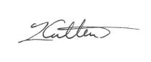

Mr Ivan Catlow  
Headteacher

**About Archbishop Temple Church of England High School**

**Introduction**Archbishop Temple Church of England High School opened in 1964 as a mixed comprehensive school for pupils aged 11-16. We have a very pleasant site in the north of Preston, in the affluent suburb of Fulwood. There are currently 832 pupils on roll.

**Leadership**  
The school appointed an experienced new Headteacher in 2021 and a newly appointed Deputy Head joined us in September 2022. This is an exciting time to work with a renewed and experienced leadership team taking the school forward to new heights, evident in our most recent Ofsted report.

**A Church of England School**We take being a Church school seriously and expect all colleagues to support our ethos, whatever their own personal faith position may be. Our aim is simply to serve our local community through providing an outstanding education to children of all faiths and none. We emphasise our Christian distinctiveness through regular acts of worship, but more importantly by valuing and caring for every member of our community.

**Curriculum**  
Archbishop Temple Church of England High School aims to provide a curriculum that meets the needs of all pupils by offering a breadth of educational opportunity. Subjects are taught with the National Curriculum as a starting point. In Years 10 and 11 all pupils follow a core curriculum of English, mathematics, science, RE, PSHE and PE. In addition, pupils select courses from a wide-ranging choice of GCSE options. We give our pupils the opportunity to take the EBacc suite of qualifications, with the most able following single science courses. The curriculum is based on five 58-minute periods per day, organised as a two-week timetable.

**Pastoral care and academic guidance**The Heads of Year and form tutors have responsibility for the welfare, academic progress and discipline of the pupils in their care. The tutors in each year have a particularly important role. Time is set aside each day for a programme of activities designed to promote the pupils’ social and learning skills, support literacy, and to enable tutors to get to know each pupil as an individual.

**Links between home and school**We aim to develop strong links between home and school. Parents receive termly Future News publications and are provided with regular communications about developments in school.

In addition, we publish various brochures and organise information evenings for parents at key points in their children’s education, together with awards’ evenings to celebrate the success of pupils at different Key Stages.

**Special educational needs and disabilities**At Archbishop Temple Church of England High School, we place equal value on the education of all pupils. Those with special educational needs or disabilities are encouraged to achieve their potential within each curriculum area; teaching assistants offer additional individual support. Some pupils are withdrawn from lessons for brief periods to work with specialist staff.

**Extra-curricular activities**    
A wide variety of out-of-school clubs and activities are available to pupils and their families. These vary across the academic year but might include dance, drama, robotics, eco club, IT and many others. There are a wide range of opportunities in physical education and the arts. The school enjoys a high reputation for music; we have school bands and choirs and aspire to have a large number of musical functions held annually. There are also excellent opportunities for pupils to begin or continue instrumental tuition as well as to participate in the annual school musical production. Educational visits and exchanges all appear in our annual programme. Enrichment activities are vital to the development of our pupils and we continue to seek new and exciting educational opportunities to develop each individual.

**School uniform**Pupils are expected to dress appropriately for a learning environment. School uniform is compulsory for all pupils.

**ICT resources**In recent years the school has invested heavily to develop our ICT provision and we have a state of the art wifi system and an excellent Virtual Learning Environment. Every pupil has their own iPad for use in learning, and this technology supports our innovative teaching and learning. Every teacher has an iPad Pro for their own personal use and PC in their classroom.

**Archbishop Temple active in the community**

Pupils at Archbishop Temple Church of England High School are encouraged to learn from the expertise, experience and information available within the local community. The school in return aims to provide a significant contribution to the community through the high-quality education, guidance and care we provide for our young people and through participation in fundraising and community service. We give the opportunity to children in local primary schools to join us for enrichment activities and to take part in a range of programmes. Archbishop Temple Church of England High School is active in its support of charities and each year we organise a number of fundraising activities. We are also committed to sustaining and extending our links with local businesses, both to enrich the curriculum and to encourage sponsorship and financial support for the work of the school.

**BUPA Cover**

All permanent staff at Archbishop Temple Church of England High School are welcome to join our BUPA scheme. You can choose cover for yourself and your family through our tax efficient salary sacrifice scheme. This extensive health care insurance will be considerably cheaper than buying it independently.

**Our local area**Despite being a university city and home to 135,000 people, over two thirds of Preston is classed as a rural area. Surrounded by many pretty villages, it is a very pleasant place to live. Preston is frequently quoted in national studies as a city that has got things right in terms of town planning and infrastructure development. Preston benefits from excellent rail and road links, indeed the school is easily accessed from the M6 motorway. The city offers the usual attractions of a vibrant place to live, but also has some beautiful areas of outstanding natural beauty on the doorstep. The coast is easily accessed; Blackpool, the beautiful Fylde Coast and Morecambe Bay are within 30 minutes’ drive. The Lake District is 40 minutes away. Liverpool and Manchester are less than 1 hour away. London is 2 hours away by train, with Preston being a mainline west coast station, giving easy access to Scotland.

**Departmental Information**

Departmental Staff

Mrs A. Downing – Head of Performing Arts (Drama)

Mrs S. Farnworth – Head of Music

Mrs E. Woods – Teacher of PE and Drama (Dance specialist)

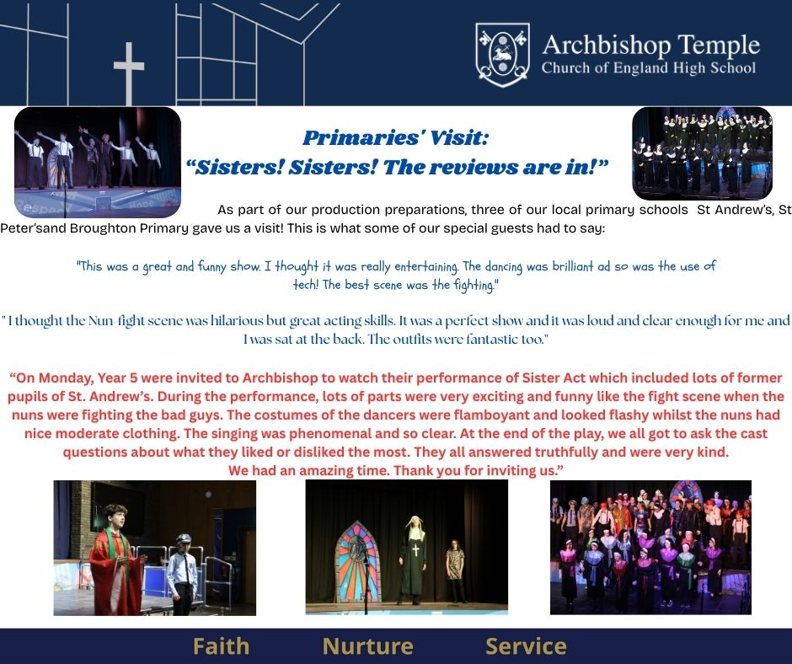Performing Arts is a thriving faculty which is core to school life here at Archbishop Temple. Music provides the harmony to Collective Acts of Worship and our pupils thrive within our shows and performances.

The Performing Arts team encompasses a broad range of skill sets from dance, drama, music and choral singing. Music is also supported by a number of staff from across the school who lead and support a range of bands and music groups.

The Performing Arts faculty has always delivered stimulating and challenging lessons, with a full range of techniques and methods used in the delivery of their subjects. Staff are fully committed to the use of technology and many lessons are delivered using this form to stimulate and engage students across the age range.

The Performing Arts faculty is highly thought of throughout the school with fantastic and various drama clubs, dance groups and choirs where everyone has a ‘can do’ attitude and all within the teams support each other. This has recently led to a number of extraordinary performances such as Matilda Jr (2023) and Sister Act Jr (2025). The results within the faculty are historically strong and we aim to further enhance the department’s reputation with the new appointment. The faculty ensures pupils are consistently challenged in all lessons. Our pupils are highly motivated, enthusiastic and very able.

All pupils at KS3 study Music and Drama and both subjects are popular with pupils at GCSE as options. Other Performing Arts courses at KS4 are currently being explored. The Music curriculum encompasses the three main strands of music - listening and appraising, composing and performing - and aims to inspire and enthuse students through the study of historical and current musical trends. Within our Drama curriculum, students will gain a better understanding and appreciation of the art form exploring a variety of genres and practitioners, as well as developing a wide range of performance and communication skills.

**Job description Teacher of Music with Drama**

|  |
| --- |
| **Key Purpose:** |
| The Teacher of Music with Drama must provide high quality teaching, effective use of resources and high standards of learning and achievement for all pupils. |
| **Key knowledge and understanding of:** |
| * The school’s aims, priorities, targets and plans in the context of the work of the department. * The relationship of the work of the faculty to the school as a whole. * Relevant statutory requirements for the curriculum and for assessment, recording and reporting. * The characteristics of high-quality teaching and the main strategies for improving and sustaining high standards of teaching, learning and achievement. * The implications of the Code of Practice for Special Educational Needs for teaching and learning. |
| **Key functions:** |
| 1. **Planning & Setting expectations**  * Set high expectations and targets for teaching, learning, achievement and behaviour. * Implement department improvement plans which focus on development, contribute to whole-school aims and identify realistic and challenging targets, actions, timescales and criteria for success. * Contribute to the development of shared schemes of work and teaching resources. * Working with the school’s Health & Safety Officer, ensure that there is a safe and healthy working and learning environment in which risks are properly assessed. * Work with the SEN department to ensure that individual education plans are used to set subject specific targets where appropriate and match work to pupils’ needs. * Contribute to resources and material for the school’s website and/or VLE (Firefly).  1. **Teaching & managing pupil learning**  * Supporting the Subject leader and curriculum leader with evaluating the teaching and learning within the department.   + Follow the self-evaluation of the curriculum area in line with school self-evaluation procedures.   + Implement a departmental policy which outlines clearly how the quality of teaching and learning will be evaluated and evidenced.   + Identify and disseminate effective practice and highlight and address areas for improvement.   *In particular ensuring the following:*   * + *curriculum coverage, continuity and progression for all pupils;*   + *constructive working relationships between staff and pupils;*   + *that lessons are based on learning objectives that are clearly communicated to pupils;*   + *select from a range of appropriate teaching and learning methods to meet the needs of the subject and of different pupils;*   + *the effective development of pupils’ skills and understanding in literacy, numeracy, ICT, study skills and PSHE.*   **3 Assessment & Reporting**   * Analyse and use relevant national, local and school data, research and inspection evidence to review own practice expectations, targets and teaching methods. * Following school guidelines, use the systems for assessing, recording and reporting achievement, and using the information to recognise and raise achievement further. * Use targets to evaluate progress by all pupils, including those with special educational needs. * Monitor the progress made in achieving targets, evaluate the effects on teaching and learning, and use this analysis to guide further improvement. * Use data effectively to identify pupils who are underachieving and, where necessary, create and implement effective plans of action to support these pupils.   **Guidance & Welfare** Manage pupil behaviour in the department and in the department’s teaching areas.  **Wider Professional Role**  *Department ethos:*   * Contribute to a positive climate in the department. Establish constructive working relationships among staff, including, through team working and mutual support, sharing responsibilities and tasks as appropriate and contributing acceptance of evaluation and accountability. * Have a clear, shared understanding of the importance and role of the subject in contributing to pupils’ spiritual, moral, cultural, social and physical development, and in preparing pupils for the opportunities, responsibilities and experiences of adult life.   *Professional development:*   * Participate in the school’s Appraisal Policy.   *Liaison:*   * Support the school’s link with the local community, using this to extend the subject, enhance teaching and develop wider understanding. * Communicate effectively, orally and in writing, with parents, governors, external agencies and the wider community.     **Promoting the Christian ethos of the school**  Support and promote the distinctly Christian ethos of the school. Through form time worship, whole school worship and supporting events on the school calendar like the Christmas Carol Service. |
| **Teaching** |
| * To undertake an appropriate programme of teaching in accordance with the duties of a standard scale teacher. |
| **Additional Duties** |
| * To play a full part in the life of the school community, to support its distinctive mission and ethos and to encourage and ensure staff and pupils to follow this example. * To undertake any reasonable duties seen fit by the Faculty Leader or Headteacher. |

**Person specification**

|  |  |  |
| --- | --- | --- |
|  | Essential | Desirable |
| ***APPLICATION FORM AND LETTER*** |  |  |
| **Qualifications and Professional Development** |  |  |
| * Qualified Teacher Status | √ |  |
| * Good honours degree or equivalent | √ |  |
| * A commitment to CPD | √ |  |
| ***LETTER, INTERVIEW AND REFERENCES*** |  |  |
| **Knowledge, skills and personal qualities** |  |  |
| Candidates should be able demonstrate they have: |  |  |
| * A genuine belief in the value of each child | √ |  |
| * A knowledge of the GCSE and NC requirements of the subjects | √ |  |
| * A good knowledge and understanding of current curricular developments in Music | √ |  |
| * A good knowledge and understanding of current curricular developments in Drama |  | √ |
| * The ability to maintain a high standard of teaching and learning | √ |  |
| * The ability to establish firm, fair and effective discipline | √ |  |
| * A willingness to be part of a team | √ |  |
| * High levels of commitment, motivation and initiative | √ |  |
| * Good ICT skills | √ |  |
| * The ability to relate well to all members of the school community | √ |  |
| * Good communication skills | √ |  |
| * High personal standards and high expectations of themselves and others | √ |  |
| * A flexible approach to school life | √ |  |
| * A desire to contribute to a range of extra curricular activities | √ |  |
| * A willingness to contribute to the exploration and development of additional KS4 courses. |  | √ |
| * An excellent health and attendance record | √ |  |
| * A willingness to support and promote the school’s distinctive Christian ethos | √ |  |
| * The ability to offer a faith reference |  | √ |

**Application Closing Date**

**The closing date for applications is**

**Tuesday 6th May 2025 (midday)**

**Shortlisted candidates will be contacted shortly after this date.**

If you have not heard from us by Friday 9th May 2025, please assume your application has been unsuccessful.

**Applications may be submitted on email to** [**head@archbishoptemple.com**](mailto:head@archbishoptemple.com) **or by post.**

Archbishop Temple Church of England High School is committed to safeguarding and promoting the welfare of children. We expect all staff to share this commitment. Appointments are subject to an Enhanced Disclosure & Barring Service check. Further details will be sent to shortlisted candidates.