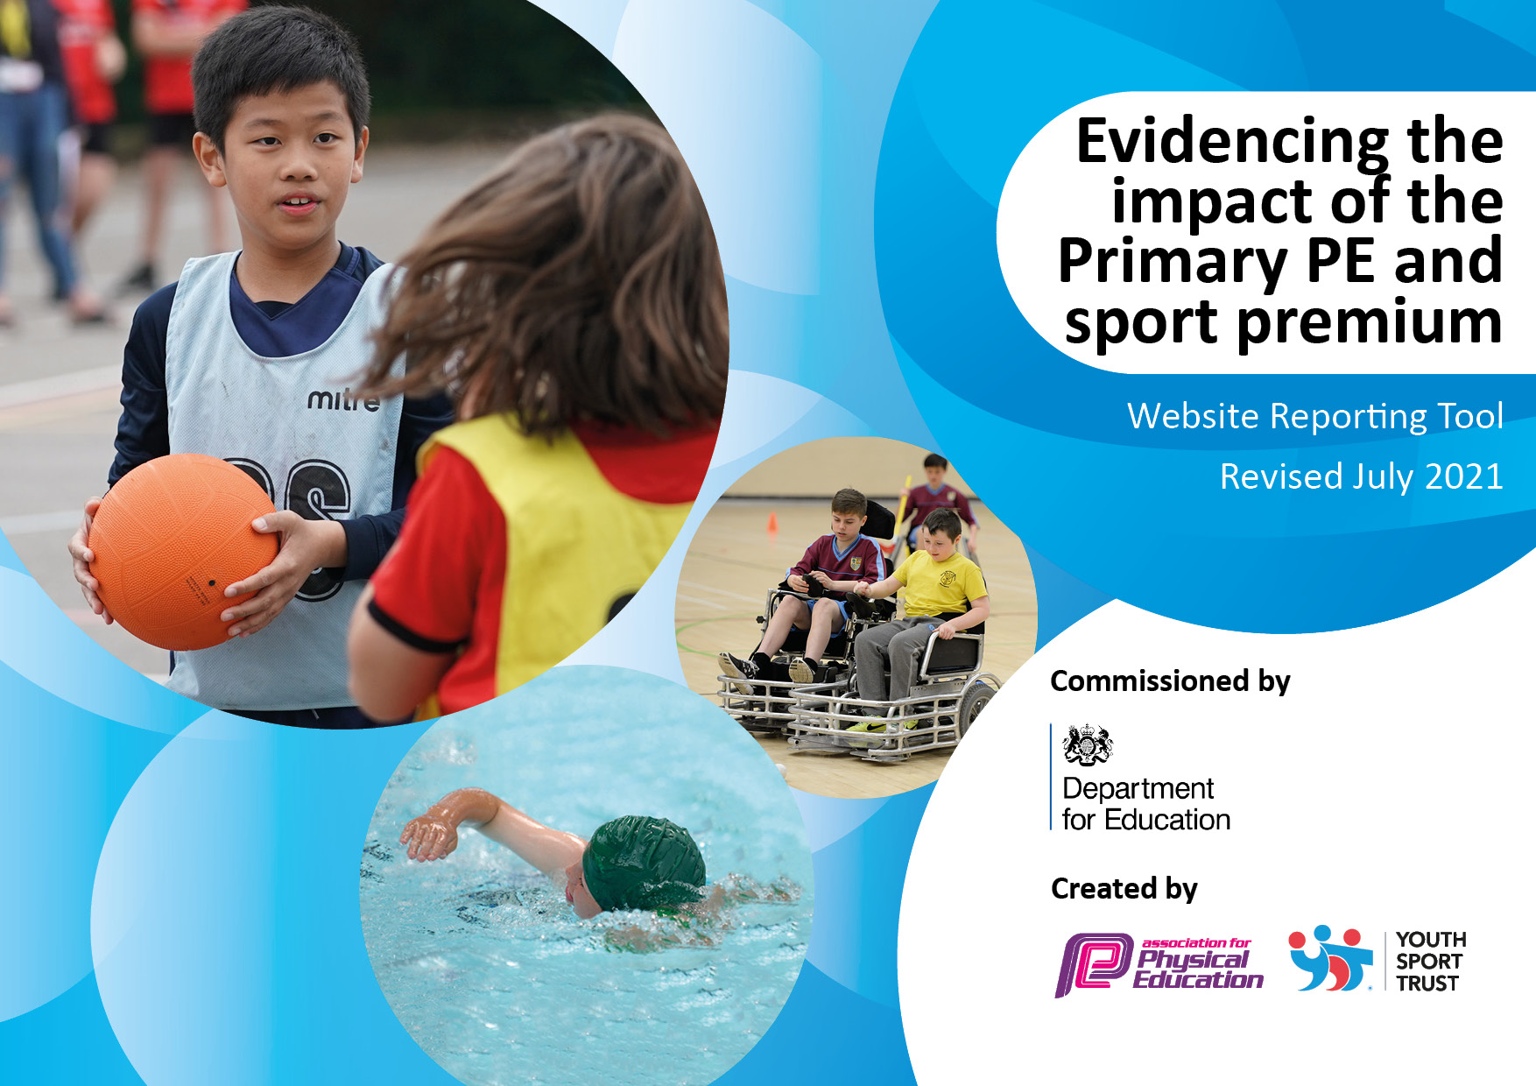
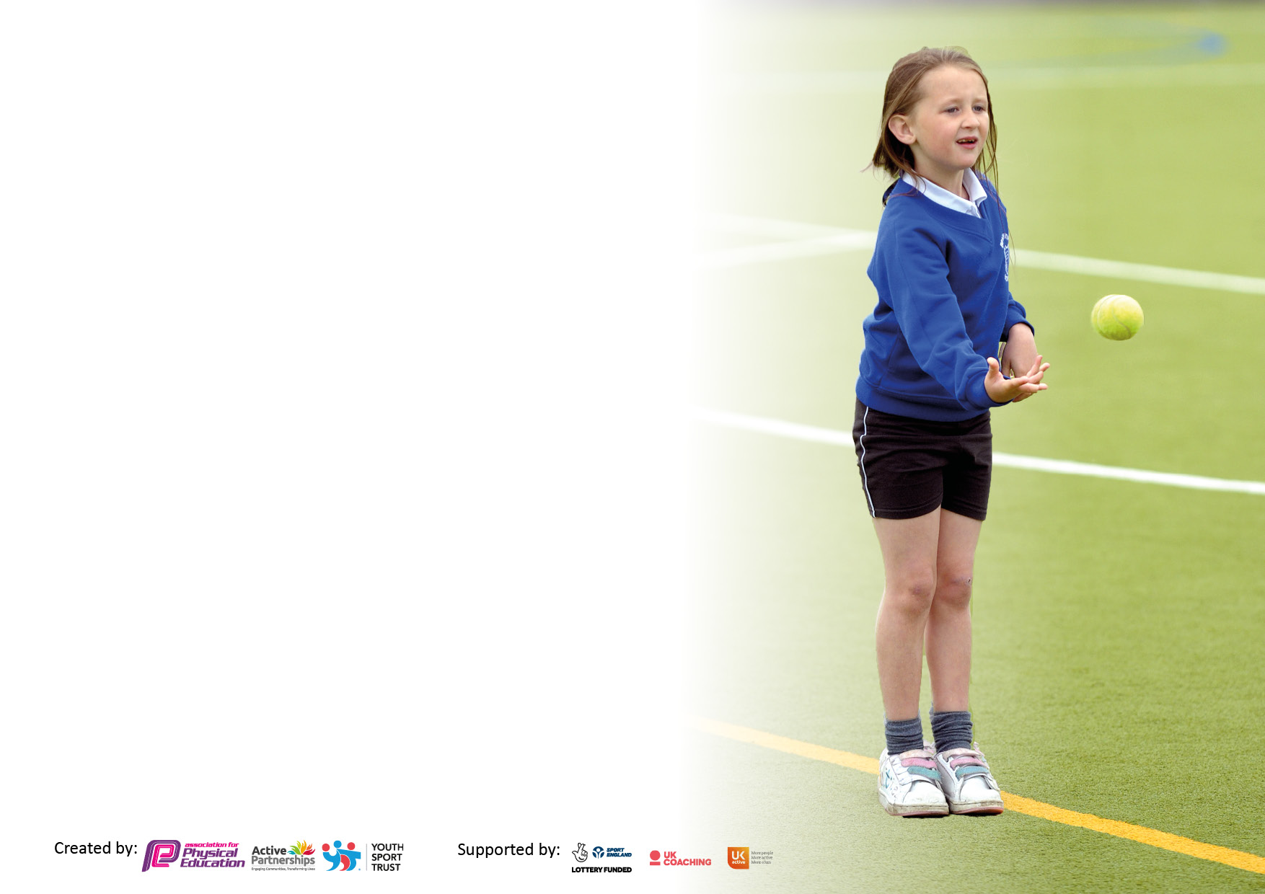

It is important that your grant is used effectively and based on school need. The Education Inspection Framework makes clear there will be a focus on ‘whether leaders and those responsible for governors all understand their respective roles and perform these in a way that enhances the effectiveness of the school’.

Under the Quality of Education Ofsted inspectors consider:
Intent - Curriculum design, coverage and appropriateness
Implementation - Curriculum delivery, Teaching (pedagogy) and Assessment
Impact - Attainment and progress

To assist schools with common transferable language this template has been developed to utilise the same three headings which should make your plans easily transferable between working documents.

Schools must use the funding to make additional and sustainable improvements to the quality of Physical Education, School Sport and Physical Activity (PESSPA) they offer. This means that you should use the Primary PE and sport premium to:

- Develop or add to the PESSPA activities that your school already offer
- Build capacity and capability within the school to ensure that improvements made now will benefit pupils joining the school in future years
- The Primary PE and sport premium should not be used to fund capital spend projects; the school’s budget should fund these.

Pleasevisitgov.ukfortherevisedDfEguidanceincludingthe5keyindicatorsacrosswhichschoolsshoulddemonstrate animprovement.Thisdocumentwillhelpyoutoreviewyourprovisionandtoreportyourspend.DfEencouragesschools to use this template as an effective way of meeting the reporting requirements of the Primary PE and sport premium.

We recommend you start by reflecting on the impact of current provision and reviewing the previous spend.

Schools are required to publish details of how they spend this funding, including any under-spend from 2019/2020, as well as on the impact it has on pupils’ PE and sport participation and attainment. All funding must be spent by 31st July 2022.

We recommend regularly updating the table and publishing it on your website throughout the year. This evidences your ongoing self-evaluation of how you are using the funding to secure maximum, sustainable impact. Final copy must be posted on your website by the end of the academic year and no later than the 31st July 2021. To see an example of how to complete the table please click HERE.

Details with regard to funding
Please complete the table below.

Total amount carried over from 2019/20 | £ 6464.74
Total amount allocated for 2020/21 | £ 16,550
How much (if any) do you intend to carry over from this total fund into 2021/22? | £ 7990
Total amount allocated for 2021/22 | £ 16,580
Total amount of funding for 2021/22. To be spent and reported on by 31st July 2022. | £ 24,570
Swimming Data
Please report on your Swimming Data below.

Meeting national curriculum requirements for swimming and water safety.  N.B. Complete this section to your best ability. For example you might have practised safe self-rescue techniques on dry land which you can then transfer to the pool when school swimming restarts.  Due to exceptional circumstances priority should be given to ensuring that pupils can perform safe self rescue even if they do not fully meet the first two requirements of the NC programme of study | All children aged 3 to 11 accessed swimming lessons in the summer term over two separate weeks.
What percentage of your current Year 6 cohort swim competently, confidently and proficiently over a distance of at least 25 metres?  N.B. Even though your pupils may swim in another year please report on their attainment on leaving primary school at the end of the summer term 2020.  Please see note above | End of Summer 2019 ~ 83% of Year 5 achieved NS (100% Year 6) Year 6 2020 projected 83%  Year 6 2021 ~ 100%
What percentage of your current Year 6 cohort use a range of strokes effectively [for example, front crawl, backstroke and breaststroke]?  Please see note above | 100%
What percentage of your current Year 6 cohort perform safe self-rescue in different water-based situations? | 100%
Schools can choose to use the Primary PE and sport premium to provide additional provision for swimming but this must be for activity over and above the national curriculum requirements. Have you used it in this way? | Yes ~ all children aged 3 to 11 accessed two weeks of outdoor swimming lessons. Additional intervention is planned for early autumn term or prior to next lessons in summer term 2022.

Action Plan and Budget Tracking
Capture your intended annual spend against the 5 key indicators. Clarify the success criteria and evidence of impact that you intend to measure to evaluate for pupils today and for the future.

Academic Year: 2020/21 | Total fund allocated: | Date Updated:
Key indicator 1: The engagement of all pupils in regular physical activity – Chief Medical Officers guidelines recommend that primary school pupils undertake at least 30 minutes of physical activity a day in school |  |  |  | Percentage of total allocation:
 |  |  |  | %
Intent | Implementation |  | Impact
Your school focus should be clear what you want the pupils to know and be able to do and about  what they need to learn and to  consolidate through practice: | Make sure your actions to achieve are linked to your intentions: | Funding allocated: | Evidence of impact: what do pupils now know and what can they now do? What has changed? : | Sustainability and suggested next steps:
1 Work together (whole school with student voice) to audit our outdoor provision for break times and outdoor play, evaluating the range of equipment and resources provided and identifying any new additional equipment or organisation that may improve opportunities for all to be physically active. This includes encouraging staff to support children through encouragement, support and wherever possible modelling the enjoyment of physical activity and challenge. Results of audit and action plans will be linked to this please see Student Voice Physical Activity Opportunities at Break Time.  2 Audit, evaluate and further develop healthy living behaviours with a focus on diet. Continue to provide a variety of fruit for all at playtime and develop awareness of the need for fluid (water) intake. Make this a focus of some student voice assemblies. Link this to work in science, Design Technology food technology and PE lessons to ensure all pupils know how to look after their physical and mental health through what they eat and how this links to the physical activity they are involved. The intention is that all pupils in school will make links and connections between healthy eating and being physically active, learning how to develop early positive habits, awareness and skills to establish and maintain life-long healthy lifestyles.  3. Discuss mental health and well-being and consider the development of a sensory garden for children to tend and use as quiet place to be if needed.  4 Develop the play leader programme which Year 5 received training for last year but were unable to implement due to bubble restrictions. | 1 By reviewing our outdoor equipment and resources we will refocus on them, exploring opportunities they provide and considering any next steps we can take to improve what we have. Discuss higher equipment for taller children in school, through student voice agree what to buy, then arrange installation.  Time to discuss will refresh our awareness, which will help both staff (including new members of staff) and children to capitalise on what we have available.  What do we have?  How do we make use of it?  What else could we do?  How can we decide?  What should staff do to support children at break time and in outdoor play? Maintain bike track and provide balance bike track in our new EYFS outdoor play area.  Play leaders ~ see below.  2 We have an embedded routine of fruit and vegetable snack each morning break. It is a timetabled part of our day. Much work went into establishing this across school, with all staff and children now engaged in this and we know that all our children are having between one and three portions of fruit and vegetables every day. Work needs to continue to maintain the focus and routine of this part of our day. This includes adults modelling and valuing it too.  Continue to provide a range of seasonal, affordable fruit and vegetables each break time.  Make sure we maintain this focus through student voice discussion and staff meeting focus.  Form links to diet, nutrition and health and well-being in PE science and DT food technology lessons.  3 Develop gardening as something that can support physical and mental health and well-being. Through student voice assemblies, involve all children in plans to create a garden for break times (developing interest shown last year).  Follow up and implement now children are able to play together rather than being in separate bubbles (with control measures if needed). All staff on duty to support the delivery, so arrange Year 5 (now Year 6) time to train staff. HH and EP to drive this through until it is embedded.  Why is this so valuable for those involved?  How will we organise?  All children to take responsibility or some? With buddies? With any younger children? Student voice decision. | £12,000  £2000  £800  £1000  Time to organise and support.
Key indicator 2: The profile of PESSPA being raised across the school as a tool for whole school improvement |  |  |  | Percentage of total allocation:
 |  |  |  | %
Intent | Implementation |  | Impact
Your school focus should be clear what you want the pupils to know and be able to do and about  what they need to learn and to  consolidate through practice: | Make sure your actions to achieve are linked to your intentions: | Funding allocated: | Evidence of impact: what do pupils now know and what can they now do? What has changed? | Sustainability and suggested next steps:
- Place PE and School Sport and physical activity at the heart of our school community’s recovery from COVID by promoting the positive impact being active can have on our health and well-being. Make this initiative fully inclusive; all ages and abilities coming together to have fun whilst being active. Assess fitness and stamina of children and respond accordingly.  - Skill development across a range of sports including badminton, sailing and bouldering.  - Further develop the strength school already has in outdoor learning.  3. Work with parents of children in Early Years (Nursery and Reception) to share information and develop understanding of early physical development in children, including using knowledge and expertise gained in the Healthy Movers training 2018-19 and the BInspired programme of training in 2020 to 2021.  4. Consider how we can remove barriers and improve access for those in greatest need.  4. Specific focus on impact of fun and challenging opportunities in our outdoor learning environment, for example chin up and jungle bars. Impact of new advanced bars at higher level for older children in school. Specific focus on impact on upper body strength. Impact of cycle track and bikes.  5. Provision of swimming intervention lessons for identified pupils. Confidence in swimming lessons. Promote attendance at swimming lessons or the benefits of going swimming as a family leisure activity. | HH and EP to refresh long term plans to meet current needs and teaching arrangements in statutory PE lessons. Medium term planning through Cambridge and other schemes to support delivery. Skill development a priority with opportunities to acquire and develop skills, tactics, strategies and compositional ideas and then apply them.  Evaluation of own and others performance to be included as an important tool for improvement.  Use of IPads to film for evaluation. Links to knowledge and understanding of health and fitness. Particular focus on fitness.  Additional to this make the most of our Eden Valley School Sports Partnership membership by accessing a range of activities to maintain standards and introduce new sports. This will include  - Delivery of Bikeability training in Year 4 and 5  - Badminton ………….and a range of other sessions requested by school.  3 Covid allowing meetings for new Reception parents at the beginning of the school year. Plans for how we can involve Nursery parents through the termly intake programme. If face to face is not possible, look to provide information online or in paper form with parent meetings to support this.  4 staff and student discussions about | £2,600  PE and School Sport fees  See Key Indicator 4  Time  Swimming intervention  £400 | Badminton  The 2 classes taking part very much enjoyed learning to play badminton. Progress and skill development was evident. Teachers benefitted from training, building knowledge and confidence. Followed up with signposting to badminton club in Penrith, with pupils in Year 5 and 6 attending. These pupils have been less involved in playing on school teams such as netball\football, but are now showing some interest in attending these clubs.

Key indicator 3: Increased confidence, knowledge and skills of all staff in teaching PE and sport |  |  |  | Percentage of total allocation:
 |  |  |  | %
Intent | Implementation |  | Impact
Your school focus should be clear | Make sure your actions to | Funding | Evidence of impact: what do | Sustainability and suggested
what you want the pupils to know | achieve are linked to your | allocated: | pupils now know and what | next steps:
and be able to do and about | intentions: |  | can they now do? What has
what they need to learn and to |  |  | changed? :
consolidate through practice:
1. Maintain high quality sports coaching sessions, CPD opportunities and through this develop and extend access to festival/competitions through continued Eden Valley School Sports Partnership Membership. In-house CPD opportunities for staff delivering PE curriculum. Again, further training opportunities through feedback to partnership; particularly any training opportunities for Smart Moves Intervention new member of staff, through attending a training programme if possible or in-house if not. PE teachers in school will plan and work collaboratively on PE curriculum and delivery.  2. Staff participating in the online BInspired Early Years Physical Development and Wellbeing training programme during 2020 to 2021 and Healthy Movers training 2018-19 will use and apply knowledge gained with children across the learning they are providing and share their expertise with other relevant staff.  3. Support SRE lead in school in delivering and coordinating health and well-being and sex and relationships education across school, with the importance of being physically active and eating healthily an important area of focus.  4. As a staff and whole school discuss how we can\are developing teamwork, collaboration, empathy and respect in our physical activity in the same way we do in other areas of our curriculum, particularly as this is central to our school ethos and vision. | Staff development opportunities through PE and School Sport Partnership. This may be restricted to in-school work with visiting providers, but if face to face training can’t be attended, source online training if possible for HH and EP.  KH to support RA in providing weekly balance bike sessions in Early Years.  Feedback and support for RA ~ JPD sharing of learning during this training. Revisit opportunities for staff attending this training.  RA to work with HH to deliver Healthy Movers for children in Year N and R (possible Y1 extension?)  HG to support the delivery of this work among all staff so that links are made between physical and mental health and well-being. Staff will then be able to positively impact on this in their approach and attitude to physical activity in school and when we are out in our local and wider community.  Link our PE and School Sport to UNICEF Rights of the Child.  Consider our single equality policy and inclusivity. Are we applying this to all areas of physical activity?  Are we challenging stereotyping ~ gender, disability, age, neurodiversity? | EVSSP membership as above.  £1000 (possible supply included)  Time  Time  Time  Posters, books and other resources ~ £250
Key indicator 4: Broader experience of a range of sports and activities offered to all pupils |  |  |  | Percentage of total allocation:
Intent | Implementation |  | Impact
Your school focus should be clear | Make sure your actions to | Funding | Evidence of impact: what do | Sustainability and suggested
what you want the pupils to know | achieve are linked to your | allocated: | pupils now know and what | next steps:
and be able to do and about | intentions: |  | can they now do? What has
what they need to learn and to |  |  | changed? :
consolidate through practice:
Additional achievements:  1. Explore further development of the range of after school sport and physical activity, particularly opportunities for younger children in order to provide the widest range possible to meet interests and needs of all children in school. Begin by restoring regular clubs like cycling, gardening and healthy living.  2. Provide alternative activity experiences ~ climbing wall, squash, wheel chair basketball, gardening so that all interests can be catered for and children have as wide a range of experiences as possible to support  3. Now restrictions are lifting introduce and use the new gymnastics frame which was installed during restrictions\lockdown. Make use of this equipment to increase climbing, balancing and travelling by all children.  4. In student voice assemblies identify games and activities for break times ~ Year 6 play leaders to organise and lead assemblies and break time activities.  5. Plan and action outward bound and adventure days for all children in school and also EYFS\KS1 healthy day out trips~ walking etc opportunities. | Restart all clubs and look to respond offer of physically active clubs. This will include cycling club, netball club, healthy living club where we play games and run around a lot and see if we can organise a new football club. Keep costs as low as possible or free if we can with sports clubs.  Organise as wide a range of activities as possible, including  - Wheelchair basketball sessions for all ages of children.  - Bouldering for whole school.  - Explore the possibility of a visit to the squash and ski clubs in Carlisle.  - Gardening  Provide support to set this up.  Will all children do this with younger buddies or on a rota?  What activities will they plan and how can staff help them.  EP and HH to support this with all staff to encourage in break times.  Sailing, kayaking, skiing, bouldering and walking trips. Use our local area ~ woods and footpaths ~ first plan is a whole school walk from the village of Armathwaite to the village of Ainstable using the old green lanes.  Can we climb a fell again? | Subsidise clubs for disadvantaged\ vulnerable children.  Family deals  £500
Key indicator 5: Increased participation in competitive sport |  |  |  | Percentage of total allocation:
 |  |  |  | %
Intent | Implementation |  | Impact
Your school focus should be clear | Make sure your actions to | Funding | Evidence of impact: what do | Sustainability and suggested
what you want the pupils to know | achieve are linked to your | allocated: | pupils now know and what | next steps:
and be able to do and about | intentions: |  | can they now do? What has
what they need to learn and to |  |  | changed? :
consolidate through practice:
1 Continue to increase access to festivals and competitions for all children in school (inclusive) ~ lacrosse, netball, football, orienteering, swimming, multi skills, dance, cross country running….  Develop breadth ~ bouldering competition etc.  2 Experience visit to watch live dance performance.  3 Active, inclusive sports day in school. | Attend all available competitions and festivals including:  - Netball  - Swimming  - Multi sports  - Lacrosse  - Cross country  - Bouldering  - Skelton 7s  Organise friendly matches with local teams  Dance workshop and theatre visit if this is possible and safe.  Whole school outdoor sports day with family attendance if possible. | Transport costs to venues  £1000

Signed off by
Head Teacher:
Date:
Subject Leader:
Date:
Governor:
Date:

