SEND Policy 2021-2022
Policy Version & Issue Date: | July 13th 2021
Electronic copies of this plan are available from: | Armfield Academy Blackpool
Hard copies of this plan are available from: | Armfield Academy Blackpool
Date of next review: | June 2022 (as required)
Person responsible for Review: | Rachel Hurst

Philosophy and purpose

Armfield is ‘an academy to be proud of’ and is part of the Fylde Coast Academy Trust (FCAT). Our aim is to create a culture where quality first teaching underpins a quality education where all learners are cared for, valued and respected. We work in partnership with parents/carers and external agencies to ensure that we provide a safe and supportive environment which offers an inclusive and personalised education to suit the needs of all learners to promote positive outcomes.

Our vision is firmly underpinned by the guidance provided in the SEND Code of Practice 2015 and incorporates the FCAT principles outlined below:

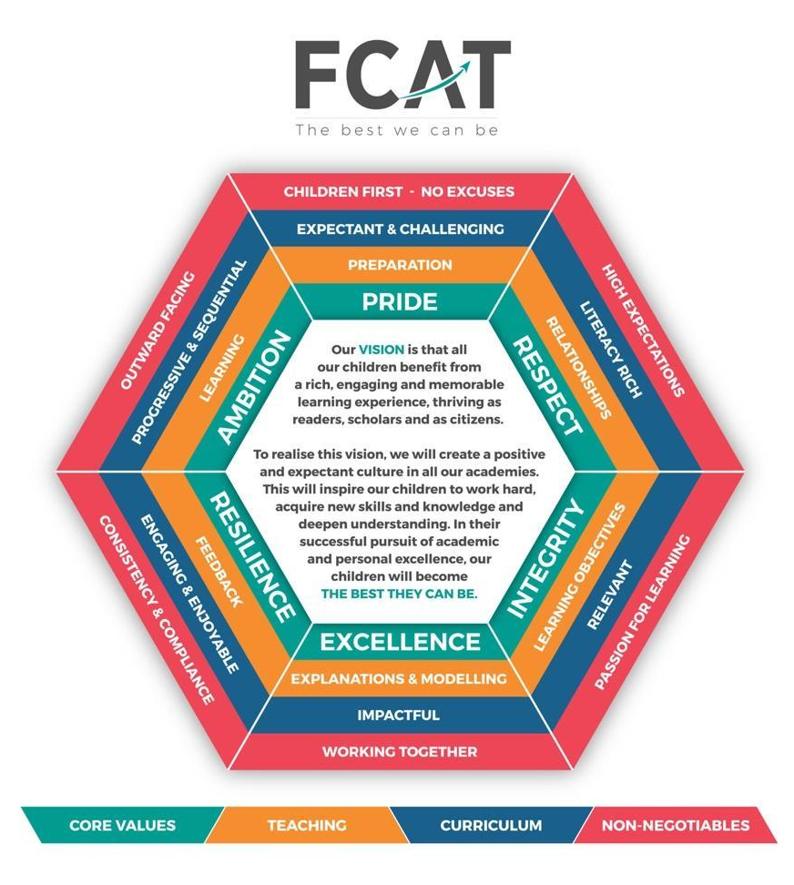

FCAT is an inclusive, non-selective trust. Our trust believes that every child has the right to access education that meets their needs and prepares them well for adulthood. As part of an inclusive trust, we are committed to working collaboratively with learners, their families and external partners to ensure that all aspects of school life are accessible and appropriately differentiated to meet the wide range of individual needs.

Policy Aims

The aim of our policy is to fulfil Armfield’s mission statement, purposes and values as outlined above and on our school website. In particular, our policy aims to ensure that the provision we offer:

- ensures high quality teaching and learning opportunities which are differentiated and varied.

- promotes and facilitates exceptional progress

- ensures all earners are challenged and able to do their very best.

- provides opportunities to foster and develop interests and talents.

- is regularly monitored and reviewed to ensure that we are providing the best and most appropriate provision to meet the needs of all our learners.

This policy pays due regard to legislation set out in key publications:

- Children and families Act 2014
- Health & Social Care Act 2012
- Equality Act 2010
- Mental Capacity Act 2010
- Children’s Act 2014
- Supporting Children with Medical Conditions 2015
- Keeping Children Safe in Education 2021
- Working together to safeguard Children 2018

Definition of SEND

The term SEND (Special Educational Needs and Disabilities) encompasses a wide range of needs. The SEND Code of Practice states that ‘a child or young person has SEND if they have a learning difficulty or disability that calls for special educational provision to be made for them. At compulsory school age, this means that the child or young person has a significantly greater difficulty in learning than the majority of others the same age, or, has a disability which requires reasonable adjustments to be made to support their learning.

Categories of SEND

Whilst there is a wide spectrum of individual and additional needs, SEND is recognised as four broad areas of need:

- cognition and learning
- social, emotional and mental health
- communication and interaction
- sensory and/or physical needs

Identification and Assessment; The Graduated Response to SEND

The effectiveness of our SEND provision is ensured through:

- early identification of need
- learner engagement
- timely and accurate record keeping
- challenging and realistic target setting
- clear, effective and honest communication with parents/carers and learners.
- effective and timely interventions and support
- review of interventions and modifying provision where appropriate.

In accordance with the SEND Code of Practice, Armfield Academy follows the Assess-Plan-Do - Review approach to managing and supporting learners with additional needs. Parents/ carers and learners are involved at all stages to ensure that individual needs are met.

SEND interventions will be in a staged and monitored approach which we call the graduated response. This is supported by the Blackpool Inclusion Team who offer wrap around expertise and support and can be categories in stages:

- Initial observations
class teacher and support staff identify a concerns

- First concerns 1
The class teacher, support staff, parents/carers and young person meet to discuss needs and plan appropriate action. A review date will be set.

- First concerns 2
The class teacher, support staff, parents/carers and young person meet to discuss if any further support is needed if needs are not met at the first concern stage. A review date will be set.

- SEN support 1
The SENDCo becomes involved at this stage and possibly the school nursing team. Your child will be added to the SEN register whilst interventions are offered and provision is put into place to help meet needs.

- SEN support 2
Learners who require a high level of intervention or support to access the curriculum and school environment will receive specialist and targeted support to ensure that their needs are met. In most cases, this will involve a multi-agency approach including the support of advisory teachers and Educational Psychologists as appropriate.

- Complex
A team of professionals will be supporting the child at this stage. It may be necessary to start the process for an educational health and care plan (EHCP) needs assessment.
In some cases, it may be appropriate to progress to an educational health and care plan needs assessment (EHCNA). The SENDCo will work with all stakeholders and coordinate the necessary specialist support to prepare the assessment documentation for the assessment panel.

All teachers are teachers of SEN. Staff receive a comprehensive package of training to ensure that they are the best they can be and are able to provide a varied and interesting curriculum that meets the needs of all of our learners. Learners will be assessed using a range of assessments and their progress will be tracked and monitored through data captures.

Local offer
FCAT and Armfield Academy work in partnership with the Local Authority to assist in the development and review of the local offer for SEND:
https://www.fyidirectory.co.uk/blackpool-local-offer
Independent, impartial and confidential advice and support can be gained from the SENDIASS team on: 01253 477083

Contacts:
SENDCO - Rachel Hurst r.hurst@armfield.fcat.org.uk
Assistant SENDCO - John McDonald j.mcdonald@armfield.fcat.org.uk

