Free School Meals Entitlement Form
Please read carefully and complete the required information below

Parent/Carer Details
Title:
Forename:
Surname:
National insurance number OR National Asylum Support Service reference number
Date of Birth (DD/MM/YYYY):
Relationship to child:
Email address:
Home address:
Postcode:

Child’s Details
Child’s full name:
Child’s Date of Birth (DD/MM/YYYY):
Child’s gender: | Male ☐ Female ☐

Please answer the following questions
 | YES | NO
I receive Income Support or Income Based Job Seekers Allowance | ☐ | ☐
I receive Income Related Employment and Support Allowance | ☐ | ☐
My income is less than £16,190 and I receive Child Tax Credit | ☐ | ☐
I receive Working Tax Credit | ☐ | ☐
I receive Guarantee Credit | ☐ | ☐
I receive support under part VI of immigration and Asylum Act 1999 | ☐ | ☐
I receive Universal Credit | ☐ | ☐

I give permission for Armfield Academy to apply on my behalf to check my entitlement for free school meals and pupil premium.
Signed:
Name:
Date:
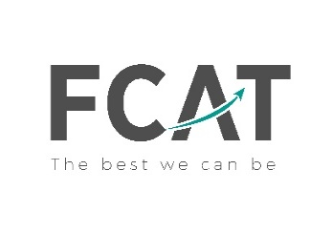
Armfield Academy Blackpool is a trading name of Fylde Coast Academy Trust. Company No. 8364709 - registered in England and Wales.

