Sportstar Uniform Order

Scan to order or fill in form below and email to info@sportstarclothing.co.uk
Item |  | Size |  |  |  | Price |  |  | Quantity |  | Total Cost
Fleece
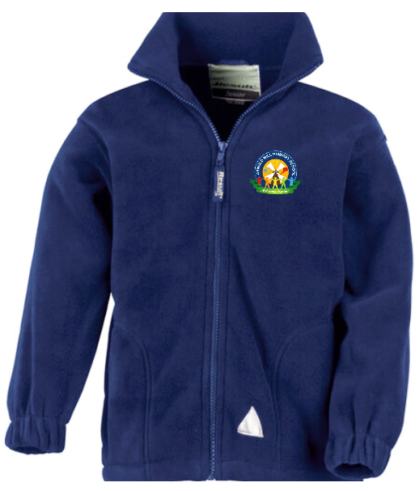 |  | XXS 55/57cm (age 3-4 |  |  |  | £13.95
 |  | XS 57/61cm (age 4-6) |  |  |  | £13.95
 |  | S 61/67cm (age 6-8) |  |  |  | £13.95
 |  | M 67/73cm (age 8-10) |  |  |  | £13.95
 |  | L 73/79cm (age 10-12) |  |  |  | £13.95
 |  | XL 79/87cm (age 12-14) |  |  |  | £13.95
Sweatshirt
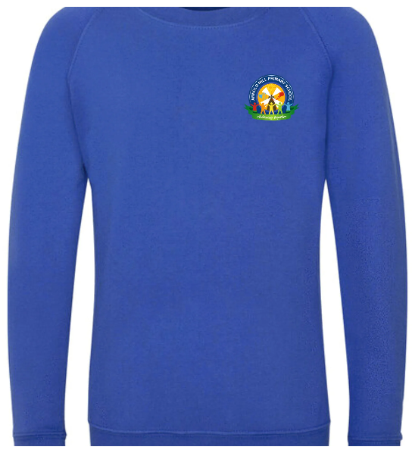 |  | Age 3/4 (26”) |  |  |  | £10.95
 |  | Age 5/6 (28”) |  |  |  | £10.95
 |  | Age 7/8 (30”) |  |  |  | £10.95
 |  | Age 9/10 (31”) |  |  |  | £10.95
 |  | Age 11/12 (32”) |  |  |  | £10.95
 |  | Age 13 (35”) |  |  |  | £10.95
Cardigan
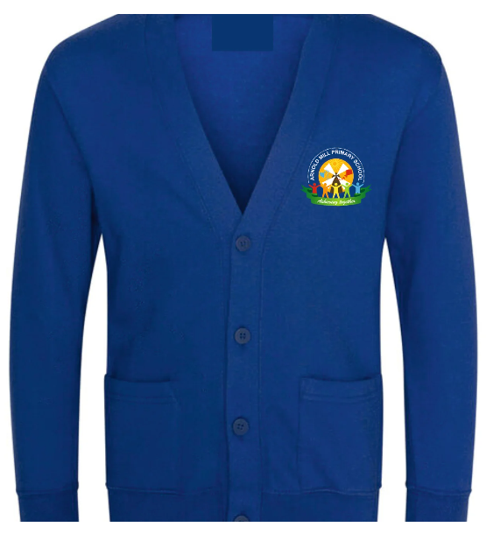 |  | Age 3/4 (26”) |  |  |  | £12.50
 |  | Age 5/6 (28”) |  |  |  | £12.50
 |  | Age 7/8 (30”) |  |  |  | £12.50
 |  | Age 9/10 (31”) |  |  |  | £12.50
 |  | Age 11/12 (32”) |  |  |  | £12.50
 |  | Age 13 (35”) |  |  |  | £12.50
Reversible Jacket
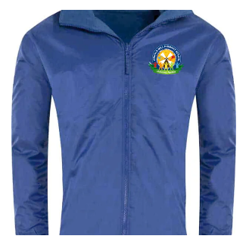 |  | XS 96-104cm |  |  |  | £22.50
 |  | S108-116cm |  |  |  | £22.50
 |  | M 120-128cm |  |  |  | £22.50
 |  | L 133-150cm |  |  |  | £22.50
 |  | L 133-140cm |  |  |  | £22.50
 |  | XL 144-152cm |  |  |  | £22.50
 |  | XXL 156-164CM |  |  |  | £22.50
Polo Shirt
 | Age 3/4 (26”) |  |  |  | £7.95
 | Age 5/6 (28”) |  |  |  | £7.95
 | Age 7/8 (30”) |  |  |  | £7.95
 | Age 9/10 (31”) |  |  |  | £7.95
 | Age 11/12 (32”) |  |  |  | £7.95
 | Age 13 (35”) |  |  |  | £7.95
PE T-Shirt
 | Age 3/4 (26”) |  |  |  | £5.25
 | Age 5/6 (28”) |  |  |  | £5.25
 | Age 7/8 (30”) |  |  |  | £5.25
 | Age 9/10 (31”) |  |  |  | £5.25
 | Age 11/12 (32”) |  |  |  | £5.25
 | Age 13 (35”) |  |  |  | £5.25
Book Bag
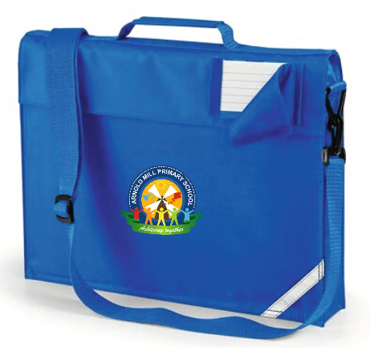 | One size |  |  | £7.95
PE Shorts
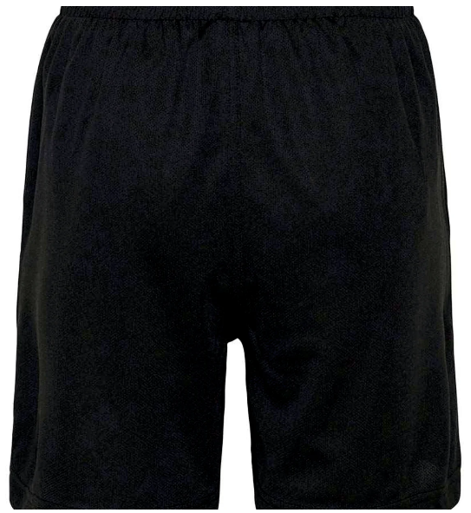 | Age 3/4 (26”) |  |  | £6.50
 | Age 5/6 (28”) |  |  | £6.50
 | Age 7/8 (30”) |  |  | £6.50
 | Age 9/10 (31”) |  |  | £6.50
 | Age 11/12 (32”) |  |  | £6.50
 | Age 13 (35”) |  |  | £6.50
Cycling Shorts
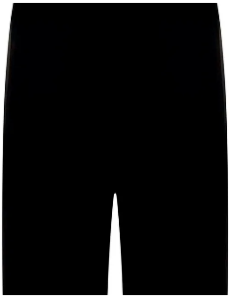 | £6.50 |  |  | £6.50
 | £6.50 |  |  | £6.50
 | £6.50 |  |  | £6.50
 | £6.50 |  |  | £6.50
 | £6.50 |  |  | £6.50
 | £6.50 |  |  | £6.50
Backpack
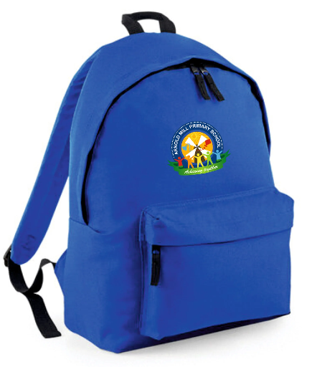 | One size |  |  | £12.50
Lunch Bag
 | One size |  |  | £10.00
PE Bag
 | One size |  |  | £6.95
Total Cost |  |  |  |  |  |  |  |  |  | £
Name of person completing order form
Email address
Contact telephone number
Please email this form to info@sportstarclothing.co.uk
You will receive an email confirmation with a payment link.
All orders placed by 14th August will be available for collection from school from
Tuesday 1st September
We cannot guarantee deliver in time for the beginning of term if placed after 14th August.

