Spread the word and help us raise funds for Arnold Mill Primary by shopping at AmazonSmile during Prime Day.
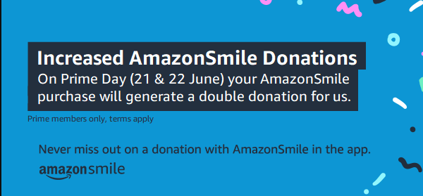
Prime members who shop Amazon Prime Day deals from 21st – 22nd June can do more than discover great deals.
Simply shop at https://smile.amazon.co.uk/gp/chpf/homepage?orig=%2F or with AmazonSmile ON in the Amazon Shopping app, and AmazonSmile will DOUBLE donations to Arnold Mill Primary School Fund at no extra cost
All Prime members who activate AmazonSmile in their Amazon mobile app between now and the end of Prime Day will generate a 10x donation (that’s 5%!) on their first AmazonSmile-eligible purchase on Prime Day. If one of our supporters buys a £500 TV on Prime Day using this special AmazonSmile offer, they will generate a £25 donation for Arnold Mill Primary School Fund, at no cost to us or them!
