Arnold Mill Primary School

Head Teacher Mrs J Oldfield B.Ed (Hons)
Cross Street Arnold Nottingham NG5 7AX
Telephone (0115) 966 7930
Email: office@arnoldmill.notts.sch.uk
_______________________________________
6 January 2022

Dear Parents and Carers,
We are pleased to announce that we will be having an author visit from the fantastic Gareth Baker on Friday 4th February. Gareth has been offering school author visits since 2015. Before becoming a writer, he worked with children for over 20 years. Since starting visiting schools he has gained a reputation of being able to engage and enthuse children and staff, whether they are in EYFS, KS1 or KS2. Please have a look at his website (https://www.gareth-baker.com/).
Each class from F1-Y6 will have a session with Gareth and this will support the school’s Reading for Pleasure initiative which is so important for children’s development with reading. To help the school with this we are asking for a £1 cash donation (to be handed to the Class Teacher by Monday 31st January please).
We look forward to welcoming Gareth into our school and we know all year groups will have an amazing time. There will also be time for a book sale during the day with prices of Gareth’s book below. If you would like to purchase one of Gareth’s books, please allow your child to bring money in on the day – price list attached.
Thanks for all your continued support and happy reading!
Shaun Hewlett
Deputy Head Teacher

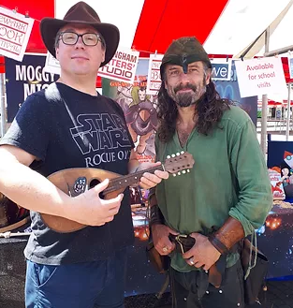 | 