Arnold Mill Primary School

Head Teacher Mrs J Oldfield B.Ed (Hons)
Cross Street Arnold Nottingham NG5 7AX
Telephone (0115) 966 7930
Email: office@arnoldmill.notts.sch.uk
_______________________________________

Dear Parents and Carers,
We hope you had a wonderful summer and are excited about the new term ahead. We are so looking forward to welcoming the all children back on Monday into the brand new KS1 unit. It looks amazing and there is a gallery of photos of the unit on the school website here: Gallery | Arnold Mill Primary and Nursery School (secure-primarysite.net) We know the children will be very excited when they see it. Over the summer, there have been a few changes in the way we expected to do things so please read the following carefully.
- Children in 1A only will now enter and leave school through the door labelled Indigo.

- Children in 1B only will enter and leave school through the door labelled Orange.

- Children in 1C will enter and leave school through the door labelled Yellow.

Please see the map below to confirm the locations of these doors:

Main Entrance

Indigo  Yellow  Orange | 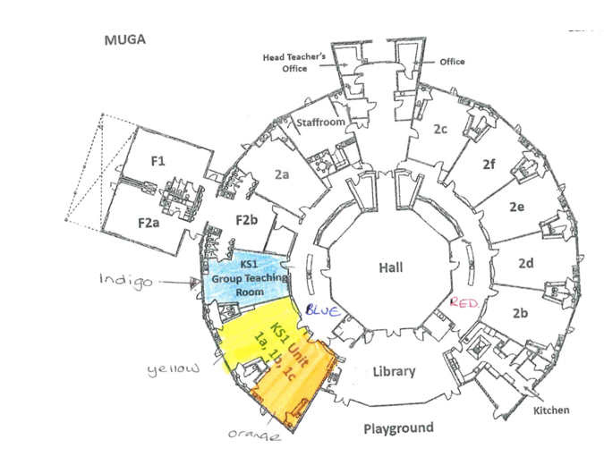

Children in 1A should wait by the wooden gate close to the foundation area.
Children in 1B and 1C should wait by the rainbow-striped bench between the orange door and the library door.
The KS1 staff will all be outside on Monday morning to welcome the children back and will direct anyone who looks lost so please just ask if you need any help!
P.E. days will be Wednesdays and Thursdays but please make sure a fully-named P.E. kit is in school everyday.
As ever, if you have any questions about anything, however big or small, please email us or contact the office.
Kind regards,
The KS1 team.

