Arnold Mill Primary School

Head Teacher Mrs J Oldfield B.Ed (Hons)
Cross Street Arnold Nottingham NG5 7AX
Telephone (0115) 966 7930
Email: office@arnoldmill.notts.sch.uk
_______________________________________

Dear Parents and Carers,
With one week to go until half term, we are squishing lots into every school day. This week KS1 have enjoyed their visit from White Post Farm and upper KS2 have had a fabulous week either outdoors at Kingswood or in school doing art, computing and forest schools.

I’d like to say a big thank you as pick up and drop off times do seem to be going smoothly. As cases of Covid-19 are on the rise again, you are most welcome to wear masks whilst on site. We have had a number of cases of Covid-19 in school this half term. So far we have not had any linked cases and so have not had an outbreak. It is really important that you keep your children at home if they are unwell. If they display any of the main Covid-19 symptoms (persistent cough, temperature, or loss of taste or smell) please get them PCR tested. Lateral Flow tests are not recommended for primary aged children and so we would always recommend getting a PCR, this will keep others safer.

GARDENING EQUIPMENT FOR SCHOOLS - We need your help, we are are collecting Morrisons 'It's Good to Grow' vouchers. The scheme runs until 24th October - please download the MyMorrisons App to donate 1 Grow Token for every £10 spent in store or online to help us get gardening equipment for the school. Find out more by visiting https://www.itsgoodtogrow.co.uk/ and logging in. | 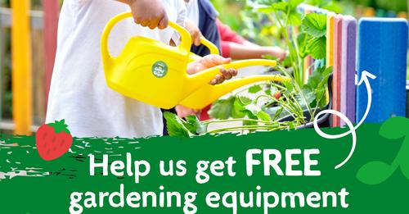

PARKING - We have had a few complaints about the parking on Cross Street and Mill Lane again this week. The police will be notified when cars park on the white zig-zag lines, so please don’t risk parking in places that could cause an accident.

AFTER SCHOOL CLUBS - Clubs will start again after half term, (here is the link - https://primarysite-prod-sorted.s3.amazonaws.com/arnold-mill-primary-nursery-school/UploadedDocument/5a14bb1c-c6c4-4995-aa63-70f8115ef56c/new-clubs-letter-to-parents.pdf) so please sign up for the waiting list using SIMS Parent and we will inform you next week whether your child has been allocated a place on their chosen club(s).

FLU VACCINATION - We have sent out details of this year’s flu vaccination programme. A copy of the School Aged Immunisation Service letter can be found on our website if you haven’t seen it (https://primarysite-prod-sorted.s3.amazonaws.com/arnold-mill-primary-nursery-school/UploadedDocument/5340ba20-7718-41be-bd3d-92cee14185c0/arnold-mill-letter-to-parents.pdf ).

PHOTO - Place your order for individual or sibling photos by Sunday 10th October in order to get them back before we break up for half term. Any orders over £35 placed before Sunday will receive a £5 discount. Any orders placed between 11th and 24th October will be delivered into school after half term free of charge. Orders placed after 24th October will require direct shipping to home addresses and there will be a small delivery charge.

CHRISTMAS - Christmas Card Artwork order forms have been sent home. The deadline for online orders (Cauliflower Cards) is midnight on 13th October.
Let’s hope the sun shines for the last week of this half term.

Have a lovely weekend!
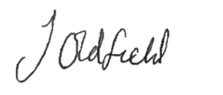
Kind regards,

Mrs Oldfield
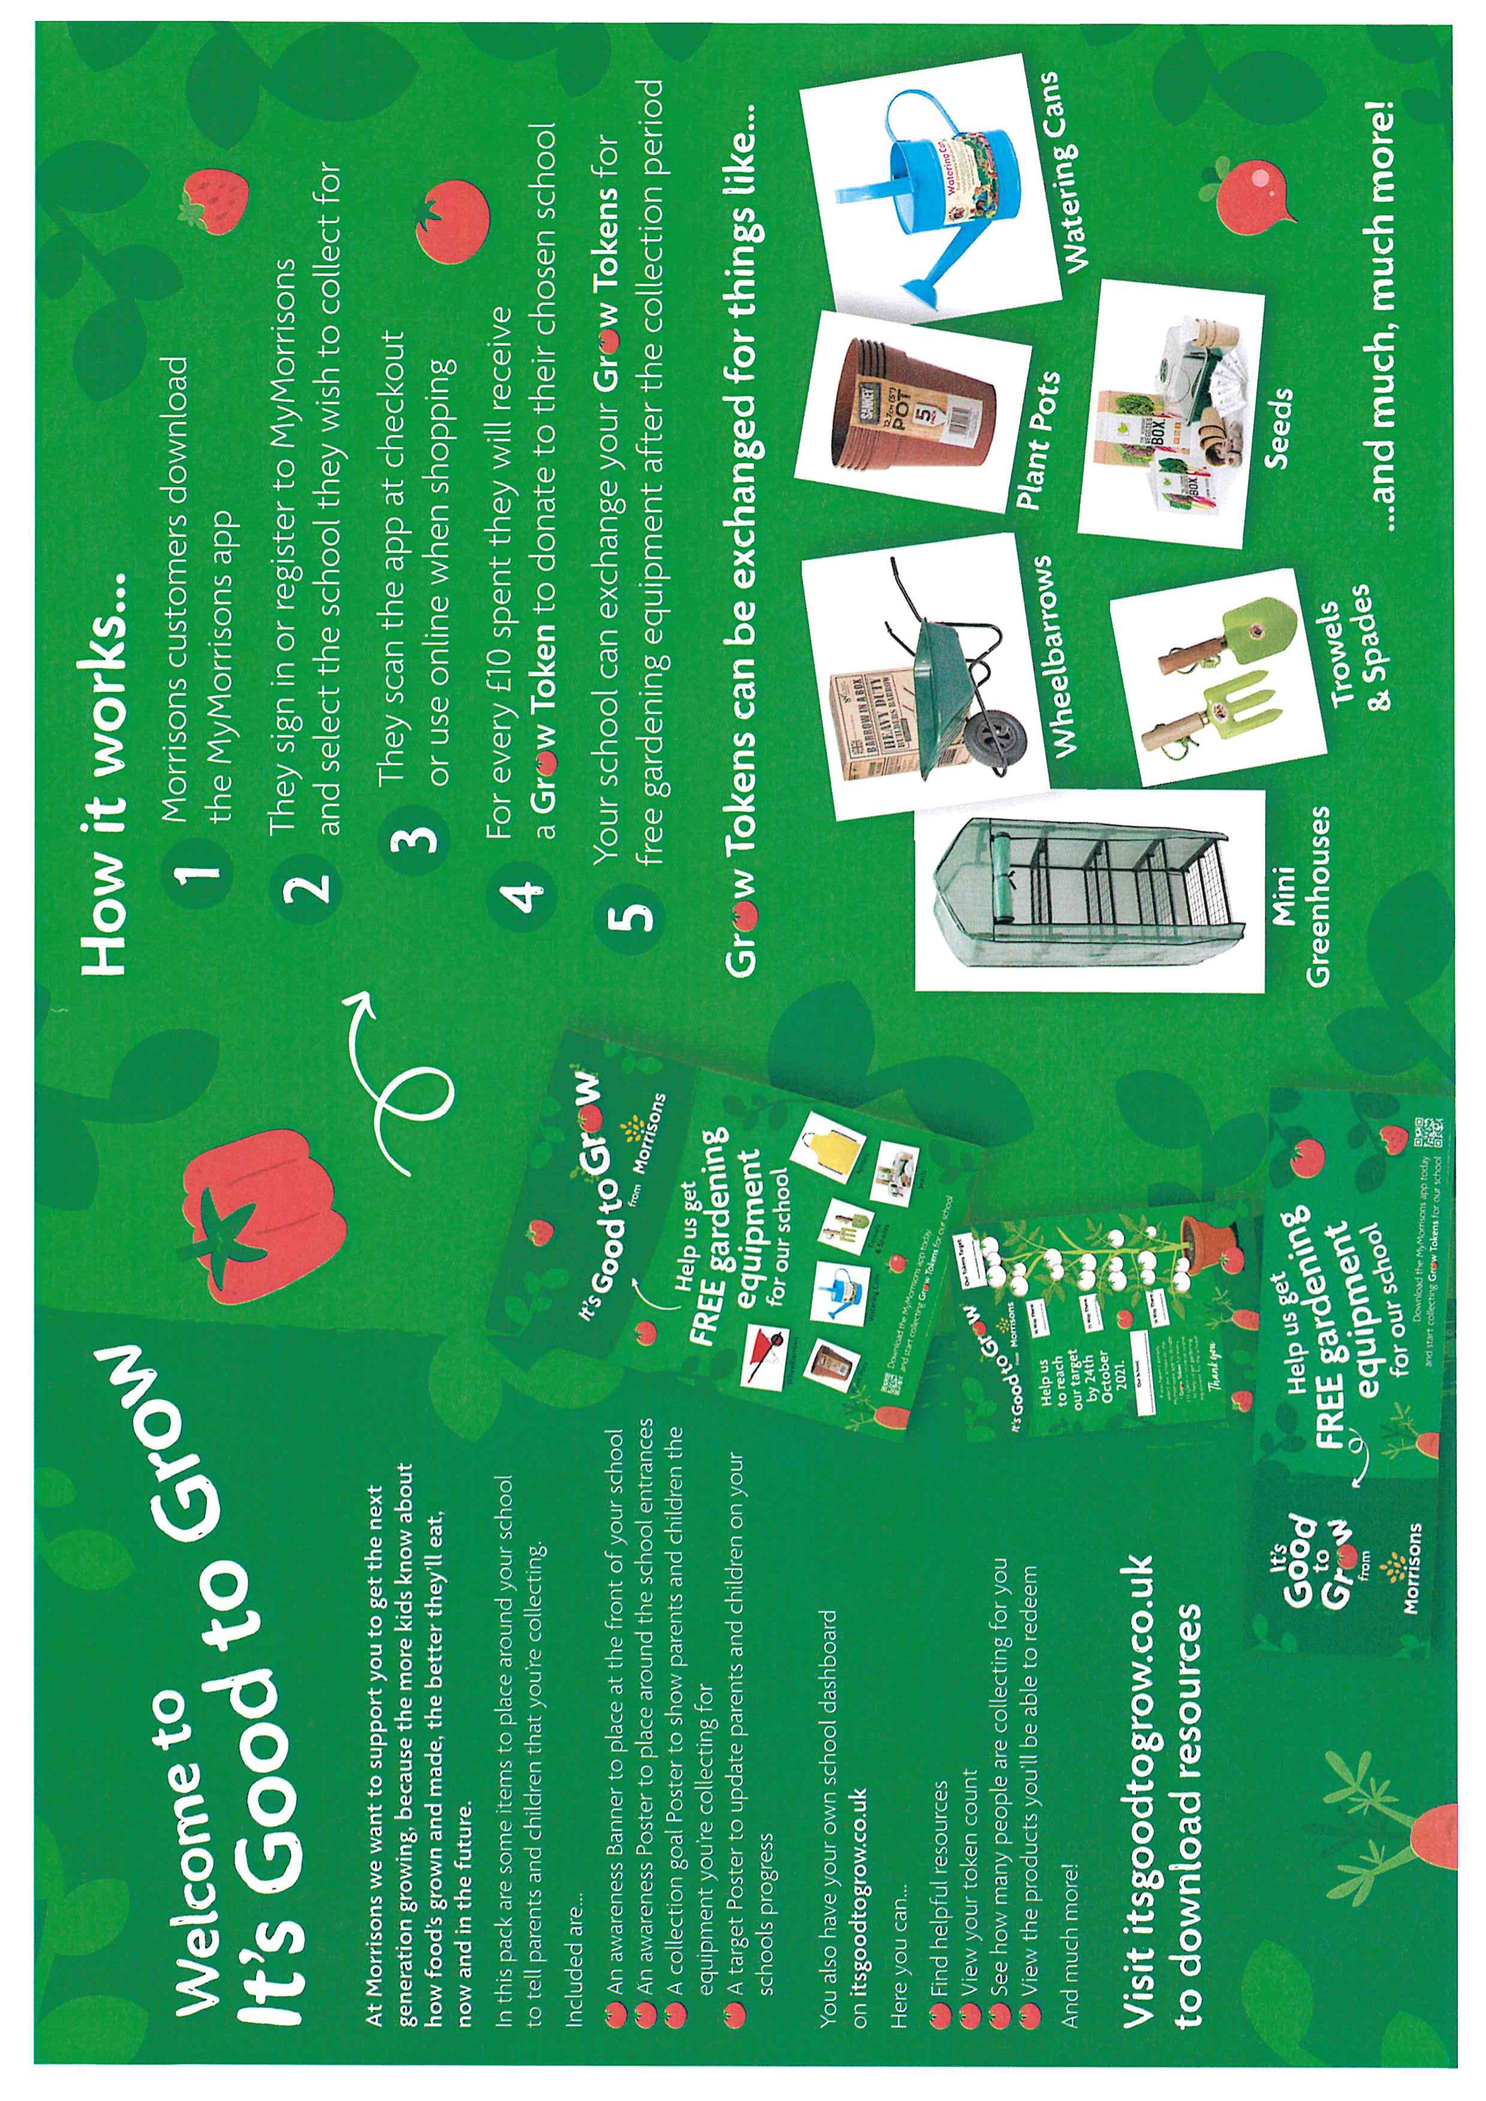
ead Teacher
