Day | Literacy | Maths | Curriculum
Mon | Lesson 1 – Speech Marks and Reporting Clauses  Use the following link: https://www.hamilton-trust.org.uk/blog/learning-home-packs/  > Learning at Home Packs for English  > Year 4 English Week 11  > Year 4 Day 1  Read or listen to the story of ‘Peter and the Wolf’.  Remind yourself about speech marks and reporting clauses using the revision cards or the following link:  https://www.bbc.co.uk/bitesize/articles/zv9hnrd  Add speech marks and a reporting clause to the sentences about Peter and the Wolf.  Spellings:  See spelling list at the bottom of page.  Log in to Purple Mash and complete the spelling quiz in your 2dos.  Grammar Activities:  Here is a comprehensive list of Grammar games to play, just work through the lists if you want something extra to do:  https://www.bbc.co.uk/bitesize/topics/zhrrd2p  https://www.topmarks.co.uk/english-games/7-11-years/spelling-and-grammar | Lesson 1 – Write Decimals  Summer Term Week 8  Click on the following link to watch the lesson presentation:  https://vimeo.com/427995729  Complete the worksheet.  https://resources.whiterosemaths.com/wp-content/uploads/2020/05/Lesson-1-Write-decimals-2020.pdf  Mark and correct your answers.  https://resources.whiterosemaths.com/wp-content/uploads/2020/05/Lesson-1-Answers-Write-decimals-2020.pdf | French – On the Move: We all go together  Follow the power point from the lesson pack below to learn about sentence construction in French. You will learn how to use verbs and pronouns in a sentence.  https://www.twinkl.co.uk/resource/tp2-l-123-planit-french-year-4-on-the-move-lesson-pack-lesson-6-we-all-go-together-french-francais  Use the activities from the resource section of the lesson pack to make sentences with subject verb agreement.  .
Tues | Lesson 2 – Punctuating Speech  Use the following link: https://www.hamilton-trust.org.uk/blog/learning-home-packs/  > Learning at Home Packs for English  > Year 4 English Week 11  > Year 4 Day 2  Using the illustration ‘Duck and Bird’, imagine some speech between the two characters. What might they be arguing about?  Write a paragraph about the story including some direct speech. | Lesson 2 – Compare Decimals  Summer Term Week 8  Click on the following link to watch the lesson presentation:  https://vimeo.com/427995775  Complete the worksheet.  https://resources.whiterosemaths.com/wp-content/uploads/2020/05/Lesson-2-Compare-decimals-2020.pdf  Mark and correct your answers.  https://resources.whiterosemaths.com/wp-content/uploads/2020/05/Lesson-2-Answers-Compare-decimals-2020.pdf | ICT Coding  Log onto Purple Mash and watch the introductory video about coding  https://www.purplemash.com/#tab/pm-home/computing/2code_lessons  Complete the code for the following programs and follow the challenges:  Send a space rocket to space  Catching game
Wed | Lesson 3 – Story ending including speech  Use the following link: https://www.hamilton-trust.org.uk/blog/learning-home-packs/  > Learning at Home Packs for English  > Year 4 English Week 11  > Year 4 Day 3  Using the illustration ‘Procession’, imagine what will happen when the procession reaches the zoo.  Write your ideas down as an ending to the story. Remember to include some direct speech. | Lesson 3 – Order Decimals  Summer Term Week 8  Click on the following link to watch the lesson presentation:  https://vimeo.com/427995825  Complete the worksheet.  https://resources.whiterosemaths.com/wp-content/uploads/2020/05/Lesson-3-Order-decimals-2020.pdf  Mark and correct your answers.  https://resources.whiterosemaths.com/wp-content/uploads/2020/05/Lesson-3-Answers-Order-decimals-2020.pdf | Mountains - Lesson 4 Mountainous Climates  Learn about the weather conditions in different mountainous locations using the power point from the following lesson pack:  https://www.twinkl.co.uk/resource/tp2-g-040-planit-geography-year-5-magnificent-mountains-lesson-5-mountain-climates-lesson-pack  Think about the risks of being in the mountains.  Use the internet to find out the weather forecast in different mountainous locations and record it on the activity sheet from the lesson pack.  Use the following link to find out more about mountainous climates.  http://primaryhomeworkhelp.co.uk/mountains/climate.htm
Thurs | Lesson 4 – Poetry Vocabulary  Use the following link: https://www.hamilton-trust.org.uk/blog/learning-home-packs/  > Learning at Home Packs for English  > Year 4 English Week 11  > Year 4 Day 4  Practise performing the poems aloud.  Read ‘Poetry Vocabulary’ ; try to match the terms and definitions.  Choose one poem to copy out in your neatest handwriting | Lesson 4 – Round Decimals  Summer Term Week 8  Click on the following link to watch the lesson presentation:  https://vimeo.com/427996387  Complete the worksheet.  https://resources.whiterosemaths.com/wp-content/uploads/2020/05/Lesson-4-Round-decimals-2020.pdf  Mark and correct your answers.  https://resources.whiterosemaths.com/wp-content/uploads/2020/05/Lesson-4-Answers-Round-decimals-2020.pdf | Art/Design – Alfred Wainwright  Look at the pictorial map information given below about Eskdale. In particular look at the information circled in red on the diagram. Create a paragraph about Arnside and add this to your pictorial representation of our village. We will keep adding different parts to this picture each week.  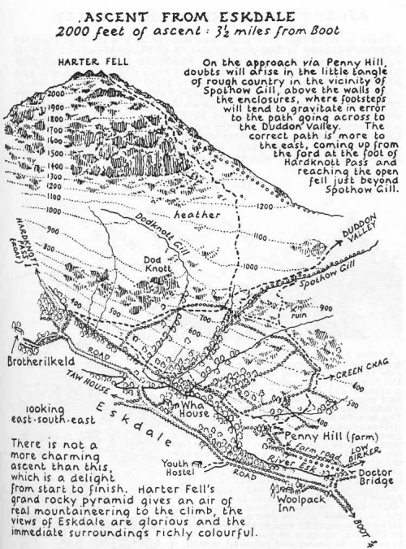
Fri | Lesson 5 – Investigating Poems  Use the following link: https://www.hamilton-trust.org.uk/blog/learning-home-packs/  > Learning at Home Packs for English  > Year 4 English Week 11  > Year 4 Day 5  Use a memory frame to help you memorise the poem ‘Snow’.  Read ‘Summer Days’ and fill in the word table to show the pattern of words.  Have a go at writing your own poem. | Lesson 5 - Maths Mastery  Summer Term Week 8  https://www.twinkl.co.uk/resource/year-4-diving-into-mastery-round-decimals-teaching-pack-t-m-31660  Choose some activities from the above teaching pack, rounding decimals.  OR  Complete the daily maths lesson on BBC Bitesize:  https://www.bbc.co.uk/bitesize/tags/z63tt39/year-4-and-p5-lessons | Arnside Archive  The Arnside Archive Group have invited the people of Arnside to write a diary about your experiences during the Covid-19 Pandemic. Each week the children could write a diary entry for the week. This could be a family diary, photos, pictures, jokes, practical tips etc.  Activity – Write your diary entry for the previous week.

* If the link is tricky to use, try ‘Chrome’ as your web browser as it doesn’t seem to work as well on Internet Explorer.

This Week’s Spellings –: Statutory Words
address
believe
business
complete
different
eighth
experience
increase
island
medicine

