Day | Literacy | Maths | Curriculum
Mon | Lesson 1 – Adverbs of possibility  Use the following link:  https://www.hamilton-trust.org.uk/blog/learning-home-packs/  > Learning at Home Packs for English  > Year 5 English Week 11  > Year 5 Day 1  Read the poem ‘Certainty’ and remind yourself about adverbs of possibility using the revision cards or power point.  Complete the sentences by filling in the missing adverbs of possibility.  Spellings:  See spelling list at the bottom of page.  Log in to Purple Mash and complete the spelling quiz in your 2dos  Grammar Activities:  Here is a comprehensive list of Grammar games to play, just work through the lists if you want something extra to do:  https://www.bbc.co.uk/bitesize/topics/zhrrd2p  https://www.topmarks.co.uk/english-games/7-11-years/spelling-and-grammar | Lesson 1 – Understanding Percentages  Summer Term Week 8  Click on the following link to watch the lesson presentation:  https://vimeo.com/428001381  Complete the worksheet:  https://resources.whiterosemaths.com/wp-content/uploads/2020/05/Lesson-1-Understand-percentages-2019.pdf  Mark and correct your answers:  https://resources.whiterosemaths.com/wp-content/uploads/2020/05/Lesson-1-Answers-Understand-percentages-2019-1.pdf | French – On the Move: We all go together  Follow the power point from the lesson pack below to learn about sentence construction in French. You will learn how to use verbs and pronouns in a sentence.  https://www.twinkl.co.uk/resource/tp2-l-123-planit-french-year-4-on-the-move-lesson-pack-lesson-6-we-all-go-together-french-francais  Use the activities from the resource section of the lesson pack to make sentences with subject verb agreement.
Tues | Lesson 2 – Summarising news stories.  Use the following link:  https://www.hamilton-trust.org.uk/blog/learning-home-packs/  > Learning at Home Packs for English  > Year 5 English Week 11  > Year 5 Day 2  Answer the questions and fill in the summary table about the news stories.  Write a paragraph about Lockdown Inspiration. | Lesson 2 – Percentages as Fractions and Decimals.  Summer Term Week 8  Click on the following link to watch the lesson presentation:  https://vimeo.com/428001420  Complete the worksheet:  https://resources.whiterosemaths.com/wp-content/uploads/2020/05/Lesson-2-Percentages-as-fractions-and-decimals-2019.pdf  Mark and correct your answers:  https://resources.whiterosemaths.com/wp-content/uploads/2020/05/Lesson-2-Answers-Percentages-as-fractions-and-decimals-2019.pdf  . | ICT Coding  Log onto Purple Mash and watch the introductory video about coding  https://www.purplemash.com/#tab/pm-home/computing/2code_lessons  Complete the code for the following programs and follow the challenges:  Send a space rocket to space  Catching game
Wed | Lesson 3 – Relative Clauses: Street Art  Use the following link:  https://www.hamilton-trust.org.uk/blog/learning-home-packs/  > Learning at Home Packs for English  > Year 5 English Week 11  > Year 5 Day 3  .Look closely at ‘Game Changer’ by Banksy and answer the questions.  Remind yourself about relative clauses using the power point, revision cards or the following link:  https://www.bbc.co.uk/bitesize/articles/z6g98xs  . | Lesson 3 – Adding decimals with the same number of decimal place  Summer Term Week 8  Click on the following link to watch the lesson presentation:  https://vimeo.com/428001477  Complete the worksheet:  https://resources.whiterosemaths.com/wp-content/uploads/2020/05/Lesson-3-Adding-decimals-with-the-same-number-of-decimal-places-2020.pdf  Mark and correct your answers:  https://resources.whiterosemaths.com/wp-content/uploads/2020/05/Lesson-3-Answers-Adding-decimals-with-the-same-number-of-decimal-places-2020.pdf | Mountains - Lesson 4 Mountainous Climates  Learn about the weather conditions in different mountainous locations using the power point from the following lesson pack:  https://www.twinkl.co.uk/resource/tp2-g-040-planit-geography-year-5-magnificent-mountains-lesson-5-mountain-climates-lesson-pack  Think about the risks of being in the mountains.  Use the internet to find out the weather forecast in different mountainous locations and record it on the activity sheet from the lesson pack.  Use the following link to find out more about mountainous climates.  http://primaryhomeworkhelp.co.uk/mountains/climate.htm
Thurs | Lesson 4 – Poetry Questions  Use the following link: https://www.hamilton-trust.org.uk/blog/learning-home-packs/  > Learning at Home Packs for English  > Year 5 English Week 11  > Year 5 Day 4  Look at the images. Think of a story that could connect them all.  Read ‘The Great Realisation’ and answer the questions. | Lesson 4 – Adding decimals with a different number of decimal place  Summer Term Week 8  Click on the following link to watch the lesson presentation:  https://vimeo.com/428001528  Complete the worksheet:  https://resources.whiterosemaths.com/wp-content/uploads/2020/05/Lesson-4-Adding-decimals-with-a-differen-number-of-decimal-places-2020.pdf  Mark and correct your answers:  https://resources.whiterosemaths.com/wp-content/uploads/2020/05/Lesson-4-Answers-Adding-decimals-with-a-differen-number-of-decimal-places-2020.pdf | Art/Design – Alfred Wainwright  Look at the pictorial map information given below about Eskdale. In particular look at the information circled in red on the diagram. Create a paragraph about Arnside and add this to your pictorial representation of our village. We will keep adding different parts to this picture each week.  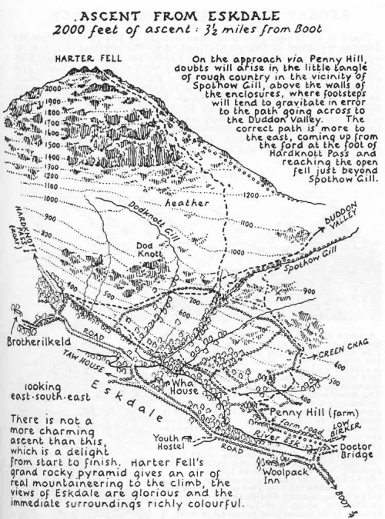
Fri | Lesson 5 – What Kind of Future?  Use the following link:  https://www.hamilton-trust.org.uk/blog/learning-home-packs/  > Learning at Home Packs for English  > Year 5 English Week 11  > Year 5 Day 5  Use the Sorting Table to note down all the positive and negative images and ideas that you can find in ‘The Great Realisation’.  Think about your hopes for the future of the world and plan a letter to your MP, Tim Farron. | Lesson 5 –  Summer Term Week 8  https://www.twinkl.co.uk/resource/year-5-diving-into-mastery-adding-decimals-with-a-different-number-of-decimal-places-teaching-pack-t-m-31734  Choose some activities from the above teaching pack, adding decimals with a different number of decimal places.  OR  Complete the daily maths lesson on BBC Bitesize:  https://www.bbc.co.uk/bitesize/tags/zhgppg8/year-5-and-p6-lessons | Arnside Archive  The Arnside Archive Group have invited the people of Arnside to write a diary about your experiences during the Covid-19 Pandemic. Each week the children could write a diary entry for the week. This could be a family diary, photos, pictures, jokes, practical tips etc.  Activity – Write your diary entry for the previous week.

This week’s spellings - Statutory Words
physical
variety
system
rhyme
ancient
category
develop
occupy
muscle
suggest

