Speed & Agility Test Recording Sheet.
Exercise Task | Time 1. | Time 2.
T Agility Test
Sideways Step Over Drill.
Lateral Double Leg Hurdle Jumps.
Sprints & Backward Runs.
Star Flip Cone Drill.
Traditional W Drill.
Bob, Weave and Jump Test.

T Agility Test
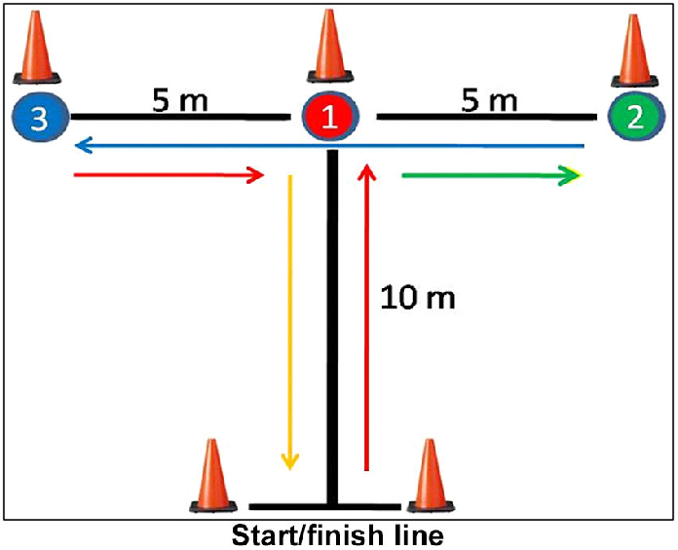

Time each player from start to finish. Set off to cone 1, then sideways to cone 2, sideways to cone 3, sideways back to cone 1 and then backwards to the finish. Have a warm up go, then 2 timed goes.
Sideways step over drill.
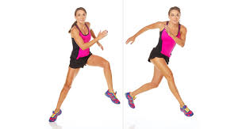
Step over each cone sideways, there and back 6 times. Time the run from start to finish. Have a warm up go then 2 timed goes.

Lateral Double Leg Hurdle Jumps.
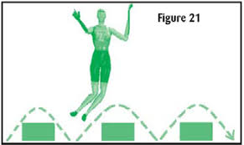
Jump sideways over hurdles, 10 hurdles, time from start to finish. Have a warm up go, then 2 timed goes.

Sprints & backward runs.
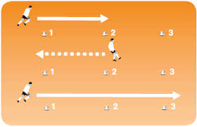
Sprint to cone and then back, then sprint to next furthest cone and back and so on. Time the runs. Have a warm up go, then 2 timed goes.

Star flip cone drill.
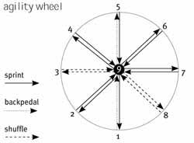
Run to each cone and flip it over, back to the centre and back to flip the next cone until all are flipped over. Have a warm up go, then 2 timed goes. Number of cones 10.
Traditional W Run Drill.
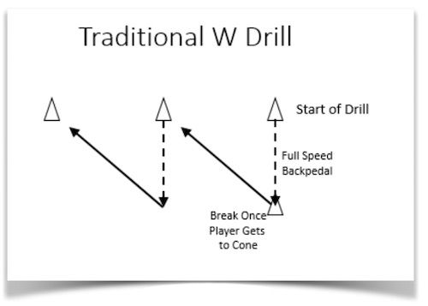
Run backwards, fast, around the cone and sprint diagonally to nest cone. Time the runs until the athlete finishes. Have a warm up go, then 2 timed goes.

Bob, Weave and Jump Test.
Set up a start line and finish line. Place 8 poles in pairs 3m apart randomly set at various places between the start and finish lines. Between each pole attach a hoop approximately 4 feet from the ground, the athlete must bob and weave between the poles and the hoops, and also the cones on the ground dotted about. Attach hoops with tape. Have a warm up go, then 2 timed goes.

