Teaching safeguarding through Physical Education at Arnside National Primary School.

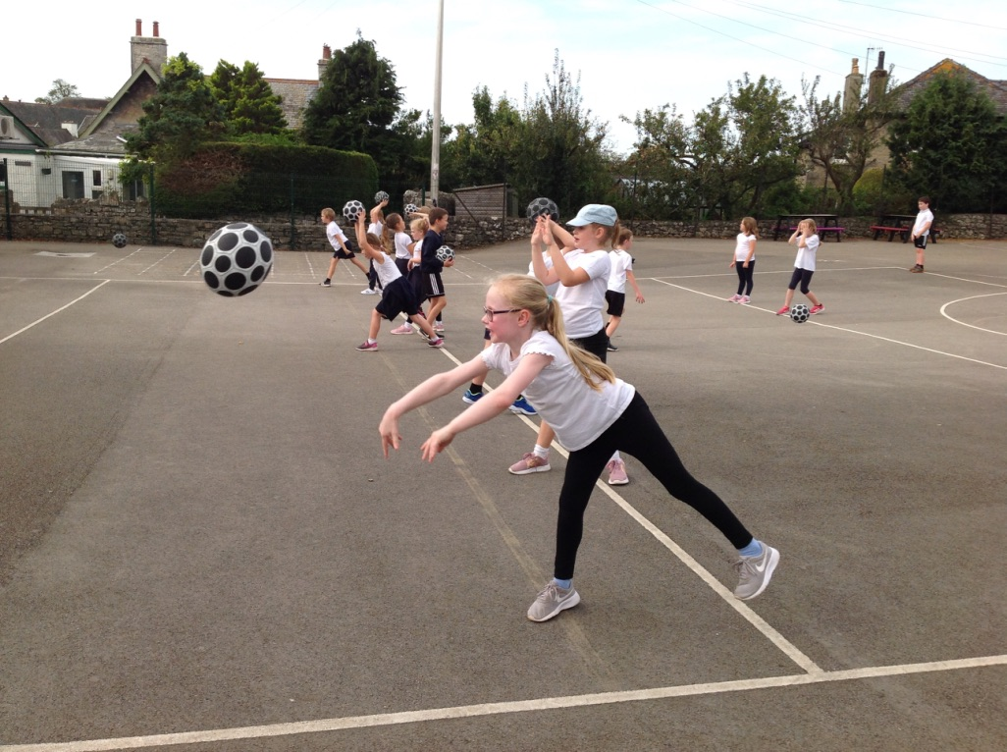

At Arnside School , through our PE curriculum we support children to…
- understand the importance of keeping healthy/well-being/physically and mentally
- recognise that everyone is different and the importance of developing a positive body image
- move safely and apply skills in a physical space with an awareness of others
- show respect to all referees and judges and staff who are making decisions based on their observations and knowledge
- set personal goals and encourage others to achieve theirs
- work in teams and encourage others to play a positive role in games physical challenges
- select team members fairly and be inclusive to everyone
- develop positive self-care and organisational skills
- manage emotions including anger and disappointment when not being able to
win.
- Be consistent and fair with praise, feedback, behavioural expectations and progress expectations.
- All children will receive appropriate support which meets their needs.
- Children should be active partners in the process of creating a culture of respect, tolerance and behavioural expectations and understand how to react to challenging inappropriate behaviours and know they can trust their teacher to listen to and support them.
- As recommended by the latest (September 2022 KCSIE Guidance) we use a `child centred and coordinated approach to safeguarding’

Safeguarding considerations for getting changed at school.

As a school we have a duty to protect the children and young people in their care. This should include putting measures in place to make sure children and young people feel comfortable and are safe when getting changed for physical education (PE), drama and other activities.
Some of the children at Arnside come to school ready changed for PE whilst others get changed in classrooms or designated changing areas, after year 2 boys and girls have separate changing areas. Male and Female members of staff will only enter the same gender changing areas if necessary.

Remain Vigilant During PE Lessons.

“Sport should be a positive and safe experience, regardless of age and ability. It should not involve conduct or practices that cause emotional or sexual harm. It should not cause physical harm beyond unavoidable hazards. Keeping participants safe requires everyone engaging in sport to maintain appropriate standards of behaviour.”
The Whyte Review, 2022.

PE teachers need to ensure that pupils are safeguarded from each other during lessons. In a large or outdoors area, it might not be possible for you to hear and see everything that is going on all the time, but peer-on-peer abuse, including physical and verbal abuse, may take place in PE lessons.

To help negate this issue, ensure that pupils are working in groups that they are comfortable in, and position yourself so that you can see as many of the pupils as possible all of the time. Work around the whole group to ensure that you are visible, and address any issues which are reported to you immediately.
Ensure that everyone in your class knows what is considered acceptable conduct and behaviour in PE lessons, and what is not acceptable.
Apply practices and codes of conduct that are in line with what the school is advocating. Communicate with other staff members to keep updated on behaviours and needs of the class, group or individuals so that measures can be applied which improve outcomes for all children.

A PE teacher should have a deep awareness and understanding of safeguarding procedures is imperative to the safety and wellbeing of pupils, and it is vital that all staff members understand the different types of abuse that may occur in PE lessons. Any concerns about safeguarding in PE will be discussed with the lead safeguarding person in school.

In PE the teacher may keep a particular eye on children who are young carers, fostered, new in school, persistently absent form school, have physical difficulties or returned to their family from care. This isn’t an exclusive list but just an example of children who perhaps will need more support and consequently more attention in regards to groupings, targets and lesson tasks.

