Class Two Show and Tell Blog Schedule - AT 1
Friday 18th September | Friday 25th September | Friday 2nd October | Friday 9th October | Friday 16th October
Joe  Alfred  Isobel  Danny  Izzy | Felix  Orla  Evan  Alfie  Katy | Elsie  George  Katy  Millie  Layla | Charlie  Eva  Charlotte  Barney  Ivy | Nikau  Kyelan  Felicity  Esme  Flo

How to access the Class Two Show and Tell blog
Step 1. Login and find the tool bar at the top right

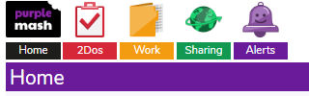

Step 2. Click on ‘Sharing’ and then ‘Shared Blogs’
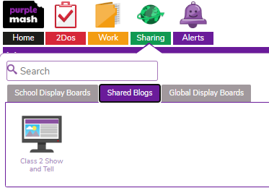
You should see this…
Step 3. Click the green plus on the top right.
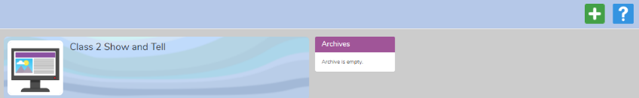

Step 4. Fill in the Title box with your child’s name and then click on the Content box.
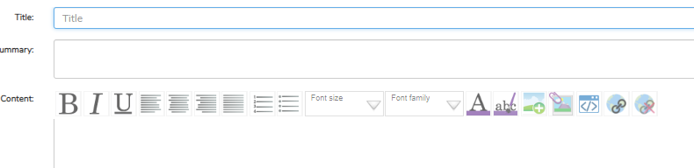
Step 5. Add an image or video.
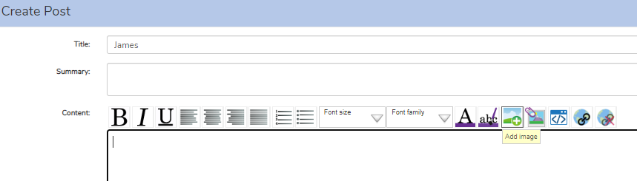
It will appear in the content box.
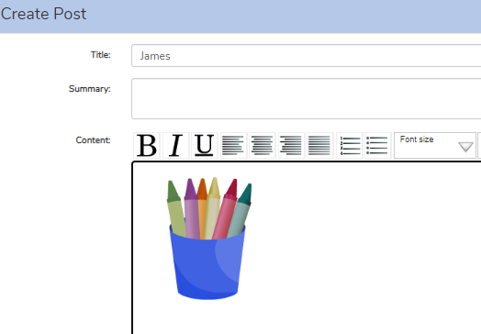

Step 6. Click the purple, save and publish button on the right at the bottom.
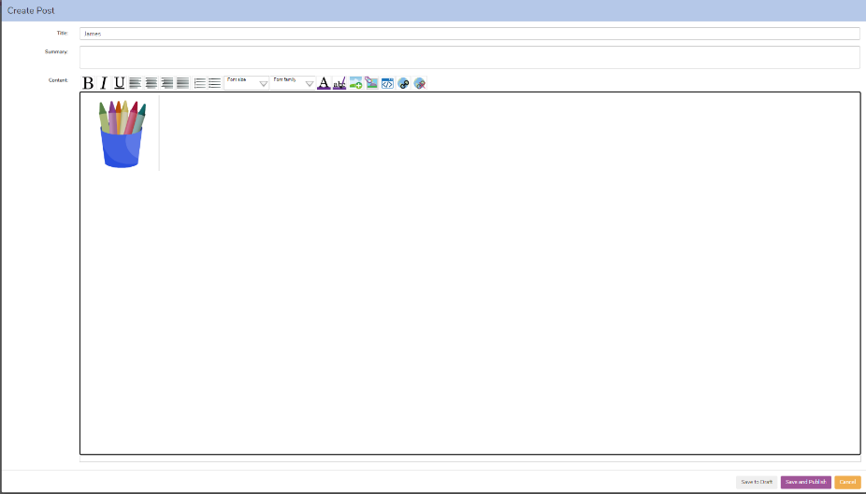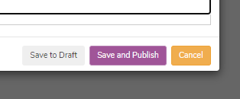
You should see your child’s post waiting for my approval.
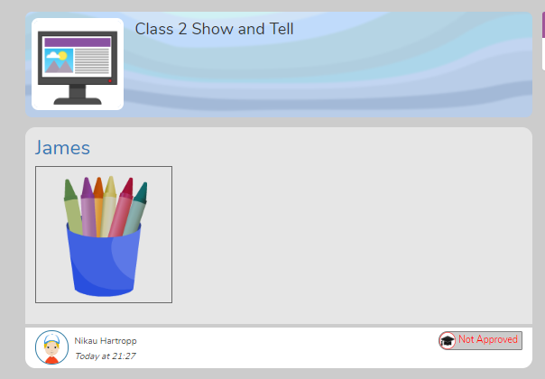

Let me know if you have any questions!
Mrs Hartropp

