Class Two Show and Tell Blog Schedule – Spring-Summer
Friday 19th March | Friday 26th March | Friday 23rd April | Friday 30th April | Friday 7th May
Felix  Orla  Evan  Alfie  Mahlia | Elsie  George  Millie  Layla  Katy | Charlie  Eva  Charlotte  Barney  Ivy | Felicity  Nikau  Esme  Flo  Izzy | Joe  Alfred  Isobel  Danny
How to access the Class Two Show and Tell blog
Step 1. Login and find the tool bar at the top right

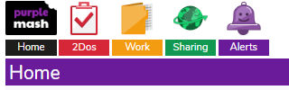

Step 2. Click on ‘Sharing’ and then ‘Shared Blogs’
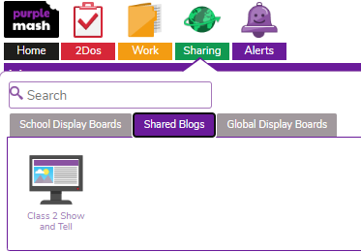
You should see this…
Step 3. Click the green plus on the top right.
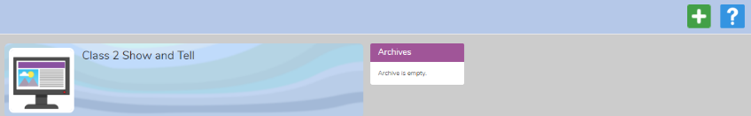

Step 4. Fill in the Title box with your child’s name and then click on the Content box.
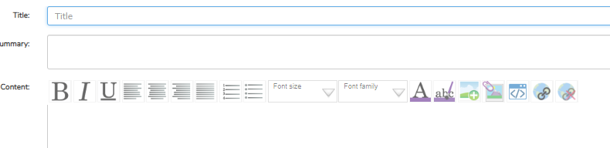
Step 5. Add an image or video.
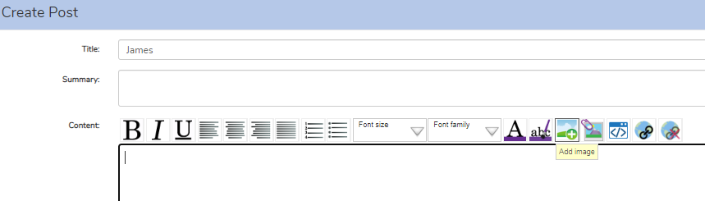
It will appear in the content box.
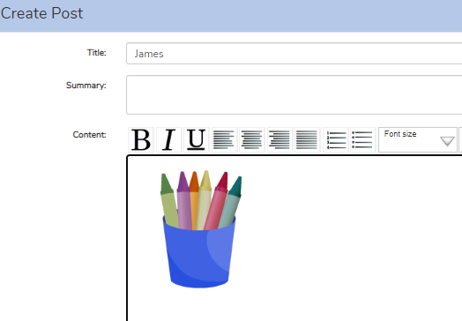

Step 6. Click the purple, save and publish button on the right at the bottom.
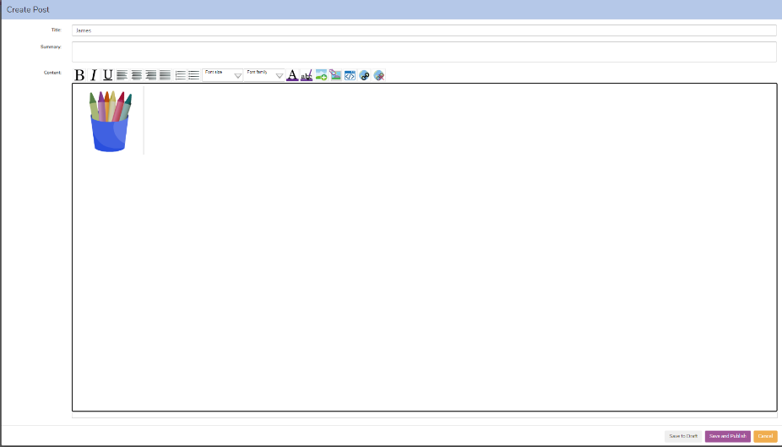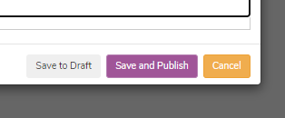
You should see your child’s post waiting for my approval.
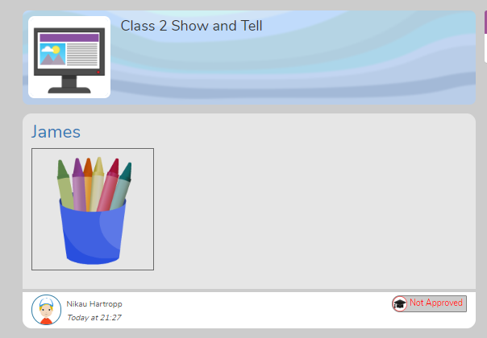

Let me know if you have any questions! 😊
Mrs Hartropp

