Week 13-w/b 13.7.20
Year 1/2
Day | Literacy | Maths | Curriculum
Mon | Choose a Literacy starter…  10:30 – Y1 Phonics  OR Reading Comprehension (Choose from the selection)  *Some texts have different levels of questions (1 star, 2 stars and 3 stars, easy, medium or harder). If your child reads the text confidently, try the harder level. If your child needs support to read the text, try the easier level.  Literacy  Choice 1: What the ladybird heard at the seaside  Choice 2: Riddles  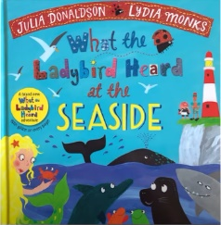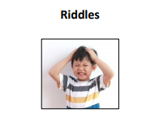  What the ladybird heard at the seaside  https://www.youtube.com/watch?v=PvguZ1YvKLw  *Parents – All resources and worksheets are in the resources folder. | Option 1: Design your own Snakes and Ladders game (see resource in the Maths folder)  Option 2:  Year 1 – Watch the video (click from links page) and then ‘Time to the hour’, worksheet.  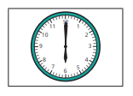  Year 2 – Watch the video (click from links page) and then ‘Telling time to 5 minutes’, worksheet.  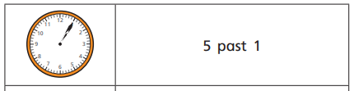  *Parents - There are video links for each lesson and worksheets saved in the resources folder. | Science – When and how was space discovered?  Science Lesson with Miss Emms from the National Oak Academy  https://classroom.thenational.academy/lessons/when-and-how-was-space-discovered  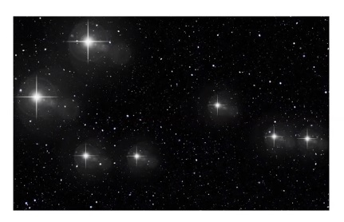  Extra activities in the resources folder…  - Space crossword puzzle  - Solar system code breaker  - Solar system wordsearch  - Design your own planet
Tues | Choose a Literacy starter…  10:30 – Y1 Phonics  OR Reading Comprehension (Choose from the selection)  Literacy  Choice 1: What the ladybird heard at the seaside  Choice 2: Magic Spells  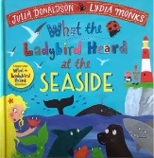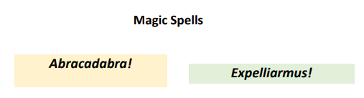  *Parents – All resources and worksheets are in the resources folder. | Option 1: Towers of Hanoi puzzle game (see resource in the Maths folder)  Option 2:  Year 1 – Watch the video (click from links page) and then ‘Time to the half hour’, worksheet  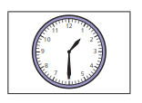  Year 2 – Watch the video (click from links page) and then ‘Hours and Days’, worksheet.  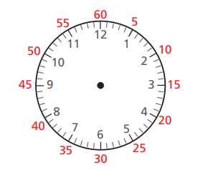  *Parents - There are video links for each lesson and worksheets saved in the resources folder. | Music  Charanga – Yumu  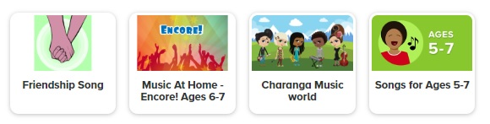  *Please continue your learning, if you have completed the Friendship package, there are three more packages to access!
Wed | Choose a Literacy starter…  10:30 – Y1 Phonics  OR Reading Comprehension (Choose from the selection)  Literacy  Choice 1: What the ladybird heard at the seaside  Choice 2: Jokes  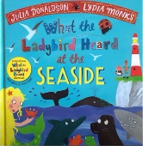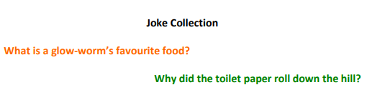  *Parents – All resources and worksheets are in the resources folder. | Option 1: Pelmanism (pairs) game (see resource in the Maths folder)  Option2:  Year 1 – Watch the video (click from links page) and then ‘Writing time’, worksheet.  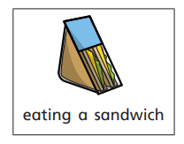  Year 2 – Watch the video (click from links page) and then ‘Find durations of time’, worksheet.  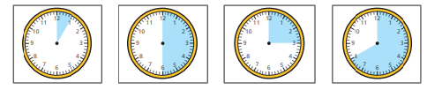  *Parents - There are video links for each lesson and worksheets saved in the resources folder. | P.E. Sock Wars  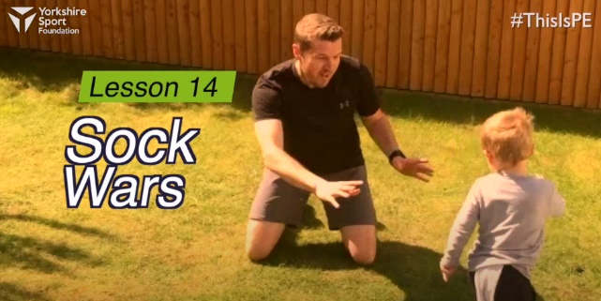  https://www.youtube.com/watch?v=TUA9CqMxI8k&list=PLYGRaluWWTojV3An2WEgsQ4qGFy_91jDL&index=15  Watch this demonstration and then give it a go!  You will need a partner, some socks of different lengths and some soft toys
Thurs | Choose a Literacy starter…  10:30 – Y1 Phonics  OR Reading Comprehension (Choose from the selection)  Literacy  Choice 1: What the ladybird heard at the seaside  Choice 2: What’s My Meaning?  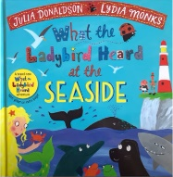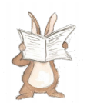  *Parents – All resources and worksheets are in the resources folder. | Option 1: Pascal’s Triangle Investigation (see resource in the Maths folder)  Option 2:  Year 1 – Watch the video (click from links page) and then ‘comparing time’, worksheet.  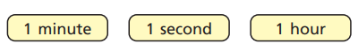  Year 2 – Watch the video (click from links page) and then ‘Compare durations of time’, worksheet.  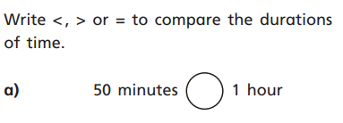  *Parents - There are video links for each lesson and worksheets saved in the resources folder. | Geography – Rio de Janeiro, Brazil, South American OR Antarctica  https://www.bbc.co.uk/bitesize/topics/zyhp34j/articles/zr2h47h  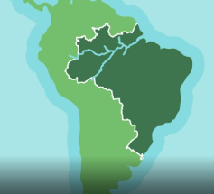  Rio de Janeiro is a city in Brazil, the biggest country in South America. The country of Brazil is nearly as big as the continent of Europe!  https://www.bbc.co.uk/bitesize/topics/zyhp34j/articles/zjg46v4  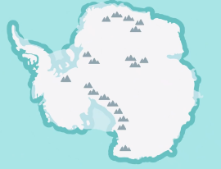  Antarctica is a desert - but it's not hot, it's really, really cold. It's called a desert because it hardly ever rains. The South Pole is near the middle of Antarctica. That's the very bottom of the planet. In parts of Antarctica the winter temperature can be minus 60°C.
Fri | Choose a Literacy starter…  10:30 – Y1 Phonics  OR Reading Comprehension (Choose from the selection)  Literacy  Choice 1: What the ladybird heard at the seaside  Choice 2: Crosswords and Palindromes  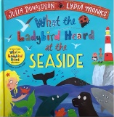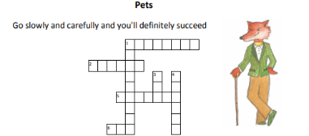  *Parents – All resources and worksheets are in the resources folder. | Play TT Rock stars and then….  Free Choice Maths | Art – Explore the technique of blending  Art with Miss Harris…  https://classroom.thenational.academy/lessons/to-explore-the-technique-of-blending-f66dc4  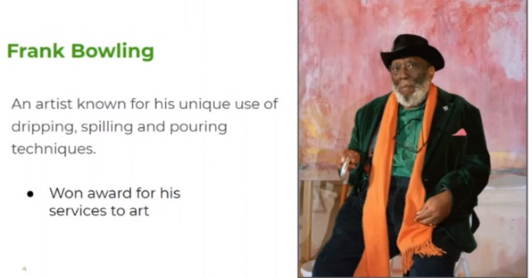  You will need…  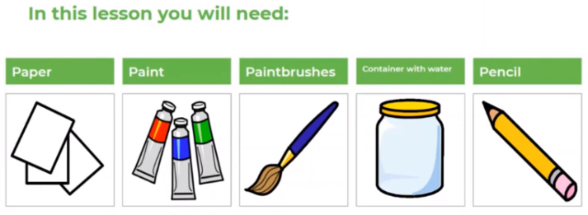
Lessons in red have resources to go with them, uploaded to our class page on the school website.
https://www.arnside.cumbria.sch.uk/classes/year-1-2

