Week 10-w/b 22.6.20
Year 1/2
Day | Literacy | Maths | Curriculum
Mon | Spelling – The spelling words are in the resources file. Can you write your spelling words out?  10:30 – Y1 Phonics  OR Reading Comprehension (Choose from the selection)  *Some texts have different levels of questions (1 star, 2 stars and 3 stars, easy, medium or harder). If your child reads the text confidently, try the harder level. If your child needs support to read the text, try the easier level.  Literacy  Choice 1: Commotion in the Ocean (Poetry) OR  Choice 2: Wombats (Non-Fiction)  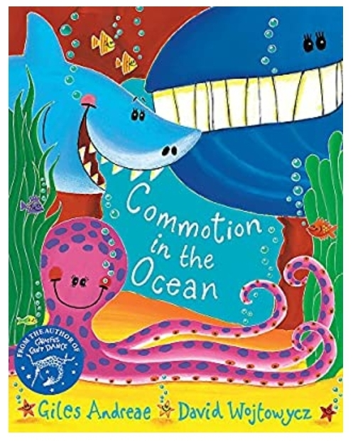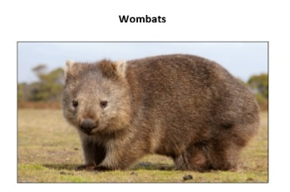  A Commotion in the Ocean  https://www.youtube.com/watch?v=9pRhgZ8Jffs  *Parents – All resources and worksheets are in the resources folder. | Year 1 – Watch the video (click from links page) and then ‘Make arrays’, worksheet.  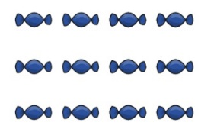  Year 2 – Watch the video (click from links page) and then ’10 times-table’, worksheet.  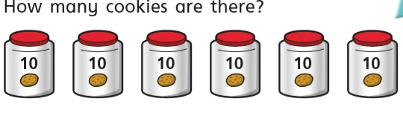  *Parents - There are video links for each lesson and worksheets saved in the resources folder. | Science – What are the planets in our solar system?  Science Lesson with Miss Emms from the National Oak Academy  https://classroom.thenational.academy/lessons/what-are-the-planets-in-our-solar-system  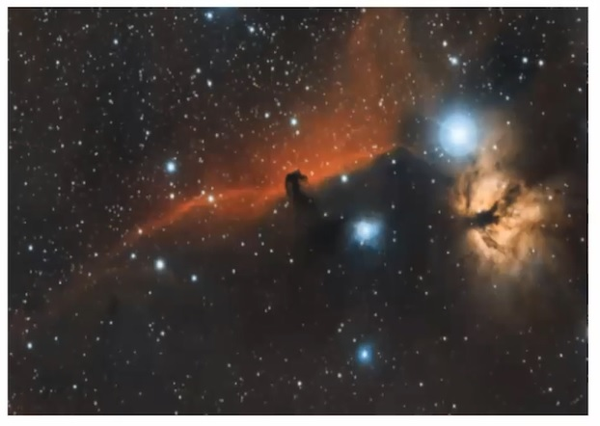  *Please note this is a lesson for Year 2, however, Year 1 children should enjoy this lesson also.
Tues | Handwriting  Joining words with oc diagraph, write 1 line of each word.  clock, block, sock, tock, flock  10:30 – Y1 Phonics  OR Reading Comprehension (Choose from the selection)  Choice 1: Commotion in the Ocean (Poetry) OR  Choice 2: Diary of a Wombat  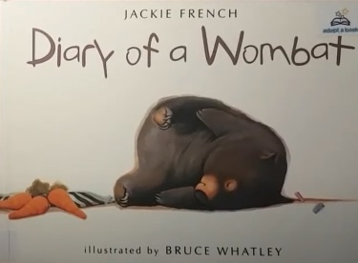  *Parents – All resources and worksheets are in the resources folder. | Year 1 – Watch the video (click from links page) and then ‘Make doubles’, worksheet  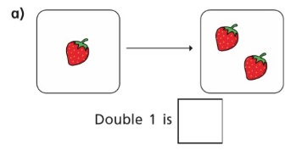  Year 2 – Watch the video (click from links page) and then ‘Make equal groups (sharing)’, worksheet.  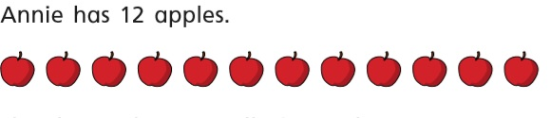  *Parents - There are video links for each lesson and worksheets saved in the resources folder. | Music  Charanga – Yumu  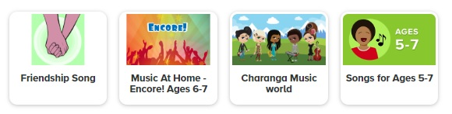  *Please continue your learning, if you have completed the Friendship package, there are three more packages to access!
Wed | Spelling – Word Search  10:30 – Y1 Phonics  OR Reading Comprehension (Choose from the selection)  Literacy - Choice 1: The Singing Mermaid OR  Choice 2: Diary of a Wombat  *Parents – All resources and worksheets are in the resources folder. | Lesson 3  Year 1 – Watch the video (click from links page) and then ‘Make equal groups (sharing)’, worksheet.  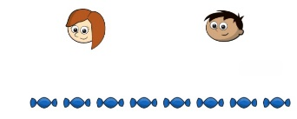  Year 2 – Watch the video (click from links page) and then ‘Make equal groups (grouping)’, worksheet.  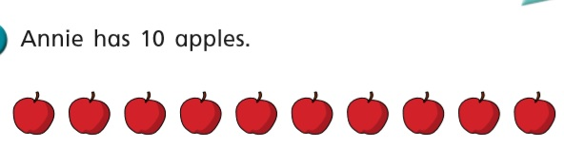  *Parents - There are video links for each lesson and worksheets saved in the resources folder. | P.E. Catching  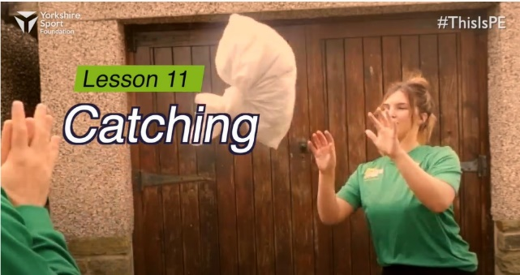  https://www.youtube.com/watch?v=NDZhgfrmogA  Watch this demonstration and then give it a go!  You will need, rolled up socks and a pillowcase of socks
Thurs | Handwriting – Spelling handwriting  10:30 – Y1 Phonics  OR Reading Comprehension (Choose from the selection)  Literacy - Choice 1: Commotion in the Ocean OR  Choice 2: Diary of a Wombat (2nd version)  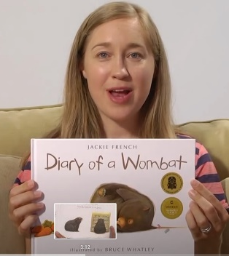  *Parents – All resources and worksheets are in the resources folder. | Year 1 – Watch the video (click from links page) and then ‘Make equal groups (grouping)’, worksheet.  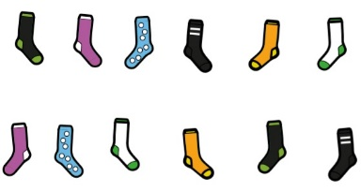  Year 2 – Watch the video (click from links page) and then ‘Odd and even numbers’, worksheet.  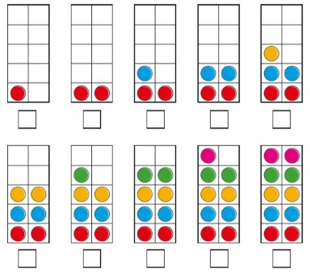  *Parents - There are video links for each lesson and worksheets saved in the resources folder. | Geography - Nigeria  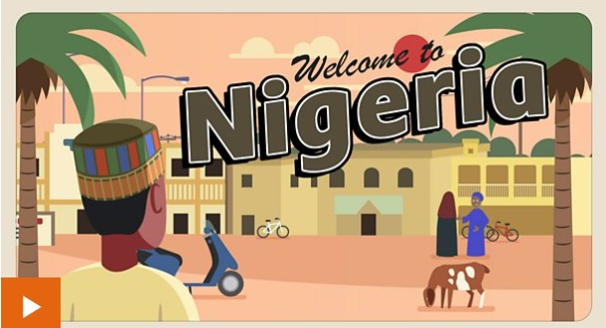  https://www.bbc.co.uk/bitesize/topics/zyhp34j/articles/znxp92p  Nigeria is a country in Africa. Africa is the second biggest continent in the world.  If you look closely at a map of Africa you will count over 40 countries!  Nigeria is four times the size of the UK and lots of young people and children live there.  Nigeria has some amazing places. There are busy cities, tropical rainforests, and river deltas full of crabs, fish, hippos and butterflies.
Fri | Spelling – Ask you Mum or Dad to test you, you can do it by saying it out loud or writing it down.  This Photo by Unknown Author is licensed under CC BY-SA-NC  10:30 – Y1 Phonics  OR Reading Comprehension (Choose from the selection)  Literacy - Choice 1: Commotion in the Ocean OR  Choice 2: Diary of a Kangaroo  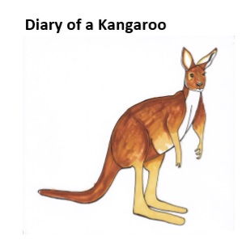  *Parents – All resources and worksheets are in the resources folder. | Play TT Rock stars and then….  Free Choice Maths | Art – Investigate Warm and Cool Colours  Art with Miss Harris…  https://classroom.thenational.academy/lessons/to-investigate-warm-and-cool-colours-04a169  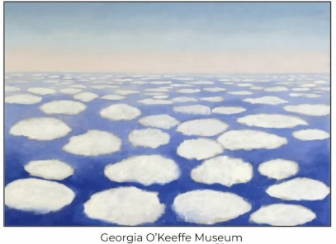  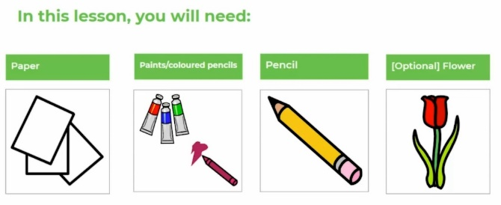
Lessons in red have resources to go with them, uploaded to our class page on the school website.
https://www.arnside.cumbria.sch.uk/classes/year-1-2

