Week 11-w/b 22.6.20
Year 1/2
Day | Literacy | Maths | Curriculum
Mon | Spelling – The spelling words are in the resources file. Can you write your spelling words out?  10:30 – Y1 Phonics  OR Reading Comprehension (Choose from the selection)  *Some texts have different levels of questions (1 star, 2 stars and 3 stars, easy, medium or harder). If your child reads the text confidently, try the harder level. If your child needs support to read the text, try the easier level.  Literacy  Choice 1: Barry the fish with fingers  Choice 2: Maise and the Dragon  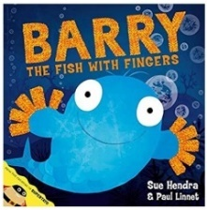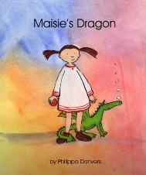  Barry the fish with fingers  https://www.youtube.com/watch?v=5yQPruodTjM  *Parents – All resources and worksheets are in the resources folder. | Year 1 – Watch the video (click from links page) and then ‘Counting to 100’, worksheet.  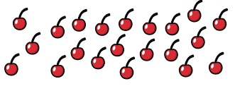  Year 2 – Watch the video (click from links page) and then ’Count sides and vertices on 2D shapes’, worksheet.  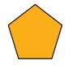  *Parents - There are video links for each lesson and worksheets saved in the resources folder. | Science – How does the Earth orbit and rotate?  Science Lesson with Miss Emms from the National Oak Academy  https://classroom.thenational.academy/lessons/how-does-the-earth-orbit-and-rotate  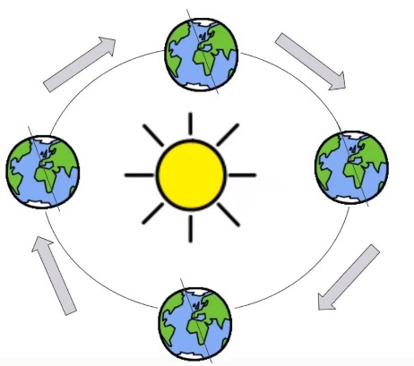  *Please note this is a lesson for Year 2, however, Year 1 children should enjoy this lesson also.
Tues | Handwriting  Joining words with s, write 1 line of each word.  sat, sip, so, some, star, stand  10:30 – Y1 Phonics  OR Reading Comprehension (Choose from the selection)  Choice 1: Barry the fish with fingers OR  Choice 2: Maise and the Dragon  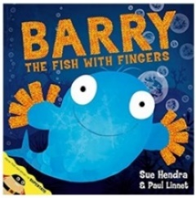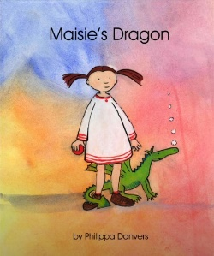  *Parents – All resources and worksheets are in the resources folder. | Year 1 – Watch the video (click from links page) and then ‘Partitioning Numbers’, worksheet  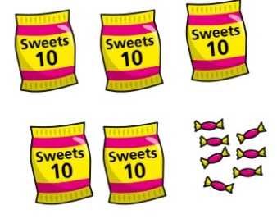  Year 2 – Watch the video (click from links page) and then ‘Count faces, edges and vertices on 3D shapes’, worksheet.  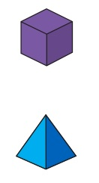  *Parents - There are video links for each lesson and worksheets saved in the resources folder. | Music  Charanga – Yumu  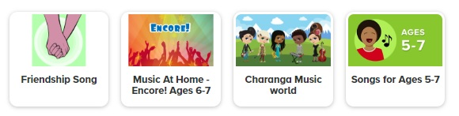  *Please continue your learning, if you have completed the Friendship package, there are three more packages to access!
Wed | Spelling – Word Search  10:30 – Y1 Phonics  OR Reading Comprehension (Choose from the selection)  Literacy - Choice 1: Barry the fish with fingers OR  Choice 2: Dogger  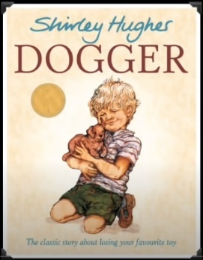  *Parents – All resources and worksheets are in the resources folder. | Lesson 3  Year 1 – Watch the video (click from links page) and then ‘Comparing numbers’, worksheet.  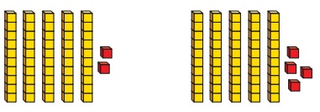  Year 2 – Watch the video (click from links page) and then ‘Sort 2D and 3D shapes’, worksheet.  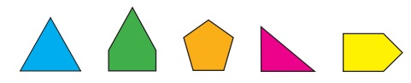  *Parents - There are video links for each lesson and worksheets saved in the resources folder. | P.E. Agility and Throws  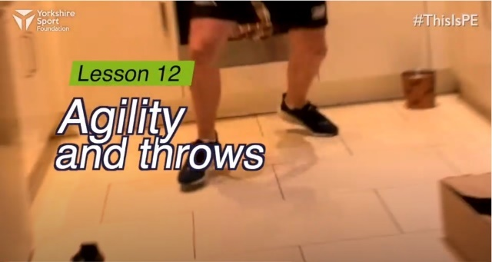  https://www.youtube.com/watch?v=gRRnI3vB1WI  Watch this demonstration and then give it a go!  You will need, 4 containers/boxes to create a square for Agility Box and also socks that need to be matched.
Thurs | Handwriting – Spelling handwriting  10:30 – Y1 Phonics  OR Reading Comprehension (Choose from the selection)  Literacy - Choice 1: Barry the fish with fingers OR  Choice 2: Dogger  *Parents – All resources and worksheets are in the resources folder. | Year 1 – Watch the video (click from links page) and then ‘Comparing numbers (2)’, worksheet.  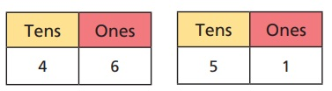  Year 2 – Watch the video (click from links page) and then ‘Merge 2D and 3D shapes’, worksheet.  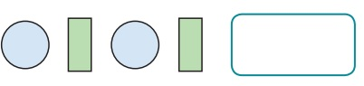  *Parents - There are video links for each lesson and worksheets saved in the resources folder. | Geography – Shanghai, China  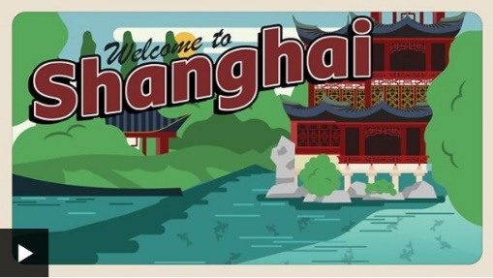  https://www.bbc.co.uk/bitesize/topics/zyhp34j/articles/zvnvjhv  Asia is the biggest continent in the world.  There are many countries in Asia.  One of those countries is China, which is where Shanghai is.  Shanghai is a really busy place.  Lots of the buildings in Shanghai are very tall skyscrapers.  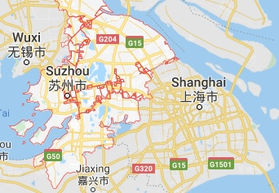  Suzhou, where I used to live!
Fri | Spelling – Ask you Mum or Dad to test you, you can do it by saying it out loud or writing it down.  This Photo by Unknown Author is licensed under CC BY-SA-NC  10:30 – Y1 Phonics  OR Reading Comprehension (Choose from the selection)  Literacy - Choice 1: Barry the fish with fingers OR  Choice 2: The Ragdoll to the Heedless Child  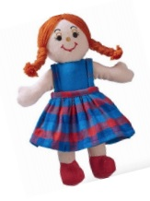  *Parents – All resources and worksheets are in the resources folder. | Play TT Rock stars and then….  Free Choice Maths | Art – Repeated Patterns  Art with Miss Harris…  https://classroom.thenational.academy/lessons/to-create-repeated-patterns-4ae78a/activities/1  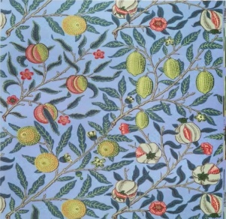  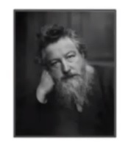You will need…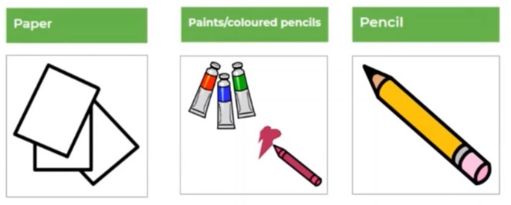  Artist: William Morris
Lessons in red have resources to go with them, uploaded to our class page on the school website.
https://www.arnside.cumbria.sch.uk/classes/year-1-2

