Week 12-w/b 6.7.20
Year 1/2
Day | Literacy | Maths | Curriculum
Mon | Spelling – The spelling words are in the resources file. Can you write your spelling words out?  10:30 – Y1 Phonics  OR Reading Comprehension (Choose from the selection)  *Some texts have different levels of questions (1 star, 2 stars and 3 stars, easy, medium or harder). If your child reads the text confidently, try the harder level. If your child needs support to read the text, try the easier level.  Literacy  Choice 1: The Rainbow fish  Choice 2: Sam’s Duck  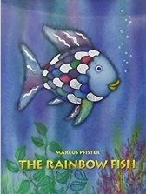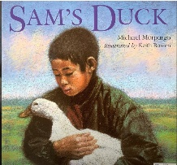  The Rainbow Fish  https://www.youtube.com/watch?v=xAAjkJRLO34  *Parents – All resources and worksheets are in the resources folder. | Year 1 – Watch the video (click from links page) and then ‘ordering numbers’, worksheet.  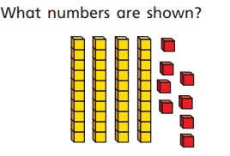  Year 2 – Watch the video (click from links page) and then ‘measure length (cm)’, worksheet.  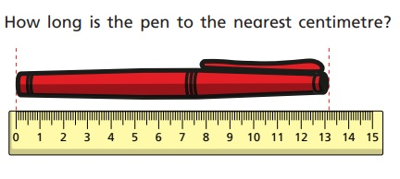  *Parents - There are video links for each lesson and worksheets saved in the resources folder. | Science – What are constellations?  Science Lesson with Miss Emms from the National Oak Academy  https://classroom.thenational.academy/lessons/what-are-constellations  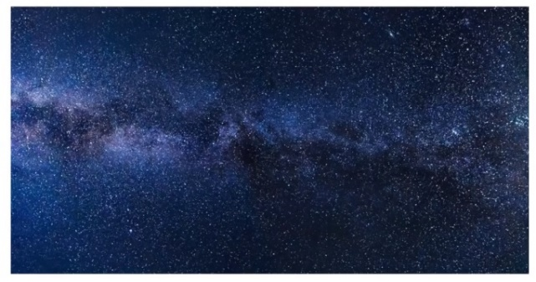  *Please note this is a lesson for Year 2, however, Year 1 children should enjoy this lesson also.
Tues | Handwriting  Joining words with s, write 1 line of each word.  van, vat, vine, very, vase, victory  10:30 – Y1 Phonics  OR Reading Comprehension (Choose from the selection)  Choice 1: The Rainbow Fish OR  Choice 2: Sam’s Duck  *Parents – All resources and worksheets are in the resources folder. | Year 1 – Watch the video (click from links page) and then ‘ordering coins’, worksheet  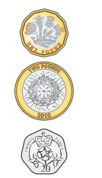  Year 2 – Watch the video (click from links page) and then ‘compare lengths’, worksheet.  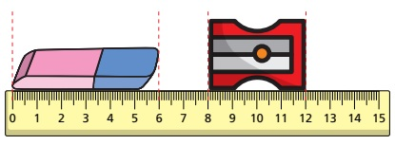  *Parents - There are video links for each lesson and worksheets saved in the resources folder. | Music  Charanga – Yumu  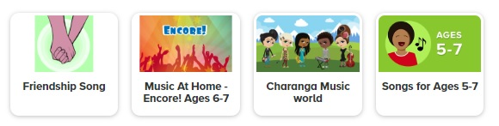  *Please continue your learning, if you have completed the Friendship package, there are three more packages to access!
Wed | Spelling – Word Search  10:30 – Y1 Phonics  OR Reading Comprehension (Choose from the selection)  Literacy - Choice 1: The Rainbow Fish OR  Choice 2: Sam’s Duck  *Parents – All resources and worksheets are in the resources folder. | Lesson 3  Year 1 – Watch the video (click from links page) and then ‘ordering notes’, worksheet.  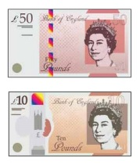  Year 2 – Watch the video (click from links page) and then ‘four operations with length’, worksheet.  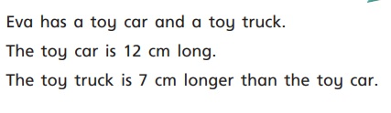  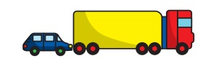  *Parents - There are video links for each lesson and worksheets saved in the resources folder. | P.E. Creative Movement  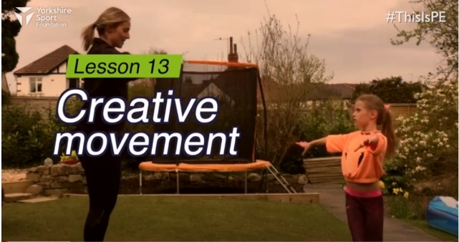  https://www.youtube.com/watch?v=_pWus22nTVI&list=PLYGRaluWWTojV3An2WEgsQ4qGFy_91jDL&index=14  Watch this demonstration and then give it a go!  You will need a partner, a prop (like a scarf) and some obstacles (a chair, boxes, a broom handle)
Thurs | Handwriting – Spelling handwriting  10:30 – Y1 Phonics  OR Reading Comprehension (Choose from the selection)  Literacy - Choice 1: The Rainbow Fish OR  Choice 2: Sam’s Duck  *Parents – All resources and worksheets are in the resources folder. | Year 1 – Watch the video (click from links page) and then ‘counting in coins’, worksheet.  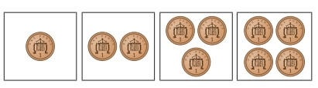  Year 2 – Watch the video (click from links page) and then ‘compare mass’, worksheet.  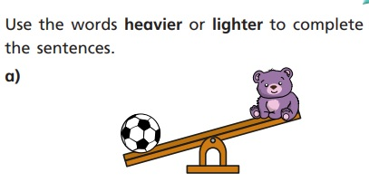  *Parents - There are video links for each lesson and worksheets saved in the resources folder. | Geography – Northern Territory, Australia  https://www.bbc.co.uk/bitesize/topics/zyhp34j/articles/zf26rj6  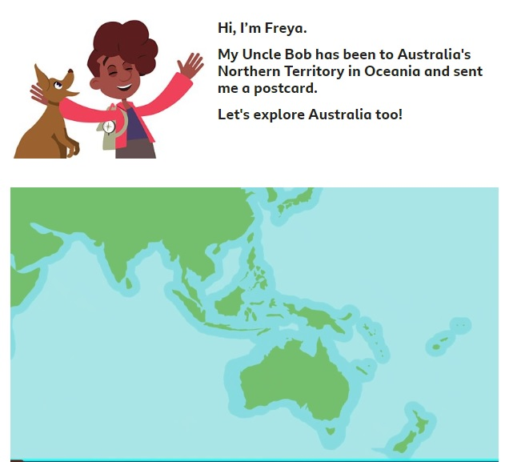  The continent of Oceania (Australasia)  Look! New Zealand 😊  Oceania is a continent which is made up of Australia, New Zealand, Papua New Guinea and many other smaller islands. Oceania is home to the Great Barrier Reef, one of the natural wonders of the world, and home to lots of ocean wildlife.
Fri | Spelling – Ask you Mum or Dad to test you, you can do it by saying it out loud or writing it down.  This Photo by Unknown Author is licensed under CC BY-SA-NC  10:30 – Y1 Phonics  OR Reading Comprehension (Choose from the selection)  Literacy - Choice 1: The Rainbow Fish OR  Choice 2: Four Ducks on a Pond (Poem)  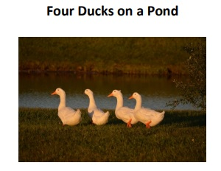  *Parents – All resources and worksheets are in the resources folder. | Play TT Rock stars and then….  Free Choice Maths | Art – Sculpture with recycled materials  Art with Miss Harris…  https://classroom.thenational.academy/lessons/to-create-a-sculpture-focused-on-reuseable-materials/activities/1  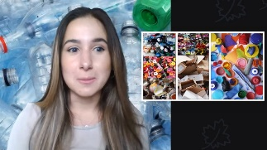  You will need…  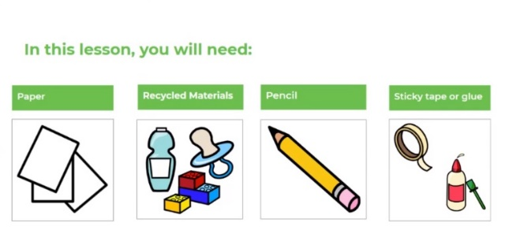
Lessons in red have resources to go with them, uploaded to our class page on the school website.
https://www.arnside.cumbria.sch.uk/classes/year-1-2

