Week 7-w/b 1.6.20
Year 1/2
Day | Literacy | Maths | Curriculum
Mon | Spelling – The spelling words are in the resources file. Can you write your spelling words out on pieces of card and play bingo?  10:30 – Y1 Phonics OR Y2 Grammar  Tiddler OR Angry Cat  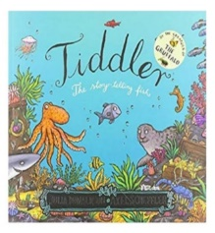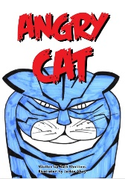  Tiddler link  https://www.youtube.com/watch?v=pBRT5vsfE3U  *Parents – All resources and worksheets are in the resources folder. | Year 1 – Watch the video (click from links page) and then ‘Find and make number bonds’ worksheet.  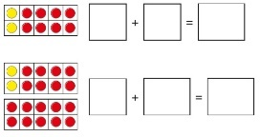  Year 2 – Watch the video (click from links page) and then ‘Fact Families’ worksheet.  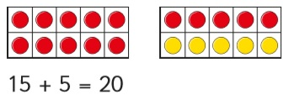  *Parents - There are video links for each lesson and worksheets saved in the resources folder. | Science – What is the difference between night and day?  Science Lesson with Miss Ems from the National Oak Academy  https://www.thenational.academy/year-2/foundation/what-is-the-difference-between-night-and-day-year-2-wk3-3  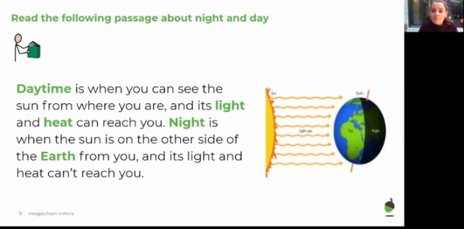  *Please note this is a lesson for Year 2, however, Year 1 children should enjoy this lesson also.
Tues | Handwriting  Joining words with diagonal joins  ch in = chin  10:30 – Y1 Phonics OR Y2 Grammar  Tiddler or Angry Cat  *Parents – All resources and worksheets are in the resources folder. | Year 1 – Watch the video (click from links page) and then ‘Related Facts’ worksheet  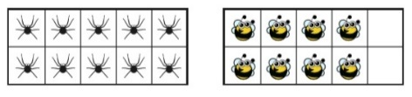  Year 2 – Watch the video (click from links page) and then ‘Compare Number Sentences’ worksheet.  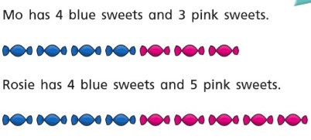  *Parents - There are video links for each lesson and worksheets saved in the resources folder. | Music  Charanga – Yumu  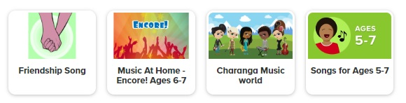  *Please continue your learning, if you have completed the Friendship package, there are three more packages to access!
Wed | Spelling – Word Search  10:30 – Y1 Phonics OR Y2 Grammar  Tiddler or Baba Yaga  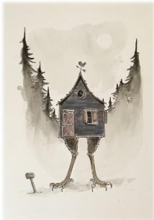  *Parents – All resources and worksheets are in the resources folder. | Lesson 3 –  Year 1 – Watch the video (click from links page) and then ‘Find a part’ worksheet.  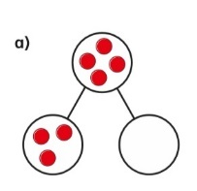  Year 2 – Watch the video (click from links page) and then ‘Related facts’ worksheet.  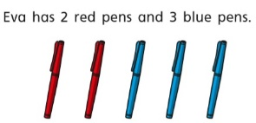  *Parents - There are video links for each lesson and worksheets saved in the resources folder. | P.E. Design a ‘Joe Wicks’ style workout!  You should choose some warm up stretches, 10 exercises that take 30 seconds each with a 30 second rest, two-minute rest, then 10 more exercises before finally some warm down stretches.
Thurs | Handwriting – Spelling handwriting  10:30 – Y1 Phonics OR Y2 Grammar  Tiddler or Baba Yaga  *Parents – All resources and worksheets are in the resources folder. | Lesson 4 –  Year 1 – Watch the video (click from links page) and then ‘Add by counting on’ worksheet.  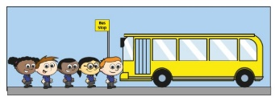  Year 2 – Watch the video (click from links page) and then ‘Add and subtracts 1s’ worksheet.  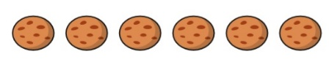  *Parents - There are video links for each lesson and worksheets saved in the resources folder. | Science: Which materials are reflective?  Science Lesson with Miss Ems from the National Oak Academy  https://www.thenational.academy/year-2/foundation/which-materials-are-reflective-year-2-wk4-3  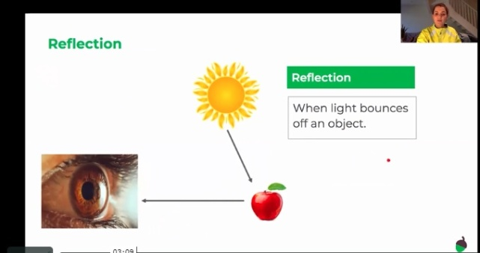  *Please note this is a lesson for Year 2, however, Year 1 children should enjoy this lesson also.
Fri | Spelling – Ask you Mum or Dad to test you, you can do it by saying it out loud or writing it down.  This Photo by Unknown Author is licensed under CC BY-SA-NC  10:30 – Y1 Phonics OR Y2 Grammar  Tiddler or Hansel and Gretel  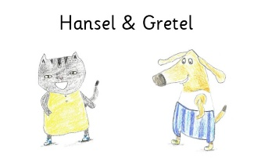  *Parents – All resources and worksheets are in the resources folder. | Lesson 5  Play TT Rock stars and then….  Free Choice Maths | Art – Insects using Natural Materials  Miss Harris will help you create shadow art  https://www.thenational.academy/year-2/foundation/to-make-insects-using-natural-materials-year-2-wk4-5  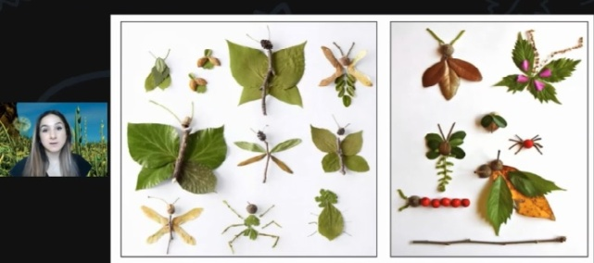
Lessons in red have resources to go with them, uploaded to our class page on the school website.
https://www.arnside.cumbria.sch.uk/classes/year-1-2

