Week 8-w/b 8.6.20
Year 1/2
Day | Literacy | Maths | Curriculum
Mon | It is World Ocean’s Day!  https://worldoceanday.school/  Spelling – The spelling words are in the resources file. Can you write your spelling words out?  You could choose,  - Chalk  - Paint  - Playdough (make the words)  - Water – use a paintbrush, dip it in the water and write it on concrete  - Cooked spaghetti (shape the words)  - Dots, then join with a coloured felt pen  10:30 – Y1 Phonics  OR Y2 Grammar, revise – What is a verb? power point (resources folder)  Literacy - Choice 1: Sharing a Shell OR  Choice 2: Whale Words  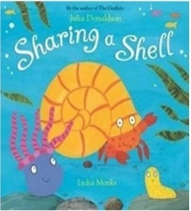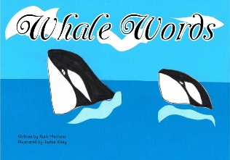  Sharing A Shell: https://www.youtube.com/watch?v=6KuSl9eXgpk  *Parents – All resources and worksheets are in the resources folder. | Year 1 – Watch the video (click from links page) and then ‘Add by making 10’, worksheet.  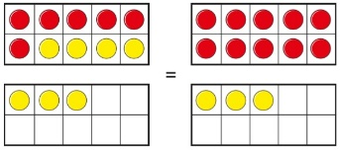  Year 2 – Watch the video (click from links page) and then ‘2- digit add and subtract tens’ worksheet.  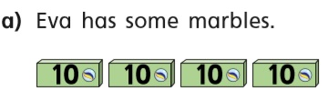  *Parents - There are video links for each lesson and worksheets saved in the resources folder. | Science – How are shadows formed?  Science Lesson with Miss Ems from the National Oak Academy  https://www.thenational.academy/year-2/foundation/how-are-shadows-formed-year-2-wk5-3  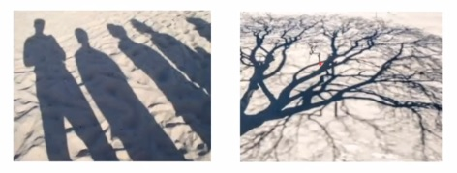  *Please note this is a lesson for Year 2, however, Year 1 children should enjoy this lesson also.
Tues | Handwriting  Joining words with oo diagraph, write 1 line of each word.  look cook book hook nook  10:30 – Y1 Phonics  OR Y2 Grammar – Finding Verbs (choose 1 star, 2 star or 3 star sheet in resource folder)  Literacy - Choice 1: Sharing a Shell OR  Choice 2: Man fish: A Story of Jacques Cousteau  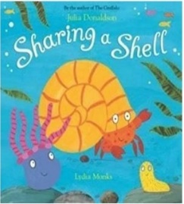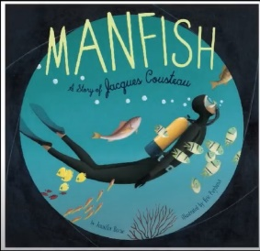  *Parents – All resources and worksheets are in the resources folder. | Year 1 – Watch the video (click from links page) and then ‘subtraction-crossing 10 (1)’, worksheet  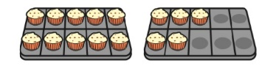  Year 2 – Watch the video (click from links page) and then ‘Add two-digit numbers’ worksheet.  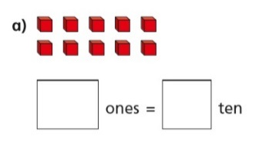  *Parents - There are video links for each lesson and worksheets saved in the resources folder. | Music  Charanga – Yumu  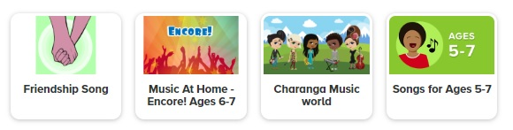  *Please continue your learning, if you have completed the Friendship package, there are three more packages to access!
Wed | Spelling – Word Search  10:30 – Y1 Phonics  OR Y2 Grammar  (Tense poster in resources folder)  https://www.bbc.co.uk/bitesize/topics/zrqqtfr/articles/z3dbg82  Literacy - Choice 1: Sharing a Shell OR  Choice 2: Manfish: A Story of Jacques Cousteau  *Parents – All resources and worksheets are in the resources folder. | Lesson 3 –  Year 1 – Watch the video (click from links page) and then ‘subtraction crossing 10 (2)’ worksheet.  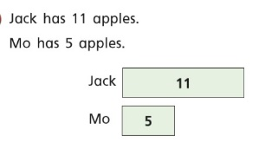  Year 2 – Watch the video (click from links page) and then ‘Subtract 2-digit numbers’ worksheet.  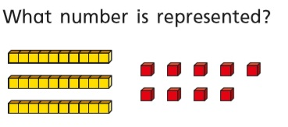  *Parents - There are video links for each lesson and worksheets saved in the resources folder. | P.E. Jumping combinations  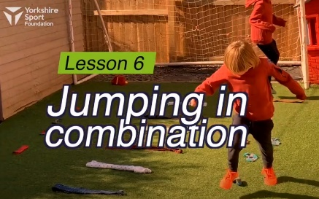  https://www.youtube.com/watch?v=cRjO1IGwbLo  Watch this demonstration and then give it a go!  You will need some socks, ties/rolled up tea towels and space inside (on carpet) or outside.
Thurs | Handwriting – Spelling handwriting  10:30 – Y1 Phonics  OR Y2 Grammar – Simple past, simple present tense power point (resources folder)  Literacy - Choice 1: Sharing a Shell OR  Choice 2: The Fantastic Undersea life of Jacques Cousteau  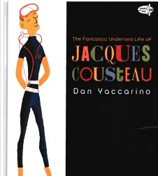  *Parents – All resources and worksheets are in the resources folder. | Lesson 4 –  Year 1 – Watch the video (click from links page) and then ‘compare number sentences’ worksheet.  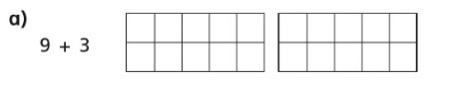  Year 2 – Watch the video (click from links page) and then ‘Bonds to 100’ worksheet.  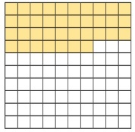  *Parents - There are video links for each lesson and worksheets saved in the resources folder. | Science – How can you change the size of a shadow?  Science Lesson with Miss Ems from the National Oak Academy  https://www.thenational.academy/year-2/foundation/how-can-you-change-the-size-of-a-shadow-year-2-wk6-3#slide-1  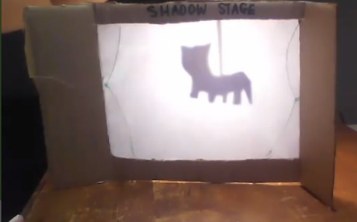  *Please note this is a lesson for Year 2, however, Year 1 children should enjoy this lesson also.
Fri | Spelling – Ask you Mum or Dad to test you, you can do it by saying it out loud or writing it down.  This Photo by Unknown Author is licensed under CC BY-SA-NC  10:30 – Y1 Phonics  OR Y2 Grammar, identifying sentences, is it in the present simple or past simple tense? (resources folder)  Literacy - Choice 1: Sharing a Shell OR  Choice 2: Doug’s Deep-sea Diary  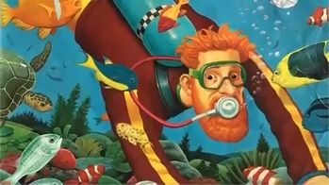  *Parents – All resources and worksheets are in the resources folder. | Lesson 5  Play TT Rock stars and then….  Free Choice Maths | Art – To build a terrarium  Miss Harris will help you make a terrarium.  https://www.thenational.academy/year-2/foundation/to-build-a-terrarium-year-2-wk6-5#slide-2  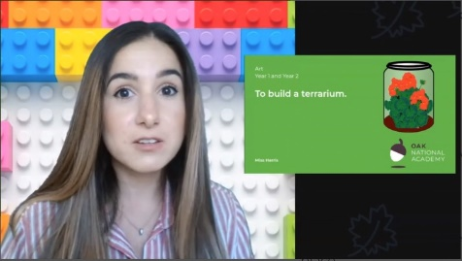  You will need…  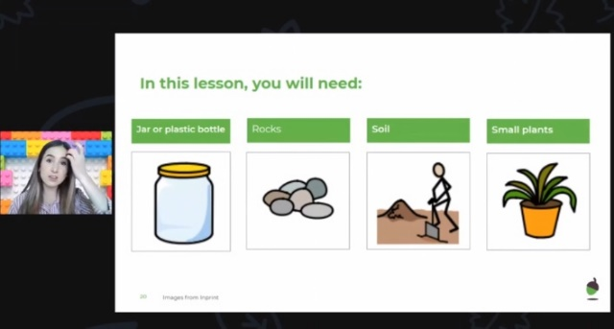
Lessons in red have resources to go with them, uploaded to our class page on the school website.
https://www.arnside.cumbria.sch.uk/classes/year-1-2

