Week 9-w/b 15.6.20
Year 1/2
Day | Literacy | Maths | Curriculum
Mon | Spelling – The spelling words are in the resources file. Can you write your spelling words out?  You could choose,  - Chalk  - Paint  - Playdough (make the words)  - Water – use a paintbrush, dip it in the water and write it on concrete  - Cooked spaghetti (shape the words)  - Dots, then join with a coloured felt pen  10:30 – Y1 Phonics  OR Y2 Grammar (In Literacy Choice 2 – Power point, ‘Noun phrases 1’  Literacy - Choice 1: The Singing Mermaid OR  Choice 2: The Paper Bag Princess  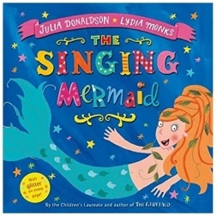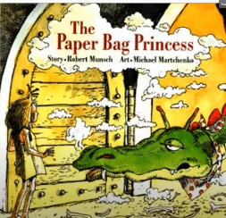  The Singing Mermaid: https://www.youtube.com/watch?v=i8E0xAL8heE  *Parents – All resources and worksheets are in the resources folder. | Year 1 – Watch the video (click from links page) and then ‘Count in 2s’, worksheet.  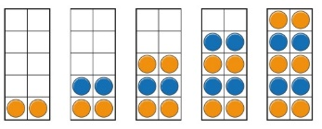  Year 2 – Watch the video (click from links page) and then ‘Multiplication sentences’ worksheet.  *Parents - There are video links for each lesson and worksheets saved in the resources folder. | Science – What is Space?  Science Lesson with Miss Emms from the National Oak Academy  https://classroom.thenational.academy/lessons/what-is-space  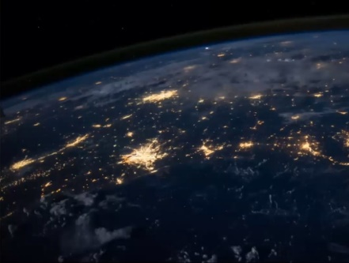  *Please note this is a lesson for Year 2, however, Year 1 children should enjoy this lesson also.
Tues | Handwriting  Joining words with oa diagraph, write 1 line of each word.  goat coat boat float moan  10:30 – Y1 Phonics  OR Y2 Grammar - (In Literacy Choice 2 – Power point, ‘Noun phrases 2’  Literacy - Choice 1: The Singing Mermaid OR  Choice 2: The Paper Bag Princess  *Parents – All resources and worksheets are in the resources folder. | Year 1 – Watch the video (click from links page) and then ‘Count in 5s’, worksheet  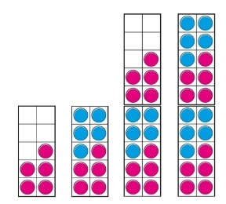  Year 2 – Watch the video (click from links page) and then ‘Use Arrays’ worksheet.  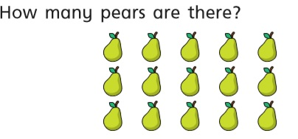  *Parents - There are video links for each lesson and worksheets saved in the resources folder. | Music  Charanga – Yumu  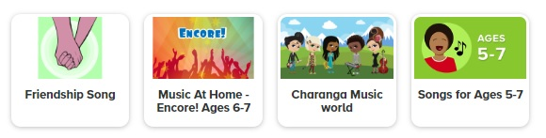  *Please continue your learning, if you have completed the Friendship package, there are three more packages to access!
Wed | Spelling – Word Search  10:30 – Y1 Phonics  OR Y2 Grammar-How to use an exclamation mark!  https://www.bbc.co.uk/bitesize/topics/z8x6cj6/articles/z3dcmsg  Literacy - Choice 1: The Singing Mermaid OR  Choice 2: Its Behind You! (Poem)  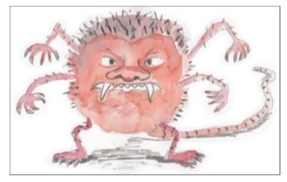  *Parents – All resources and worksheets are in the resources folder. | Lesson 3  Year 1 – Watch the video (click from links page) and then ‘Count in 10s’ worksheet.  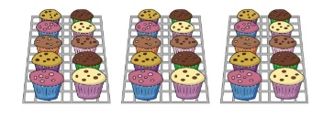  Year 2 – Watch the video (click from links page) and then ‘2 times-table’ worksheet.  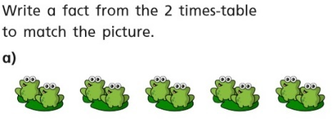  *Parents - There are video links for each lesson and worksheets saved in the resources folder. | P.E. Agility  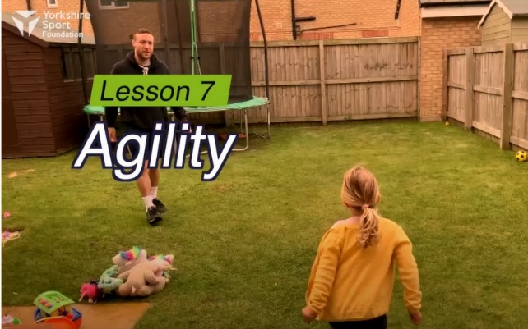  https://www.youtube.com/watch?v=cUy-nGjLWQM  Watch this demonstration and then give it a go!  You will need some toys/obstacles and balls.
Thurs | Handwriting – Spelling handwriting  10:30 – Y1 Phonics  OR Y2 Grammar – What are adjectives?  https://www.bbc.co.uk/bitesize/topics/zrqqtfr/articles/zy2r6yc  Literacy - Choice 1: The Singing Mermaid OR  Choice 2: There are Gribbles (Poem)  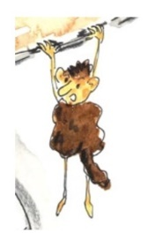  *Parents – All resources and worksheets are in the resources folder. | Year 1 – Watch the video (click from links page) and then ‘Add equal groups, worksheet.  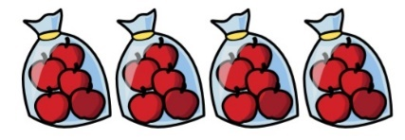  Year 2 – Watch the video (click from links page) and then ‘5 times-table’ worksheet.  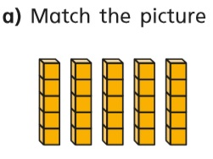  *Parents - There are video links for each lesson and worksheets saved in the resources folder. | Geography - France  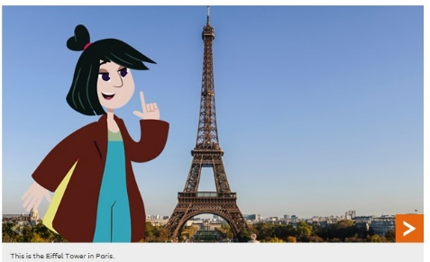  https://www.bbc.co.uk/bitesize/topics/zyhp34j/articles/zhw7vk7  There are lots of things to see and do in France. Visitors go to theme parks, ski in the mountains, build sandcastles on the beach and visit the capital, Paris. France is in Europe. This is the continent you live in.
Fri | Spelling – Ask you Mum or Dad to test you, you can do it by saying it out loud or writing it down.  This Photo by Unknown Author is licensed under CC BY-SA-NC  10:30 – Y1 Phonics  OR Y2 Grammar, How to use commas  https://www.bbc.co.uk/bitesize/topics/z8x6cj6/articles/zxvcrdm  Literacy - Choice 1: The Singing Mermaid OR  Choice 2: The Football Field Foul Friend  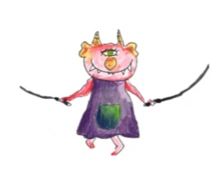  *Parents – All resources and worksheets are in the resources folder. | Play TT Rock stars and then….  Free Choice Maths | Art – Explore tints and shades  Art with Miss Harris…  https://classroom.thenational.academy/lessons/to-explore-tints-and-shades-ae6dfb  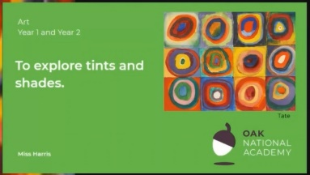  You will look at the artist, Wassily Kandinsky.
Lessons in red have resources to go with them, uploaded to our class page on the school website.
https://www.arnside.cumbria.sch.uk/classes/year-1-2

