Week 5-w/b 11.05.2020
Year 1/2
Day | Literacy | Maths | Curriculum
Mon | Spelling – The spelling words are in the resources file. Can you write your spelling words in alphabetical order and write the vowels in blue?  10:30 - Phonics  Grammar-Possessive apostrophes (if you don’t do phonics)  https://www.bbc.co.uk/teach/supermovers/ks1-english-apostrophes-with-sasha-tyler/z49hd6f  Can you collect 6 things that belong to someone in your family (ask their permission first )  Can you draw each item and write some sentences about each item? Can you add a conjunction to make a complex sentence?  (e.g. and, but, if, when, because)  This is my Mum’s winter hat. She uses it if it is cold.  These are my Dad’s shoes. He uses them when he goes running.  Emily’s hairbrush is pink and black. She likes it because it is a tangle teaser brush.  Home Learning Time Capsule – Parents, in the folder there is a guide to read through and then four activities to complete. I have planned for this to be the Literacy work for this week, apart from Thursday. | Lesson 1: - Addition and Subtraction – Number Bonds  If you are learning your number bonds to 10 https://www.bbc.co.uk/bitesize/articles/zh8m6v4  Plus complete the lego challenge in the resources folder.  If you are learning your number bonds to 20 https://www.bbc.co.uk/bitesize/articles/zjn3gwx  Plus complete the ‘addition and subtraction speed test’.  If you are secure in your number bonds to 10 and to 20, then complete the addition and subtraction speed test in the resources folder. Then you could try ‘adding and subtracting 10s’. | Geography – mapping  To be ready for the next time you and your family go for a walk, can you plan a route for your family’s walk? Can you work on, ‘Planning a walking route’ in the resources folder.  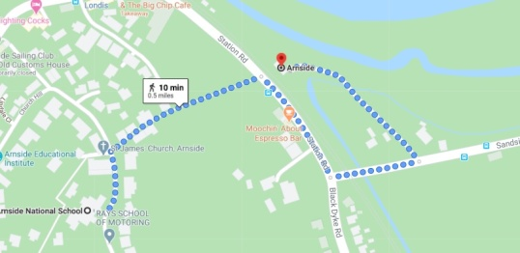
Tues | Handwriting  The diagonal join to a, c and o  ca ic co ea ac no  10:30 - Phonics  Home Learning Time Capsule | Lesson 2 – Measurement Hunt  - Go on a measurement hunt – find all of the equipment in your house that you can use to measure. Sort them into groups.  - Which equipment did you put in each group?  - Draw it  - Can you label it with what you would use it for?  - Find the document ‘Tuesday Maths’ in the resources folder | Music  Charanga – Yumu  Lesson 5 – The Friendship Song  You Give a Little Love  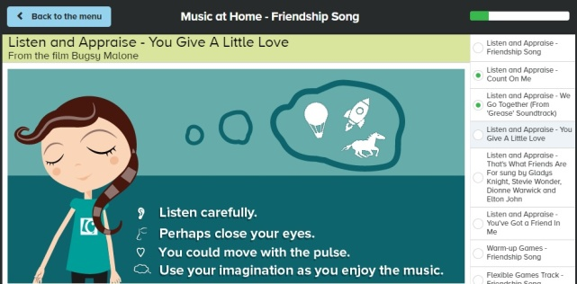
Wed | Spelling – word search  10:30 - Phonics  Home Learning Time Capsule | Lesson 3 – Measuring Weight  Complete the lesson labelled Wednesday Maths in the resources folder.  (parents, please ignore the week and day title at the top) | P.E. – Dance  Can’t stop the feeling  https://www.youtube.com/watch?v=KhfkYzUwYFk  That’s what makes you beautiful  https://www.youtube.com/watch?v=k2hBMkZuvP8  I like to move it  https://www.youtube.com/watch?v=ymigWt5TOV8
Thurs | Handwriting – Spelling handwriting  10:30 – Phonics  George’s Marvellous Medicine Activity – invent a recipe | Lesson 4 – Measuring Weight  Complete the lesson labelled Thursday Maths in the resources folder.  (parents, please ignore the week and day title at the top) | Geography- mapping  The World  Now that you have looked at maps of Arnside, can you zoom out and look at our Wonderful World? View the power point, ‘Round and Round’ in the resources folder. Choose which activity sheet you want to complete, ‘Activity sheets mapping the world’ (there are three choices) Or you can draw your own world map!  **Parents – on the ‘Round and Round pp, slide 13 requires a globe, Goggle Earth could possibly be used instead, or skip the slide.
Fri | Spelling – Ask you Mum or Dad to test you, you can do it by saying it out loud or writing it down.  This Photo by Unknown Author is licensed under CC BY-SA-NC  10:30 - Phonics  Reading – Get your poetry book and read two of your favourite poems.  George wanted to make Grandma a magic medicine. He put in some ‘scarlet’ (red) nail varnish, that would paint her teeth, ‘as red as roses’. When Grandma had the medicine she thought she was on fire. She said, ‘I’ll be boiled like a beetroot’. When she started to grow, ‘Up she went like a jack-in-the-box. These are all similes. Similes compare two things.  As red as roses compares how red something is and how red, red roses are.  Boiled like beetroot. Beetroot is mostly boiled or cooked before it is eaten, although it can be eaten raw. So Grandma will be boiled and cooked just like how beetroot is boiled and cooked.  Up like a jack-in-the-box means she popped up just like a jack-in-the-box pops up.  Your turn....Using the rainbow simile template can you think of things that are like the colours in a rainbow? For example...  A rainbow is as red as strawberries | Lesson 5  If you are not confident with the ten times tables, practise them! Try skip counting first and then sing along with Webster the Spider  https://www.bbc.co.uk/teach/supermovers/ks1-maths-the-10-times-table-with-webster-the-spider/zm32cqt  Play TT Rock stars and then….  Free Choice Maths | Art – Self Portrait (using natural or recycled materials  https://www.thenational.academy/year-2/foundation/to-make-a-self-portrait-using-natural-or-recycled-materials-year-2-wk3-5  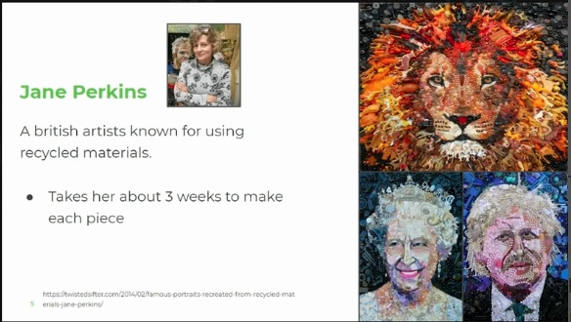
Lessons in red have resources to go with them, uploaded to our class page on the school website.
https://www.arnside.cumbria.sch.uk/classes/year-1-2

